**Post 1**

(Referring raw json train dataset of comments)

**Url :** <https://i.redd.it/gvwivhq9nmf31.jpg>

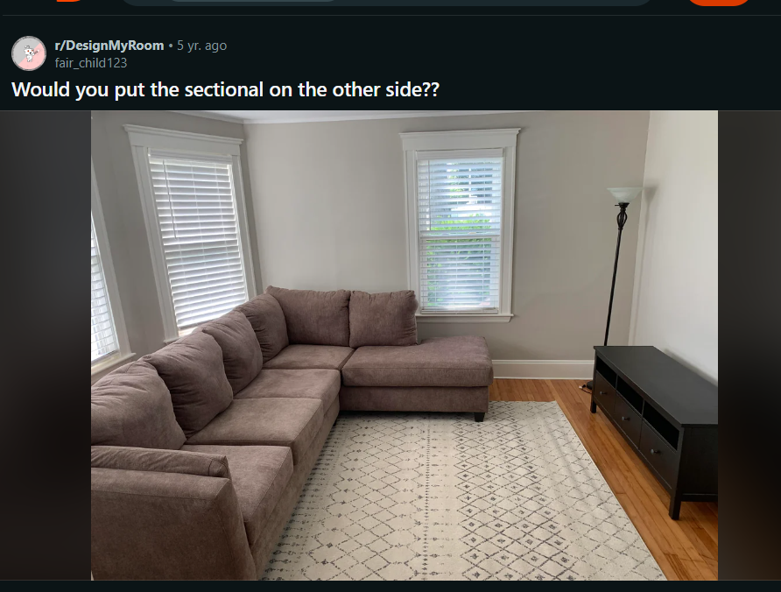

**Summary of the post :**   
The post is about the OP seeking advice on whether to change the placement of their sectional couch in the living room. They are specifically asking if the sectional should be moved to the other side of the room, particularly near bay windows. The OP is concerned about losing space and is open to suggestions.

**Related comments:**   
- Commenters generally agree that the seating arrangement should stay by the windows.

- Some suggest solutions like getting a smaller couch or using blackout curtains to reduce glare on the TV.

- Discussions on the ideal placement of the TV in relation to windows and the overall room layout.

- Opinions on the coziness and size of the existing couch.

**Here are some keywords extracted from the given post and comments:**

Sectional

Couch

Bay windows

TV stand

Console table

Chaise

Room layout

Furniture placement

Rug

Window seating

Entertainment center

Wall mounting

Blackout curtains

Glare reduction

Space optimization

Seating arrangement

Living room design

Room size

Compromise

Sectional orientation

**Comments:**

1. It sounds like you would be losing foot space regardless because the tv stand wouldn\u2019t be able to fully fit in the bay window either. I think it looks nice as is. Maybe look into if there is a console table you could put behind the couch that is designed to fit with a bay window?"

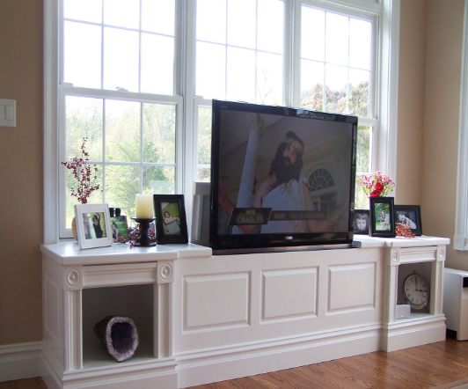**Image :**   
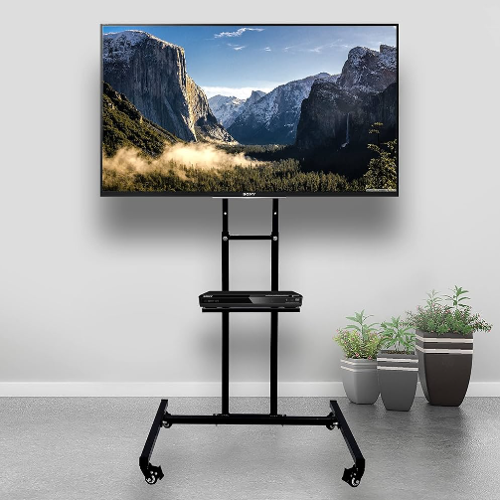

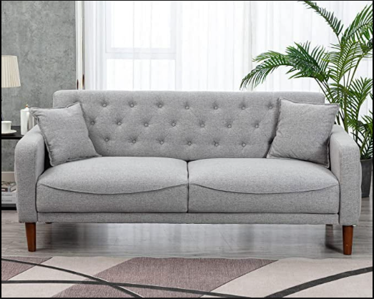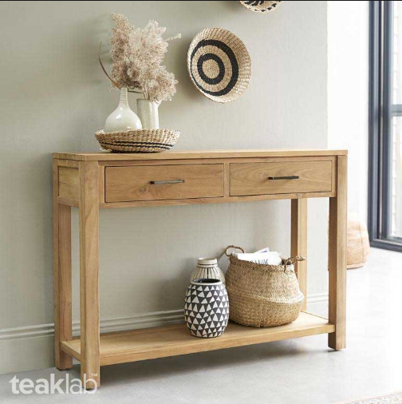

1. Is there space to put a TV stand in the corner by the windows?
2. Is there space to put a TV stand in the corner by the windows? (User 2)
3. You could put some tall plants behind the sofa or find a sofa table that fits between the couch and the windows? It\u2019s hard to tell how much room there is back there in this photo.

**Image:**

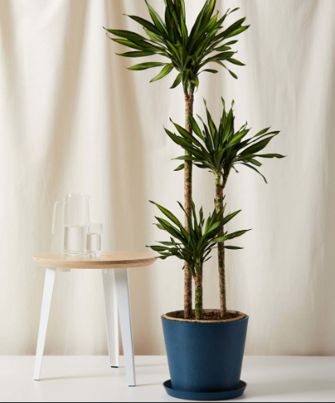

1. Ps. I wouldn\u2019t put the tv in front of the windows, not just because of lighting but because it won\u2019t look nice with the tv blocking the lovely windows. It can also be more difficult to hide all the inevitable connectors and cords. (User 3)

**Image :**

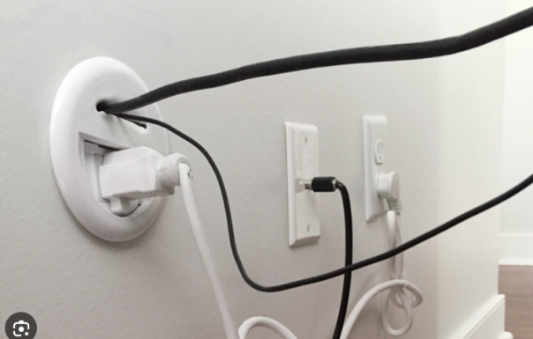

1. I would rather sit facing the windows! (User 4)
2. No. In my humble opinion, the chaise part of the section always go along the wall/window side of a room.. because you don\u2019t want the space to feel closed off.  My sectional couch is non adjustable, so if I move to a new place where the chaise side doesn\u2019t work with the layout of the room, then I will have to get a new couch.
3. Agreed. I think this is the best possible set up for the space\u2013 chaise along the wall/window side, entertainment center on blank/focal wall. It may be difficult to view a TV against a backlit wall of bright windows. (User 6 )
4. This comment is everything I\u2019ve been trying to explain to my husband. Thank you. LOL.

(User 7 )

1. The chaise part can be switched to the other side. Yes, you should definitely swap it around.

(User 8)

…..(User 5)

1. Absolutely do not put the tv in front of your beautiful windows. This sofa won't work in this room no matter what you do so you might as well leave it where it is. Possibly hang the tv on the wall instead of crowding the room even more with more (dark) furniture. (User 9 )
2. Honestly, I would sell the couch and buy a smaller one; it's too big for the room.
3. I understand. It's not a battle worth fighting.  \n\nIn that case, I recommend blackout curtains to reduce glare on the TV. As for positioning the couch, try it out both ways. If it's facing the window, move the TV in the far corner at an angle (you might need a smaller TV stand). Also, you could access the windows much easier if the couch wasn't in the way. With the couch where it is now, direct light exposure might make the color fade, depending on the material. Also, the couch might collect dust and pollen from open windows if it's too close. (User 10)

**Image :**

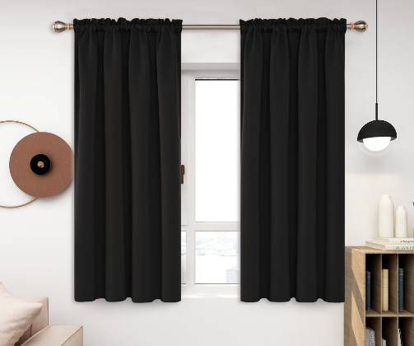

1. If you put it on the other side and are able to keep the chaise on that side it seems like you\u2019ll cover more of that window up, which would not be a good thing imo (it appears your window is closer to the wall on the right in the picture?).\n\nBut tell us about your rug, I love it!"

**Image:**

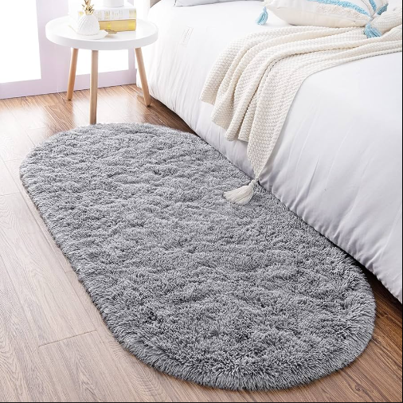

1. Well I mean it\u2019s not a tragedy, it\u2019ll be fine :) I only meant \u201cnot good\u201d relative to its current position. It\u2019s a great space! And I\u2019m just a dummy on the internet with possibly bad opinions.\n\nJust noticed, is the window behind it now a bay window type thing? If so then you made the right choice.

….….(User 11)

1. I\u2019d mount the tv on the wall, not block the windows w it
2. I mean retain this setup vs turning everything around. (User 12)
3. Yes, if there wont be a tv. (User 13)
4. Love your rug\n\nI don\u2019t think the couch is too big. It looks cozy. (User 14)

…...(User 15)

Post 2 - Line : 382

Post 3 - Line : 954

Post 4 - Line : 1345 (Deleted)

**Post 5 - Line : 1770**

Url : https://i.redd.it/vqz824lwq1b81.jpg



**Summary of the post:**

The post is from the subreddit "petitefashionadvice," where the author, "Sashaisbroke," is seeking help finding an outfit to match their gorgeous burgundy/brown Prada shoes. The post has received a high score of 298 and has 43 comments, indicating active engagement from the community.

For outfit suggestions, commenters recommend various color combinations and styles, including dark green, burgundy, navy, beige, creme, flare pants, dresses, and 90s prep style. The suggestions cover a wide range of options, from casual to more formal attire, showcasing the versatility of the Prada shoes. Additionally, there are expressions of admiration for the beauty of the shoes.

**Related Comments:**

- "I can see colors like a nice dark green, burgundy, or navy work with them well. Maybe a beige or creme color too." - themoralmenace

- "I had a far less nice pair of shoes just like these in high school in the 90s. Flare pants, dresses. I would wear these with anything. I also think a reddish shoe is even more of a neutral than a black or a brown shoe. I'm jealous!" - missmisfit

- "Maybe some flowy bootcuts of some kind. Perhaps a patterned print on the bottom." - clothesamiright

- "I think you could lean into styling them like Cher from Clueless—think 90s prep style. You could go with an oversized sweater vest with a turtleneck/button down underneath or a fitted cardigan with a plaid flared skirt and some knee-high socks. Since we’re at the point in the fashion cycle where those styles are popular, I don’t think you would have too much trouble finding those items! Hope this helps!" - libra_aesthetics

- "You could also do a dress like they were in Sabrina the Netflix show. A actually anything with a Peter Pan collar would probably work." - MidniteClairity36

- "Color suggestions? I would go one of two ways. Or, do a combo of the two. You could contrast the reddish brown against something on the other side of the color wheel. Like others have said, navy would be beautiful." - TRex65

- "Navy blue would work great with those shoes, and a suit (especially with pants) would balance very well the feminine aspect of your shoes." - Please_call_me_Tama

- "These are AMAZING. You can style it in the 60s/70s fashion. You can wear them with bell-bottom jeans and a western-inspired shirt or mod dress." - Cruzeria

- "Beige/khaki wide shorts with a white slub loose fit t-shirt. Maybe matching belt and bag complimenting the shoes." - None

- "Natural tone floral, and or a long flowing dress, honestly a dress long frilly dress would be perfect with these." - None

- "I would wear a babydoll dress and some tights! Probably a solid color so the shoes can stand out." - spicygrillll

* These comments provide a variety of outfit suggestions and style ideas, contributing to the overall discussion on how to best complement the brownish burgundy Prada shoes.

**Post Keywords:**

Prada

Burgundy/brown

Outfit

Gorgeous

Fashion advice

Subreddit

Petite

Submission ID

URL

Caption

**Comment Keywords:**

Dark green

Navy

Beige

Flare pants

90s

Reddish shoe

Jealous

Flowy bootcuts

Patterned print

Cher

Clueless

Oversized sweater vest

Turtleneck

Cardigan

Plaid flared skirt

Knee-high socks

Sabrina

Netflix show

Peter Pan collar

Color suggestions

Color wheel

Suit

Feminine aspect

60s/70s fashion

Bell-bottom jeans

Western-inspired shirt

Mod dress

Beige/khaki

Wide shorts

White slub loose fit t-shirt

Matching belt

Natural tone floral

Long flowing dress

Frilly dress

Babydoll dress

Tights

Solid color

Navy sweater dress

Longsleeve white button-down

Brown top

Black bottoms

Black trench coat

Baby blues

Wide-leg trousers

Jeans

Culottes

T-shirt

Boater hat

Small leather sling bag

Flowy floral maxi dress

* These keywords capture the essence of the post and comments, highlighting fashion-related terms, color suggestions, and style recommendations.

**Comments :**

1. I can see colours like a nice dark green, burgundy or navy work with them well. \nMaybe a beige or creme colour too. (User 1)
2. I had a far less nice pair of shoes just like these in high school in the 90s. Flare pants, dresses. I would wear these with anything. I also think a reddish shoe is even more of a neutral than a black or a brown shoe. I'm jealous! (User 2)

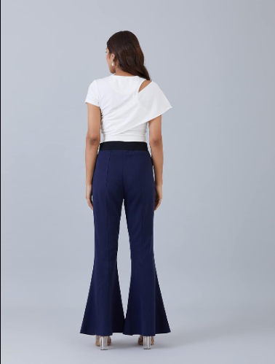

1. Maybe some flowy bootcuts of some kind. Perhaps a patterned print on bottom.

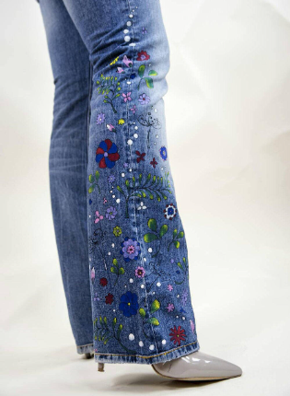

….…(User 3)

1. I think you could lean into styling them like Cher from Clueless\u2014think 90s prep style. You could go with an oversized sweater vest with a turtleneck/button down underneath or a fitted cardigan with a plaid flared skirt and some knee high socks. \n\nSince we\u2019re at the point in the fashion cycle where those styles are popular, I don\u2019t think you would have too much trouble finding those items! Hope this helps!

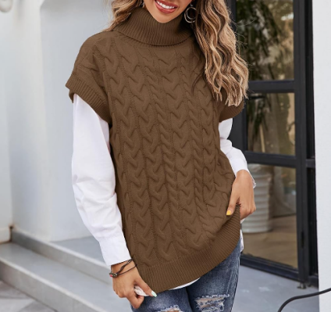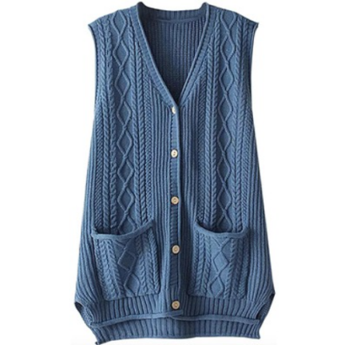+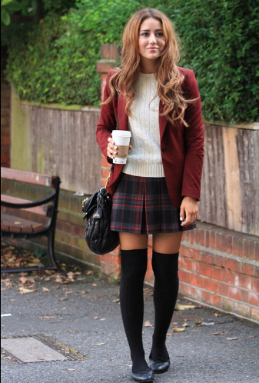

1. You could also do a dress like they were in Sabrina the Netflix show. A actually anything with a Peter Pan collar would probably work. This shirt is really cute Allegra K Women's Peter Pan Collar Blouse Long Sleeve Valentine's Day Heart Dots Top [URL] (User 5)

….…..(User 4)

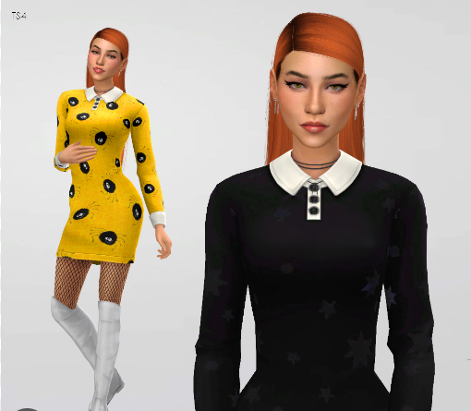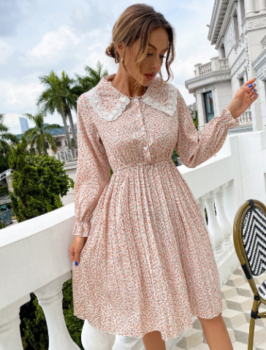

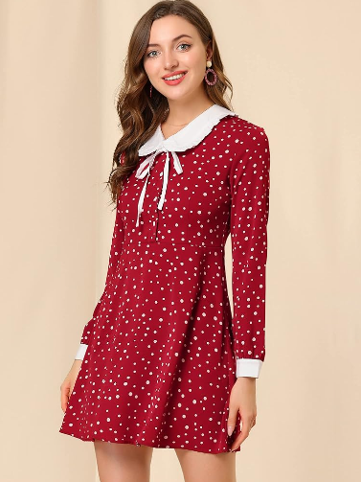

1. Color suggestions? I would go one of two ways. Or, do a combo of the two.\n\nYou could contrast the reddish brown against something on the other side of the color wheel. Like others have said, navy would be beautiful. You could also go with other shades of blue, like cobalt or baby blue or even denim. I would personally put a pop of warm brown elsewhere in my outfit, maybe with a belt or by using a print that includes blues and a pop of brown.\n\nOr, you could do a mix of warm browns, maybe using a retro looking 70's print or a colorblock garment using shades of brown. I would lean heavily into the retro vibe personally, but I'm sure you could do something less extreme and still look fantastic. (User 6)



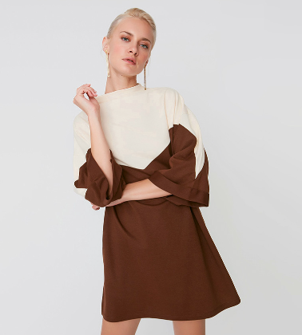

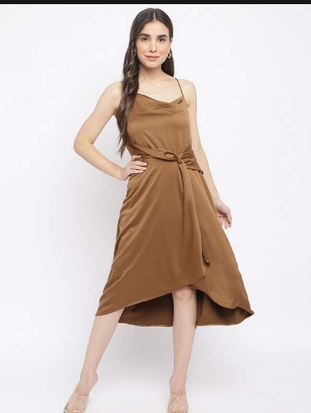

1. Navy blue would work great with those shoes, and a suit (especially with pants) would balance very well the feminine aspect of your shoes.

….…..(User 7)

1. These are AMAZING. You can style it in the 60s/70s fashion. You can wear them with bell-bottom jeans and western inspired shirt or [mod dress]([URL]\n\nGreat find!

….…..(User 8 )

 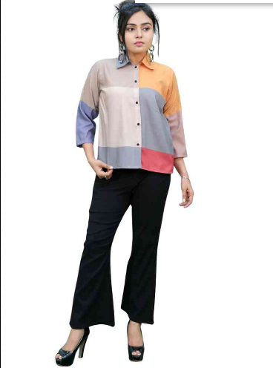

1. Beige/khaki wide shorts with a white slub loose fit t-shirt. Maybe matching belt and bag complimenting the shoes. These are beautiful by the way. They won\u2019t have been on the shelf for longer than a few hours.

….…..(User 9)



1. Natural tone floral, and or a long flowing dress, honestly a dress long frilly dress would be perf with these. ( User 9)

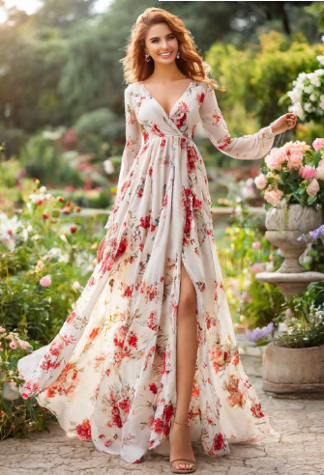 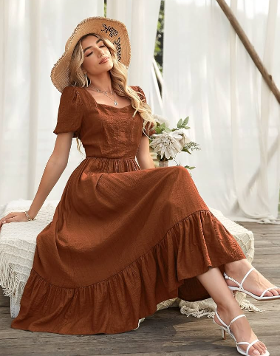

1. I would wear a babydoll dress and some tights! Probably a solid color so the shoes can stand out

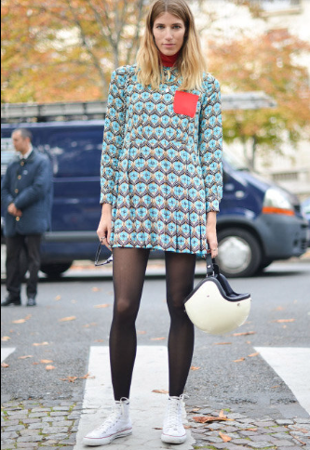

1. Same! (User 11)

….…… (User 10)

1. Navy sweater dress like this:\n\n[[URL]\n\nPair it with a longsleeve white button down underneath! (User 12)



1. Maybe a brown top, black bottoms, and a black trench coat? Idk (User 13)

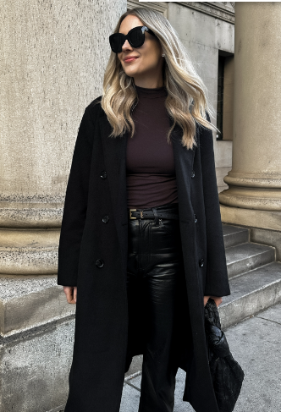

1. Can I ask where you got them?  They\u2019re gorgeous.  I think baby blues will look great!

….……..(User 14)

1. Omg, they're beautiful. (User 15)
2. These are really beautiful, I\u2019m so jelly!\nI\u2019d totally rock these with some wide-leg trousers, Jeans or Culottes, with a cute Tshirt, boater hat, small leather sling bag (matching shoe colour).\nAlso could look really gorgeous with a flowy floral Maxi Dress, boater hat & leather sling bag \ud83d\ude42 ( User 16)

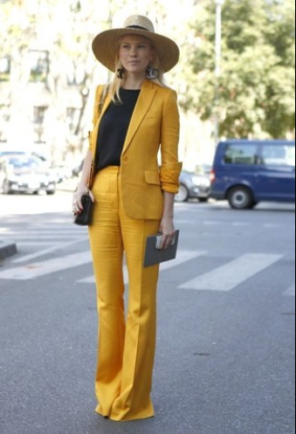 

1. Those shoes are adorable (User 17)
2. Navy dress (User 18)
3. Earthy tones would look amazing! Greens, browns, oranges, etc (User 9)
4. I love jewel tones. Emerald green, Amethyst Purple, SapphireBlue, or even Nude tones. Either a pant suit, or a pant jumpsuit. Find a crossbody bag in the similar color to reinforce the color of the shoes. \n\nAnother option is wide leg pants that are more tapered at the waist in a beige/nude color, and a nice white or off white blouse, with gold jewelry. (User 19)

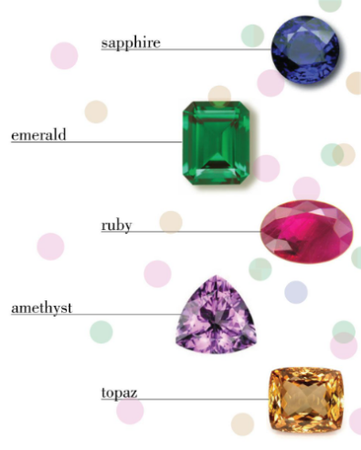  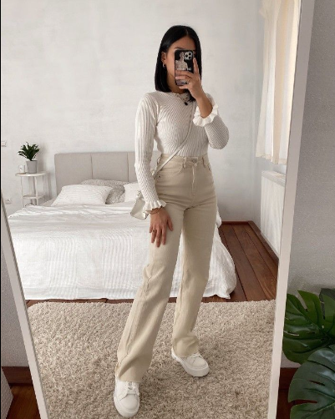

1. I would wear all black/burgundy and let the shoes do the work. (User 11)
2. ooooo, sweet heels!   I'd try them with some flared jeans ... dark wash\n\nanother great look would be with a pleated mini skirt ... dark blue  ? (User 9)
3. Omg I have shoe envy so hard right now they\u2019re immaculate \ud83d\ude2d\u2764\ufe0f\u2764\ufe0f please wear them once for all of us ok? \ud83e\udd72\nThey would look phenomenal with any natural tones, I see them with best with deep green and cream \ud83e\udd70 (User 20)
4. Oh, oh! Maybe try them with a bottom (skirt with tights/pant) made out of rayon, it seems really chic! Also, if they work for you, maybe try some ankle length skinny flare pants with them! (i felt like being more specific hehe) (User 21)

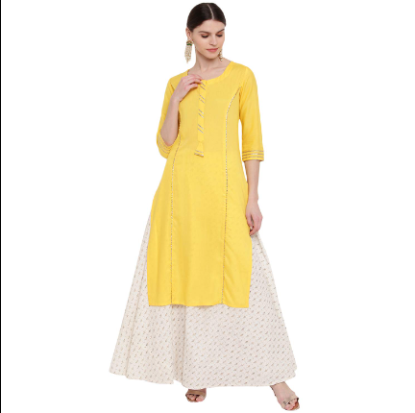

1. Not exactly the season but in the spring I\u2019d wear them with a pair of cropped/kick flares like this and a white linen button up [URL] (User 22)
2. Anything autumn toned! :) (User 23)
3. I have a bit of a wide foot. How do these fit? Assuming they are authentic! Thanks

….……(User 24)

1. I think a 60s inspired look with flare pants and a flowy \"hippie\" look would be super cute! pairing it with those creams/browns/oranges/yellows and fun prints  \nAlso, a 90s prep look as someone else suggested would be so cute, like a play on a school uniform look :D (User 25)
2. OMG. I had these shoes in the 90's! Only they were Nine West or something. Would love to have the Prada version this time around ;) IIRC, I wore mine with J crew chinos and a white slightly cropped T. Also wore them with babydoll dresses. And I had one outfit that was a heather grey pencil skirt with a dark red sleeveless funnel neck chunky knit sweater. (User 26)

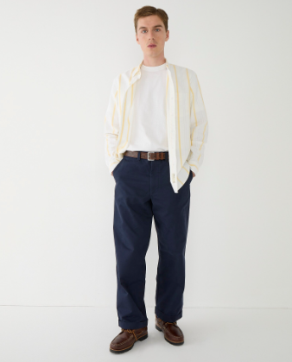 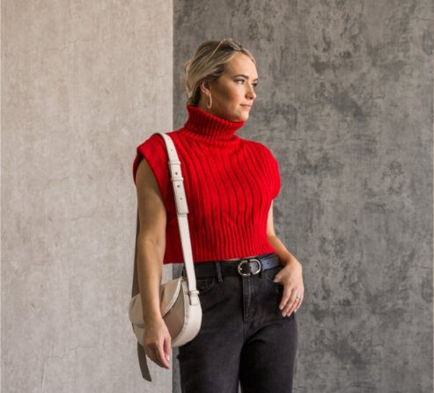

1. Look at Rachel\u2019s outfits from friends. She wears shoes similar to this (but shorter) in early days at Bloomingdale\u2019s if I remember correctly? I think it\u2019s mostly a blazer and skirt combo but can be played up or down very easily. (User 27)



1. OMG stunning \ud83d\ude0d (User 28)
2. Helo (User 29)

**Post 6 - Line 2412**

**Url : https://i.redd.it/6e17j9twh8i71.jpg**

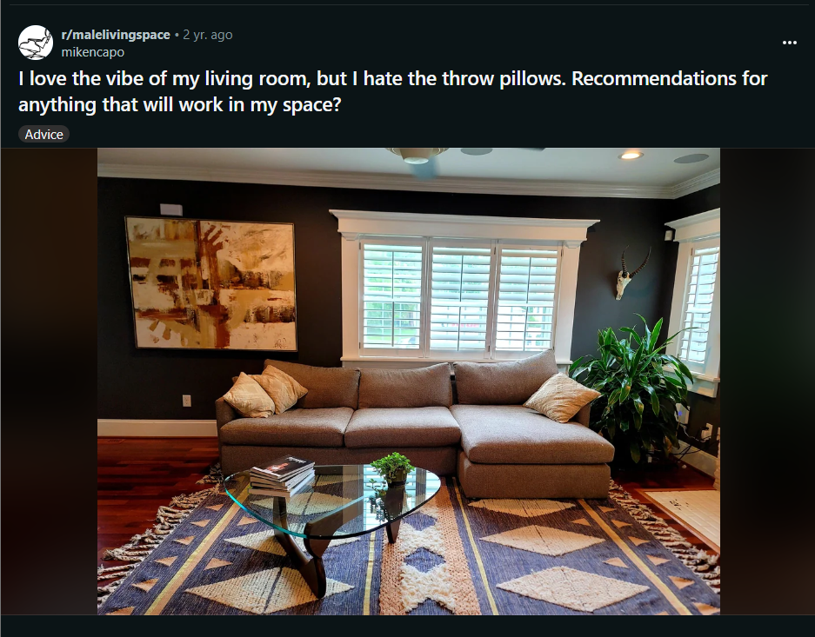

**Summary:**

The post is from the subreddit "malelivingspace" with the submission ID "p76y82." The author, mikencapo, shared an image of their living room, expressing love for the overall vibe but dissatisfaction with the throw pillows. They seek recommendations for replacement options that would complement the space. The post has garnered a score of 602 and received 50 comments.

**Related Comments:**

- Commenters suggest cylindrical pillows for the couch corners, emphasizing that the existing yellow color works well.

- Recommendations include darker brown pillows or various shades of blue, complemented by a crocheted throw blanket.

- Advice on adjusting the scale and color contrast of the pillows for a more cohesive look is provided.

- Some users mention the possibility of removing the pillows, while others suggest adding contrasting colors like red, rust, or terracotta.

- Questions about the furniture, including the couch and Noguchi table, receive attention.

**Keywords:**

Living room

Throw pillows

Recommendations

Vibe

Couch

Color continuity

Cylindrical pillows

Yellow

Darker brown

Shades of blue

Crocheted throw blanket

Scale

Color contrast

Cohesive look

Removal of pillows

Contrasting colors

Red

Rust

Terracotta

Furniture

Noguchi table

* These keywords encapsulate the main themes, recommendations, and discussions within the post and comments, providing a comprehensive summary of the content.

**Comments :**

1) I\u2019m a big fan of cylindrical pillows on the couch corners - regarding color I think the yellow works because of that cool artwork ya got

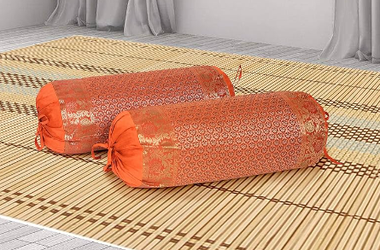

1. Agreed, the colour continuity works well. Some cylindrical pillows would work well.
2. I think if they did want to change the color, a slightly darker brown than the couch would also look good (User 3)   
   …..(User 2)

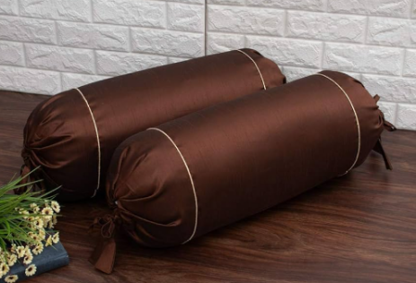

1. I agree! Also, you could do various shades of blue for your pillows, and add a crocheted throw blanket. The blanket could be a linen color or some other color in your decor (User 4)

….( User 1)

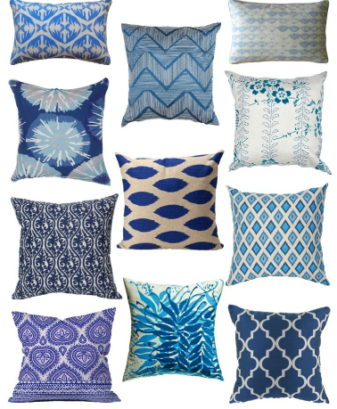 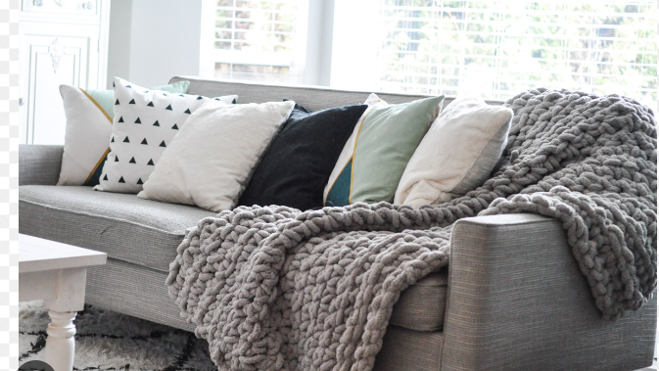

1. What couch is that?? (User 5)
2. I really love this! I don't have any specific recommendations for throw pillows, but an awesome tip that I've heard for figuring out those final touches is to find a piece of clothing with the color that you're considering, and placing it where you want to place the item to get an idea of how it will look. So if you want to see how a black throw pillow would look without having to buy one first, grab a black t-shirt from your closet, and wrap it around one of the throw pillows that you already have on your sofa.\n\nThis is wicked cozy -- finding the right throw pillows and adding task & accent lighting will take it to a new level! (User 7)

…...(User 6)

1. The scale of the pillows is off, and the color is not contrasting enough against your sofa so the sofa feels disconnected from the room.\n\nScale: get two pillows that are 24\u201dx24\u201d, and one pillow that is 18x18 or 20x20.\n\n24x24: go simple with a true white or slightly off-white (see your window frames and baseboards)\n\n20x20 or 18x18: patterned with navy blue and white, preferably with diamonds or triangles. \n\nI would leave the warm tones to the painting (red and yellow). You can possibly find some red/yellow books for coffee table books for that extra oomph, since you clearly enjoy staging. But I wouldn\u2019t go overboard with more. The room is predominantly blue and white and the painting adds just enough minor color for interest. \n\nLast thought: wouldn\u2019t go too transitional or boho. The interior architecture is pulling towards a transitional or traditional or coastal vibe, so keep the contrast and clean lines and geometry to balance it out (esp with the noguchi). \n\nJust a thought. Good luck!

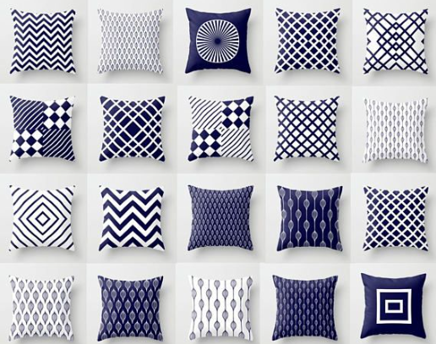

1. >and the color is not contrasting enough against your sofa so the sofa feels disconnected from the room.\n\nI agree completely!\n\nDark floors with the light-colored rug looks great.\n\nDark walls with the white trim looks great.\n\nDark sofa with ??? pillows looks great. It's got to be light-colored pillows.\n\nI think having that contrast between the pillows and sofa would help the sofa blend into the rest of the room, as you mentioned. I also agree that the wall art is enough warmth against the cool tones of the rest of the room. (User 9)

….….(User 8)

1. I agree, a red corduroy or even a yellow would look real nice; whatever the color, the textures in the room are great and the pillows should def reflect that. (User 10)
2. Gray fluffy pillows that sort of look fuzzy up close. (User 11)

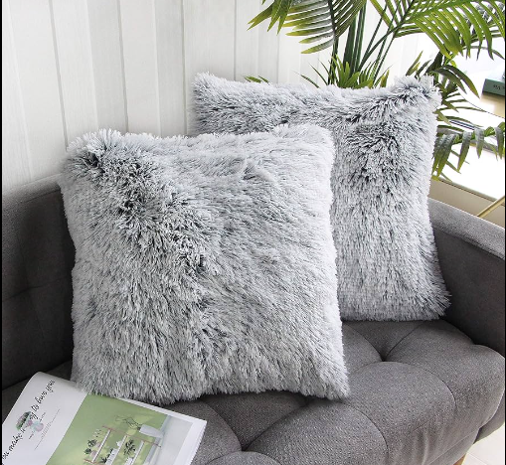

1. I think a rust or Terracotta coloured pillows would be great, will pop on the lounge and dark wall though tie in with the artwork and even the reddish hardwood and the tiles (User 12)

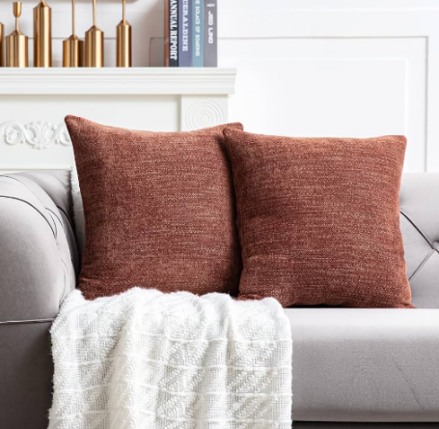 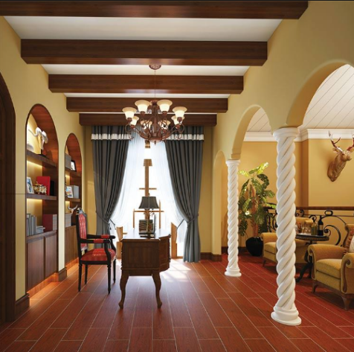

1. Woah, is that a real Noguchi table???
2. God, you're a lucky man (User 13)
3. What kind of plant in the corner?

….…….(User 14)

1. too small and too beige. pick up the blue colour from the carpet and add larger cushions in a mix of flat, patterned and textured fabrics. (User 15)
2. Dark pillows will pop on that couch. (User 16)
3. looking at getting that coffee table, do you find yourself needing to clean it very often?
4. It\u2019s beautiful but yes you will be cleaning it a lot. I used to own one and have since decided not to go glass. (User 18)

…...(User 17)

1. Get some that bring out that brick red color in the painting. (User 19)
2. Loooove this setup! Can you find pillows with a similar print to the rug? OR get solid color pillows to match the rug, and get a throw blanket in that print, and fold the blanket over the middle couch cushion (User 20)
3. Pull the blue from the rug up onto the couch.  Something textured would help too.

(User 21)

1. Id on rug? (User 22)
2. How often do you have to put those cushions back into place? (User 23)
3. I was thinking SW Iron ore (User 25)

….…(User 24)

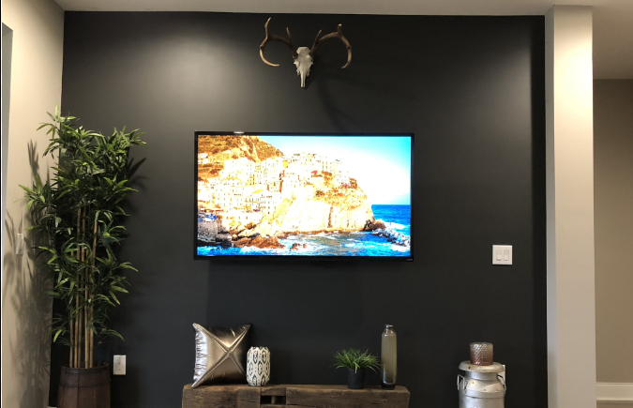

1. Yellow or orange slipcovers? (User 26)

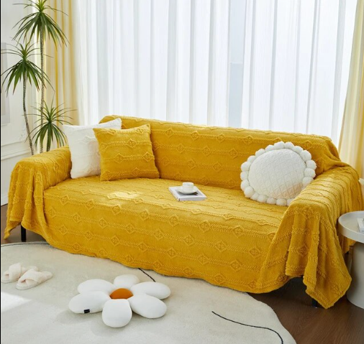 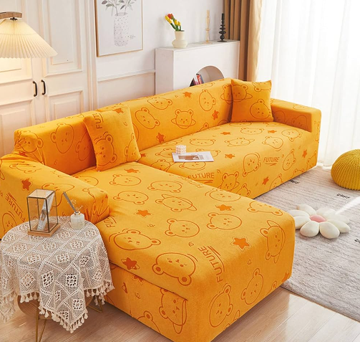

1. no pillows would work (User 27)
2. * I'm of the opinion that pillows should be contrasting, colorful, and show your personality. Given that the rug and wall are blue, I'd try to keep blue on the pillows minimal and go for something that contrasts more (blue can be in the pattern but not the main color). Look at a color wheel to find some flattering colors depending on how adventurous you are. I'd go for a yellow/orange/red bright pattern to try and create a visual eye-line-link between the wall and the painting. (User 28)
3. Your pillows are all the same size and color, Try starting with a larger pillow with several colors. I like to call this my hero pillow, maybe something with the triangular shapes from the rug, then add some smaller pillows in colors pulled from the hero pillow. consider pulling colors with more depth, like the mustard, rust, and blues you already have in the room. Beautiful room whatever you decide. (User 29)
4. Have you considered... removing the pillows? (User 30)
5. Agree with what many others have said. Brown and yellow are too similar to the couch color. Go for more contrast, larger size, and texture. Navy or white would probably work well. (User 31)
6. Bring some of the blue from the carpet on to the couch with pillows or a throw. \n\nLooks great. So chill. (User 32)
7. Yellow orange or blue pillows maybe a larger size and it should be sorted, this a pretty amazing room already. (User 33)
8. I think you need more variety in the texture, shape and pattern of pillows. An offwhite shaggy sheepskin one, a kilim one to pick up reddish tones from the hardwood, a round plain one in a dark colour, etc. (User 34)

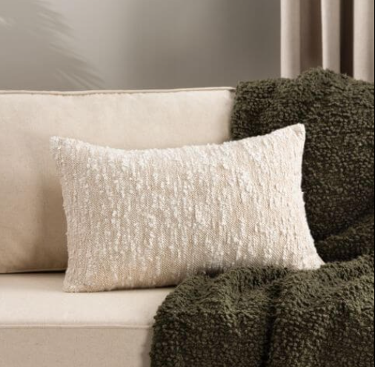 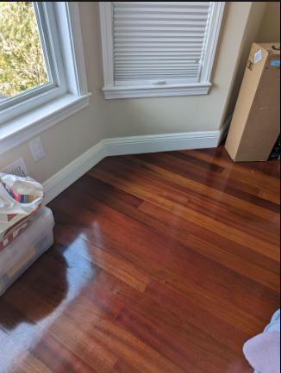

1. Is that a real Noguchi? (User 35)
2. Good god where did you get that beautiful rug?(User 36)
3. You have almost a old west vibe going. Maybe leather chairs instead of a couch? (User 37)

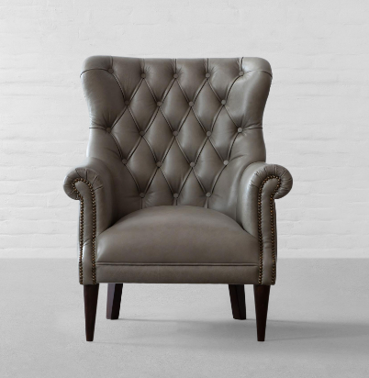

1. Red corduroy and then one with Elvis on it. Maybe a black one with fuzzy fur texture on it too. Then watch out ladies, it\u2019s time to relax. (User 38)

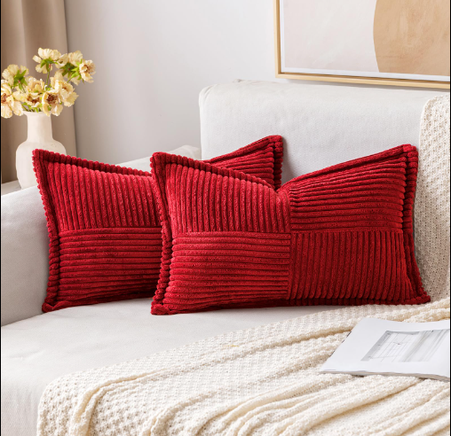

1. Tonicliving.com - I think their pillows vibe with your look (User 39)

**Post 7 (line 3178)**

**Url : https://i.redd.it/c3h7vzbtykb51.jpg**

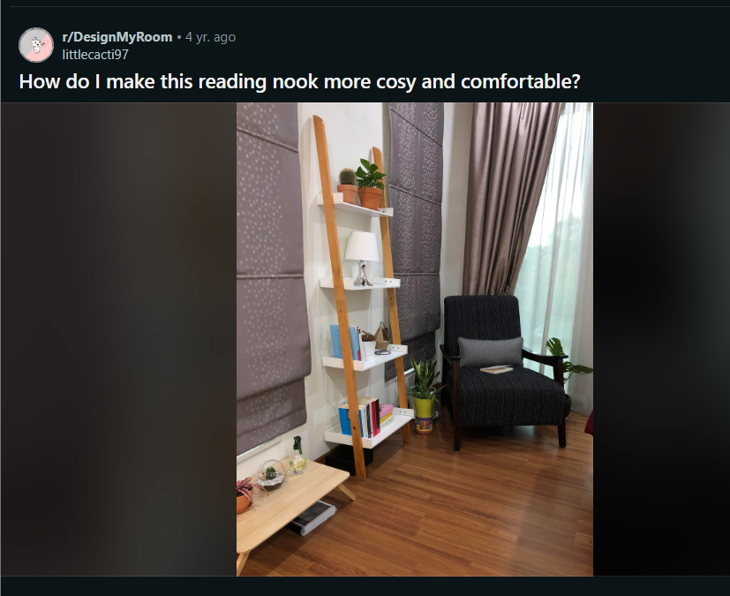

**Comments:**

1. I'd swap out the little lamp on the shelf for a floor lamp, few more books on the shelves would also help it look more like a reading nook.\n\nAdd a rug to the floor, maybe a fluffy one, and a cosy looking blanket.\n\nAnd I don't think it's needed but if it was me, I'd definitely add a footstool to put your feet up on when reading, and a little side table for cups of tea to sit on.

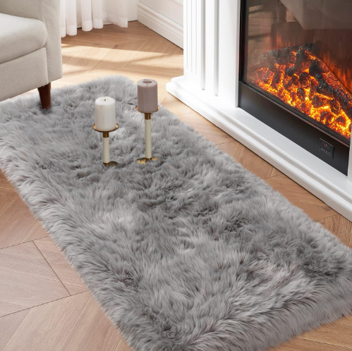 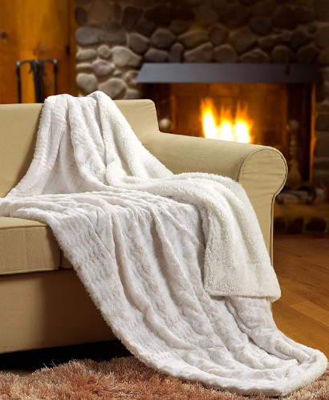

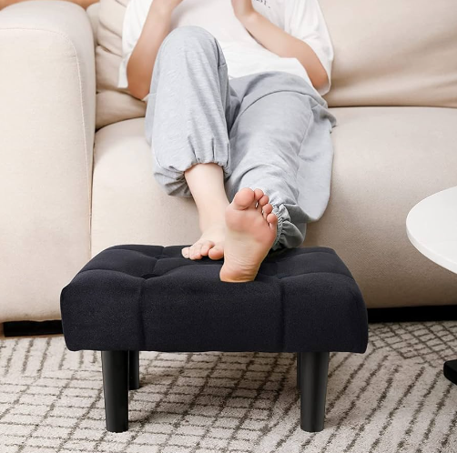 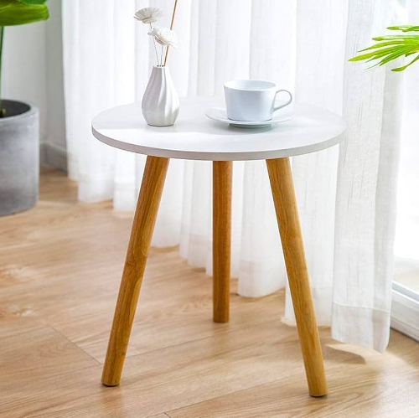

1. Which color does take the majority? If it's red, then you should pick light pink/cream to balance it. Neutral colors also help since it doesn't clash other bright or main colors. (User 2)
2. Yes!! All of this!! (User 3)

….…(User 1)

1. Plush rug and a lamp. And maybe a cat (User 4)

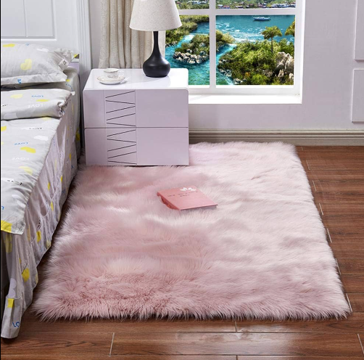 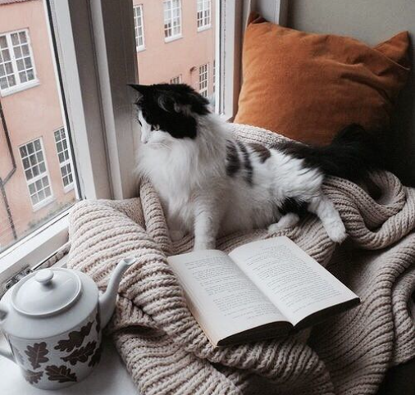

1. This looks so lovely already! Agree with the rug, little side table and footstool suggestions. Also a couple of warmer tone cushions on the chair, cute embroidered red would make it warmer and a bit more folksy.

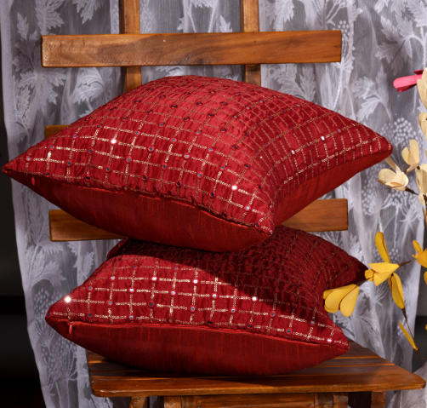

1. Reading in a chair while resting your legs on the bed is the definition of cosiness! (User 5)
2. I agree with the comment suggesting a foot stool! I have a little pouf from article that is comfy and cute and was also well priced (score). I think a nice throw blanket and rug would help as well. When I think cozy I think of cuddling up. A floor lamp behind the chair instead of the one on the shelf would also work well in the space and then you have more shelf space for books and plants! (User 6)

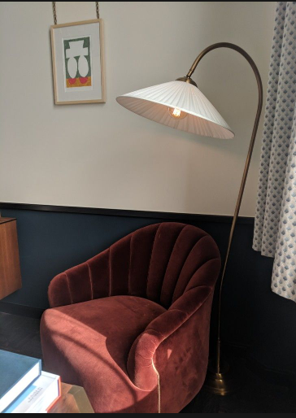

1. I like how it is going already, my only suggestions would be changing the curtains to a softer/ warmer colour (edit: perhaps like a cream or off white, and also add in some warm tone lighting) and perhaps adding an egg chair or beanbag for extra coziness (User 7)

….….(User 8)

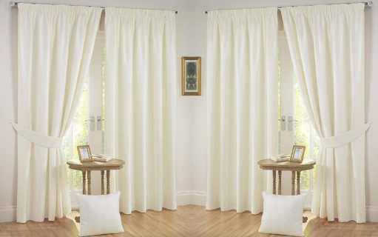 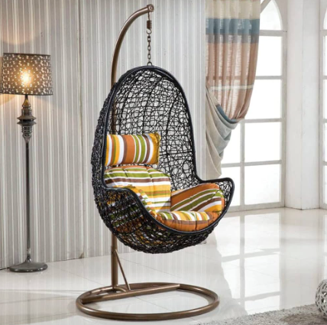

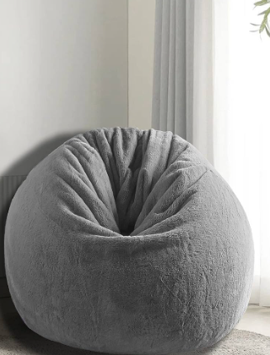

1. Fluffy rug, ottoman, a couple more squashy throw pillows. Maybe a small round end table where you can put your drinks/snacks. (User 9)

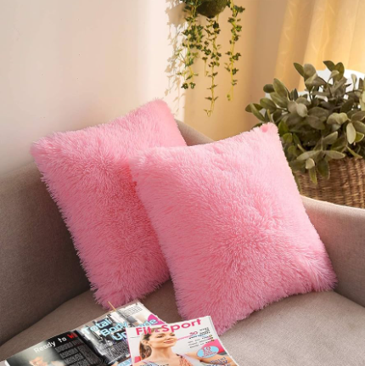 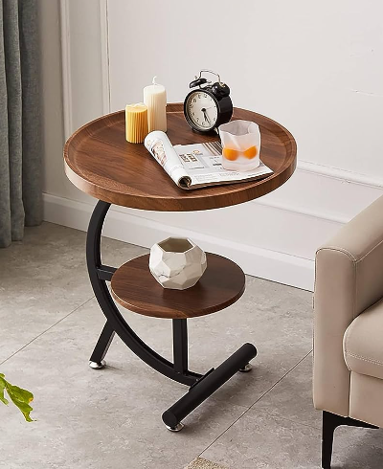

1. I think you've got a lot of good things going on. But, why the stuff on the floor? The plants and little tray could use a place to be. Agreed on the lamp, footstool, and rug. (User 10)
2. Lighter curtains for sure. Something airy that allows a bit of light while still maintaining privacy. \n\nLose the tiny lamp, add a floor lamp arching over the reading chair. \n\nI would also switch out the chair for something lighter and cozier. The chair is the coldest part for me. Maybe add a small fluffy rug too. \n\nOh and plants!! Always plants. (User 11)
3. please don't try change it,i think it is so beautiful and suit for the color of your room
4. i will change my room as your picture\ud83e\udd14\ud83d\ude0athanks so much for your sharing. (User 12)
5. More books lol (User 7)
6. Are you really going to read here, or is this a faux reading nook?(User 13)
7. BOOKS! (User 14)
8. This area is begging for some soft, fluffy texture. Textured hanging plant, a soft throw on the chair, a nice rug, a small ottoman, and a pet. (User 15)
9. My personal opinion - you need to bring in fluffy/fuzzy textures. I\u2019d get a small shag rug and drape a blanket on the back of the chair. Everything has a strict rigid angle and the textures are harder - it could use just a bit of softness to add visualComfort (User 16)

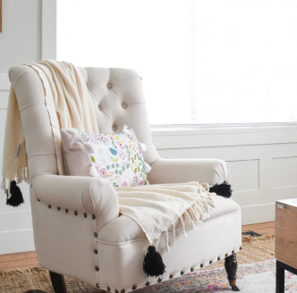

1. I think it\u2019s adorable. I love those curtains!(User 17)
2. Get a giant love sac, or something similar. I think that\u2019d be way more comfortable while reading than in that chair. (User 18)

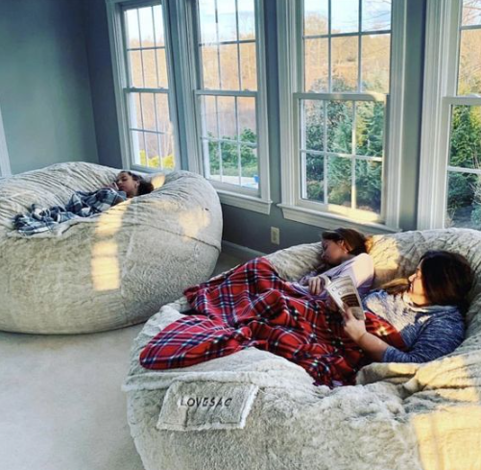

1. Lots of good suggestions on the rug, side table, more books. \n\nThe thing I noticed is that the lighting here is very bright white. If you swapped your bulbs for the more yellow lights, it would have an instantly cozy effect. Also a set of yellow string lights is always fun.\n\nEdited: definitely lose the tiny lamp for an arching one, as previously suggested (User 19)
2. Add a rug and more colorful cushion that match the rug (User 20)
3. More books, rug, larger upholstered arm chair with a foot stool, side table for hot chocolate or an old fashioned and a snack, lamp on said side table or behind chair, maybe a kitty (User 21)
4. The white walls and bright furniture, while nice, make the space more airy and energetic. This is the opposite of what a lot of people are saying, but I think if you pulled your furniture away from the walls and closer together, and maybe supplemented with a fuzzy rug (to absorb and refract light), it\u2019ll create more of a \u201cnook\u201d feeling and less of an open office (User 22)
5. Small picture on wall above top shelf? Definitely second the rug. And maybe a plant stand or small table (User 7)
6. I\u2019d swap the black pillow for dark wine red, dark forest green, or a mustard yellow and add a carpet.(User 23)
7. Maybe a floor lamp behind the chair. I also like to find old menus from hotels and cruises, little things like that for the walls. (User 24)
8. I love everyone's suggestions! I'd like to add to the footstool idea tho, I think it should be a small ottoman for more storage space as well as something to put your feet on. I prefer a round shape but even a rectangle would be great. \nI love things that have multiple uses! (User 25)

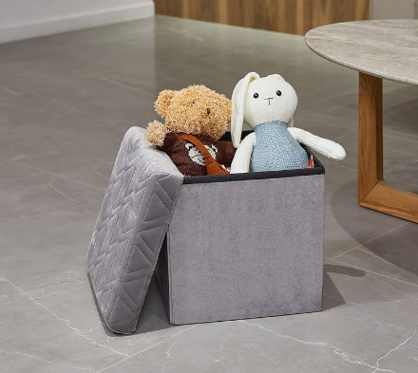

**Post 8 (Line 3780)**  
  
**URL :** https://i.redd.it/1mn7wx7qlns41.jpg

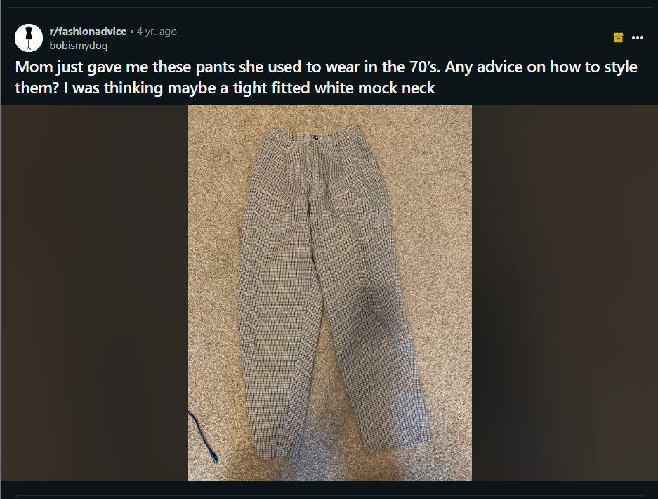

**Comments :**

1. firstly, they\u2019re gorgeous pants and i definitely need to fond myself a pair. Secondly there\u2019s a few ways you could style them. I think a white turtle neck or jumper would go best with it. For shoes I would probably say doc martens. Either the boots or actual shoes would go really nicely with them (User 1)

 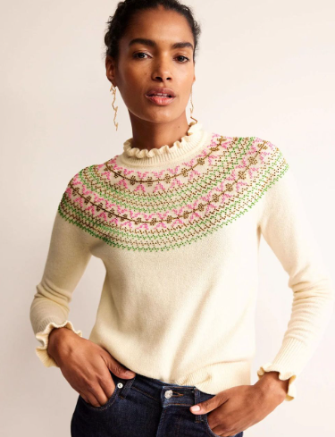 

1. Mustard yellow, orange, dark chocolate, mountain green, black, and dark grey turtlenecks will look nice with that pair. (User 2)

 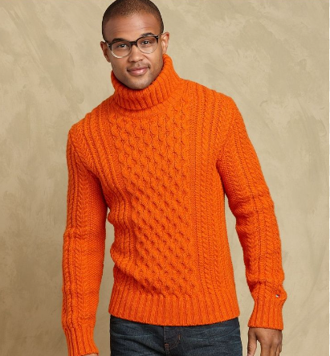

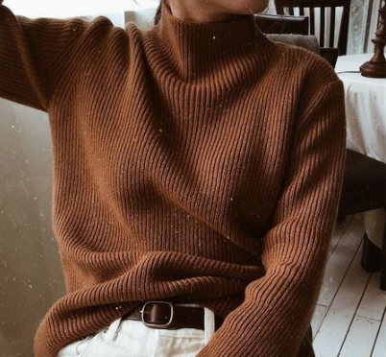 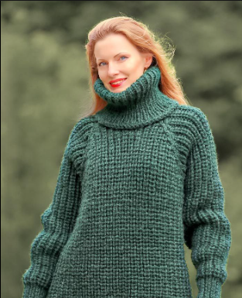

1. I love these! Your idea sounds awesome. A black turtle neck would also look cool. Also maybe a cropped sweater. (User 3)



1. I think blouses, leotards with cleavage and maybe oversized shirts and sweatshirts. (User 2)



1. Such nice pants! I'd suggest a turtleneck top or a fitted top just about any colour (orange, green, black, white, beige, dark brown) with a pair of black boots.



1. Yess! The pants seem like they'd go with a bunch of different colours (User 4)
2. You should look up mod fashion! It heavily used plaids and this type of pant. I love to wear black lace body suits with mine. (User 5)
3. I love the pants!\n\nIt\u2019s fairly easy to take out the pleats for an updated shape. \n\nOne way is to open the waistband in front, convert the pleat into a dart and reattach the waistband. \n\nAnother way is to narrow the entire leg. Open the waistband, stitch along a foldline from waist to cuff, taking in as much width as you want. \n\nThere will be a seam, but you can add a single or double row of top stitching to make it look like a design feature. (User 6)

**Post 9 (3984)**

**Url :** https://i.redd.it/k6ixv7omeuq31.jpg

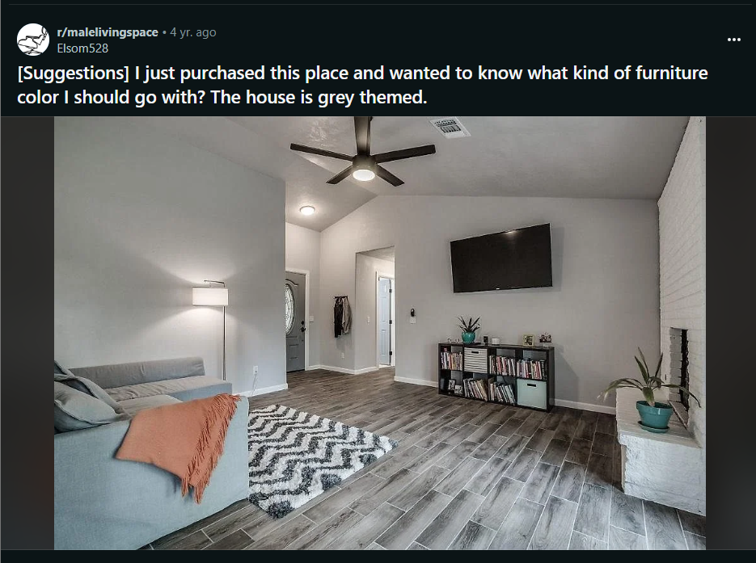

Comments :

1. Our house is also very grey so we went with blue, yellow, and coral to bring some color in. Blue and great go great together, but you could also go for a monochromatic white and grey look with accents of sage and rust (for example). Additionally, bringing in some warm wood tones and plants helps tone down the coldness. (User 1)

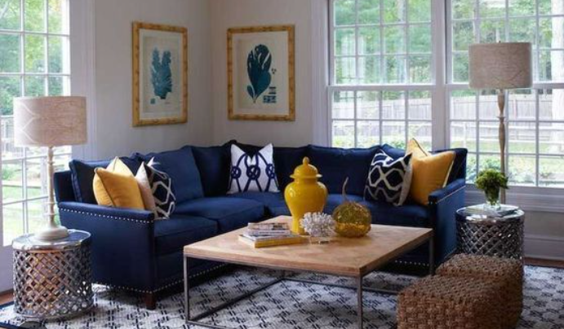

1. That's a nice color palette. I like the vintage teak or walnut piece, helping to warm it up and bring in some personality. (User 2)
2. The TV looks awfully high. And, I know that the photo is wide angle, but near the ceiling it looks loop sided.\n\nYou could probably put an end table next to the corner and move the sofa closer to the TV by a couple feet to make an arrangement with the sofa, FP and TV. You could probably fit in a small club chair as well. not sure of the behind the sofa, but if it's against the wall now, that wall could have a bookcase, or you could maybe put a desk behind the sofa, facing the TV.\n\nRight now you have accent colors of terracotta and turquoise, and that's a little tame. But as someone suggested, a dark blue, even navy would fit the color scheme.\n\nThe greys all seem to be be on the cooler side and harmonize well. with the light blue/grey sofa and white FP and trim. I like the fan by the way.\n\nI am seeing the room going toward one [value]([URL] which is light. Black can have a tendency to cheapen a room, especially one with a \"grey theme\", I would encourage you to look at dark brown wood that read close to black like espresso. I feel you should try to warm up the space a little.  However, blond wood might be too pastel. and red (mahogany) may clash and medium warm browns as well.\n\nI'm not sure what you are going after right now. It looks kind of pedestrian and trendy.\n\nI would like to see a large coffee table, but a dark would could overpower and throw off what you have now. A coffee table can be a kind of sculpture and a way to introduce some personality. depending on your style, You should look for a contrast of texture, my first thought is a large, modern white lacquer, or something substantial in a [milk white plexi]([URL] For a more rustic look, a[barn wood]([URL] looking for that medium value that the room is missing and, again, with an eye toward how the table introduces personality and sculpture.\n\nLastly I might introduce warmer metal accessories namely brass, like a tray or pokers and grill for the fireplace.\n\nI think that most floor lamps look awkward. Like they are being bad and made to stand at attention in the corner, or like yours, are being creepy and hanging over you. The need a purpose, that purpose can be 'to light the room\" but then they have to look like that's what they are doing. In short, I think your floor lamp is more of a tall task lamp, and if you introduce an end table like I suggested, then the lamp pole could go behind it and the lamp shade like a floating end table lamp.

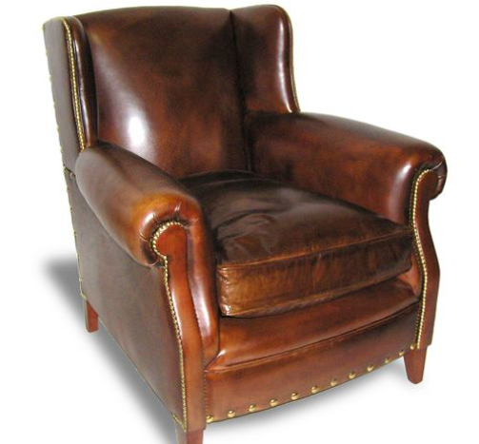 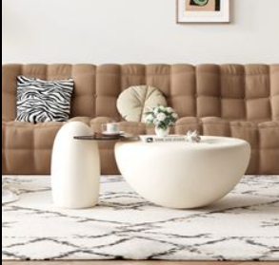

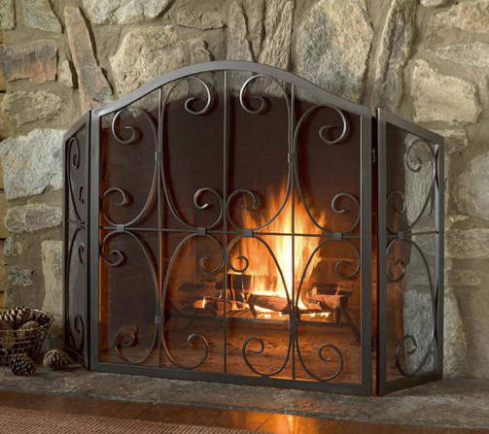

1. I agree with the TV statement. I made the mistake of mounting mine too high when I initially wall mounted it. I ended up bringing the TV down 12\" so that natural eye line is about 2\" below center of TV, but I have it tilted down so it works. (User 3)

….……..(User 2)

1. Unless you\u2019re an 8 foot tall giant, the tv is placed awfully high (User 4)
2. Dark colours. Navy would balance well like a royal blue (User 5)
3. Holy tv is too high", (User 6)
4. For neutral. Grey, black, white.\nFor color, burgundy, soft oranges, pinks, blues.(User 7)
5. I would go with mostly a variation of grey\u2019s, mostly dark. And a splash of blue/navy for features like throw pillows, art, mini decorations etc. (User 8)

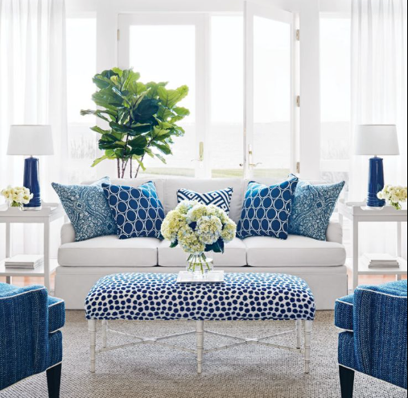

1. I think some nice oaky wooden furniture would be really nice. (User 9)

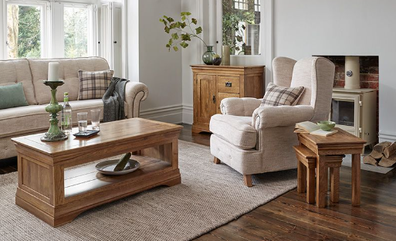

1. If you're interested in seeing the furniture that the top September posters on r/malelivingspace are buying then I put together this spreadsheet:\n\n[[URL] (User 10)

**Post 10 (Line 4186)**

.

.

.

.

**Post 21 (Line 8654)**

Url : https://i.redd.it/6vcob79xipe81.jpg

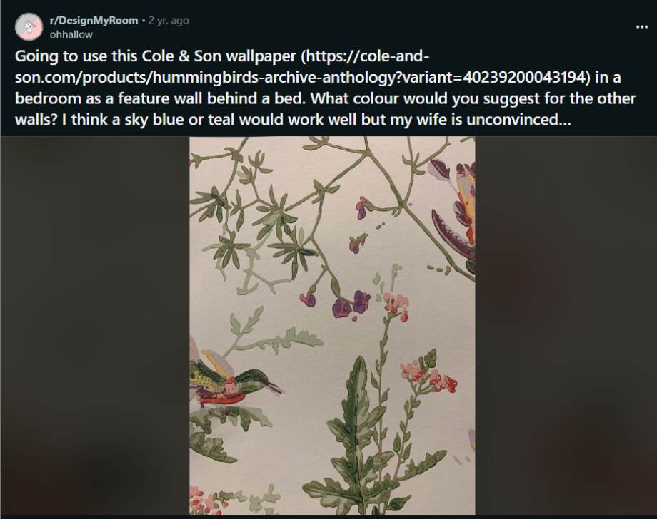

Comments :

1. A light sage green would be best. It\u2019s beautiful wallpaper!



1. I agree with your wife. The blues will not look right with your paper. What you want to do is pull a color from the paper to have it go together properly.  It\u2019s the same idea as when you are putting a matte on a piece of art. Whichever color you want to be more highlighted in your paper, go with that color. I would go with that pale purple color in the bird and flowers but, I\u2019m partial to purple. :)



1. I\u2019m just going to throw this out there. I think you should go with the purple of the flowers
2. This! Or a lighter version of it if that\u2019s too dark for you.
3. Depending on the mood you want, I'd be more inclined to pick out a green from the paper and go either lighter or darker green depending on amount of light in the room. I could also see going neutral by picking something in the same color way as the wallpaper's background. This is a pretty eye-catching, beautiful paper and you want to let it be the star of the room.
4. It's beautiful paper and there are lots of ways to go with both paint and curtain fabric. I hope you come back to post the room when done!
5. I think you need to keep the walls light - because otherwise you are closing off the space, it will be dark, and your dark painted walls will compete with your wallpaper for attention. Not a good vibe for a marriage lol.\nI love the light minty color that is in the branch above the bird\u2019s head. But I might do it a couple shades lighter. \n\nIvory would be an option BUT it is risky because if it\u2019s not a good match to the wallpaper tone, it will just be a little \u201coff\u201d. And plus, it sounds like you are eager to not be basic. \n\nYour wife is right. Teal is a bad move - you have a focal point already - and it\u2019s the beautiful wallpaper.
6. I wouldn't over-think ivory, it's going to look a bit diff on every wall/surface due to lighting anyway. I agree w/keep walls light. I think there's plenty of green in the w-p design so I'd try a grey-pink to help the bits of pink/red/purple come forward a bit more and not go to waste. See Craig and Rose #1829, CAMISOLE PINK. Again, each wall will look diff, so try a few and don't freak out b/c your walls will have furnishings/other decor to draw eye. Your paint is the backdrop to your decor. \n\ngood luck!



1. You are hereby revoked of your interior design license.
2. I would go with any lighter colour that's found in this wallpaper. I'd even stuck with white. But whatever you do, do not go with sky blue or teal. Absolutely under no circumstances does bright blue match this wallpaper.\n\nI assume you're thinking \"birds are in the sky\", in which case imagine that these birds are in a forest.



1. This pattern should actually have 2 different blues in it. It is hard to tell in photo, but the birds have sky blue, right? I say pull the blue shade.\n\nI just looked it up, this may be the only colorway without blues. I have not seen this one before (green/multi?) If that is the case, maybe blue is not the best choice, but a very pale sagey green will be calming and great for the bedroom
2. It depends on what look you\u2019re going for and where the light in your room is coming from. First, pick a color from the wallpaper. Second, are you going for a dark cozy deep snoozy bedroom, or a Scandinavian light-filled modern look? Third, what direction is the light coming into the room from and what time of day do you spend the most time there? If your room is a northern exposure it will have a cool indirect light, southern exposure will have a warmer brighter  light. Eastern exposure, bright until noon then the light will fade to a cool light. Western exposure, darker in the am and warmer and brighter in the pm. So think of how you\u2019re going to use the room and the mood you want. Are you an early riser and your bedroom has a western exposure? You might be going to bed earlier when the sun is high in the sky in the summer and throwing heat so you\u2019ll want the mood to be cooler by not using a warm or bright color, choose a deeper or cooler color. If your bedroom is on the north or south side you\u2019re lucky because there won\u2019t be such variation through the day, but the south side will appear brighter. Will you use the bedroom as a home office by reclining on the bed with a laptop during the day? Do you like cooler more relaxing hues or more vibrant hues? You\u2019ll have to take the exposure into consideration for daylight especially and the type of lightbulbs you\u2019re using because northern light and LED light will appear cooler, whereas southern light and incandescent will appear warmer. I\u2019m not trying to confuse you, just trying to give you considerations once you pick a color family I recommend you incur the additional expense of purchasing sample cans and painting large swatches on several walls of the different colors so you can see how the color changes throughout the day. It may cost more upfront but in the long run it will save you time and money. Beautiful wallpaper btw, I\u2019m sure it will be lovely.
3. Very pretty wallpaper. I would stick with the background color for the other walls so as not to compete.
4. Fern colour

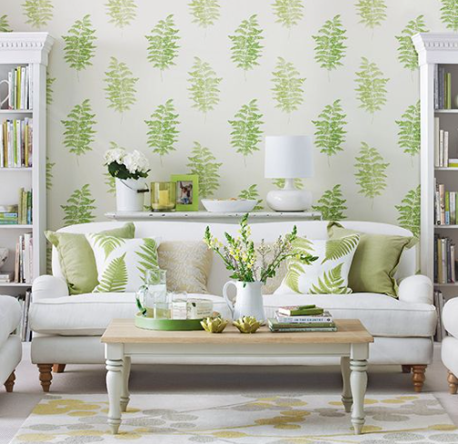

1. Any soft pastel.

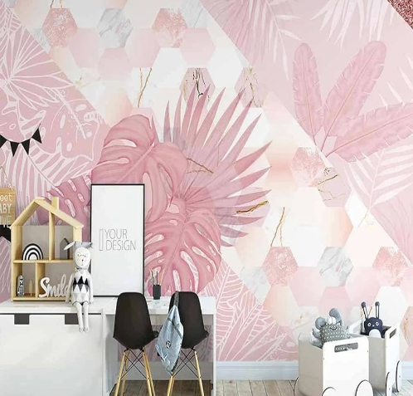

**Post 22 (Line 9000)**

Url : https://i.redd.it/u0b5ftr4xmi21.jpg

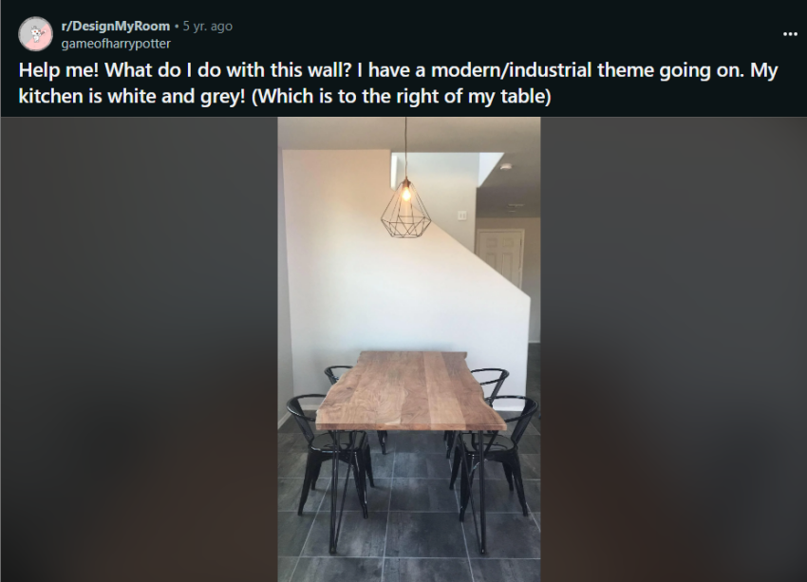

Comments :

1. Floating wall shelves with plants, photos, and art

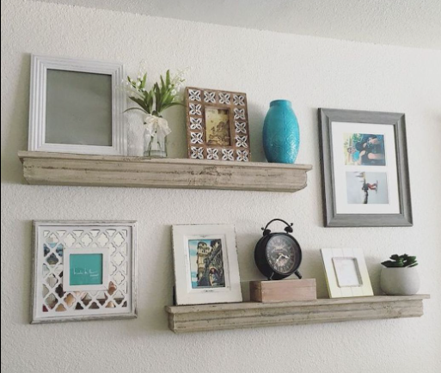

1. Search decor grouping shelf in Pinterest and go through and pick up things you like. Play with it til you think you\u2019ve got something, and then post on here and we can help you tweek it.

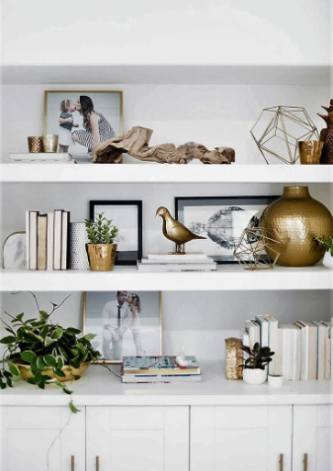

1. To add to this, I would do 3 staggered floating shelves on the stair wall, and on the long wall behind the table I would do a black and white city scape photo, with pops of orange or yellow in the art) or accent color of your choice)

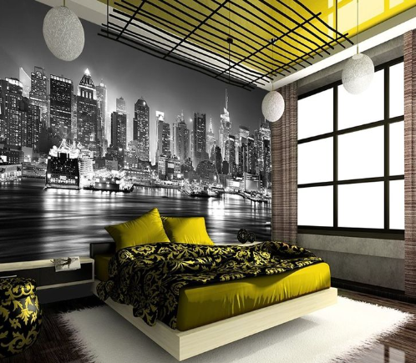

1. Check out Rugs USA!

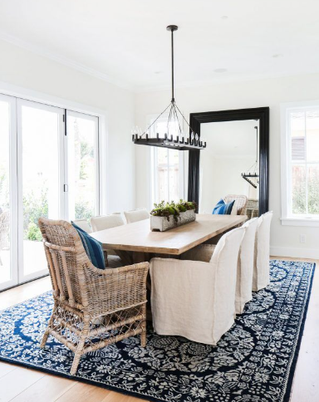

1. I think a jute rug would be cool, add some texture.

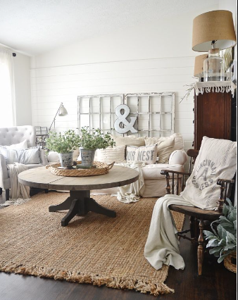

1. Wallpaper it in a fun print that matches the style of the rest of the room. It'd make a great accent.\n\nSomething like these could be eye-catching:\n\n[[URL]\n\n[[URL]\n\n[[URL]\n\n&#x200B;

 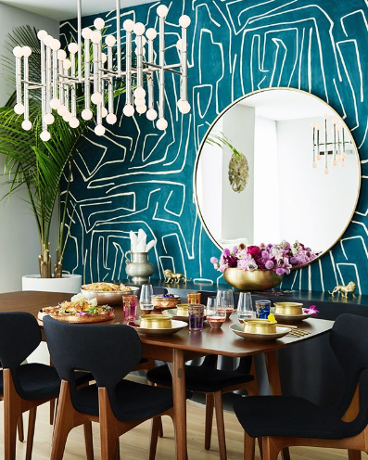

1. I agree. I love the first and third choices. He could also do a funky succulent/plant wall there, or some kind of decal

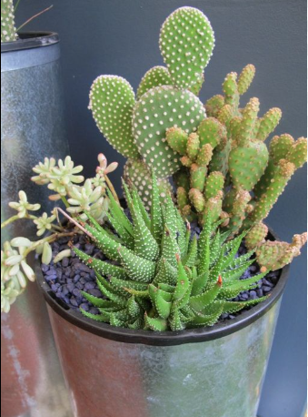 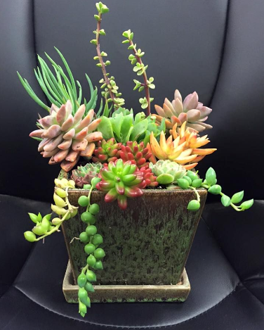

1. Yes, agreed. Plants are really important for bring life into an industrial space. I would love to see some floating wood shelves with some greenery and light open storage for the kitchen (cookbooks, matching dishes, etc.) Like this:  [[URL]
2. I\u2019d get a mirror with a metal/gold frame that\u2019s big enough to make a statement

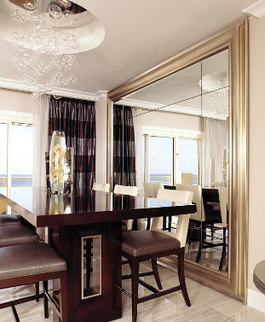 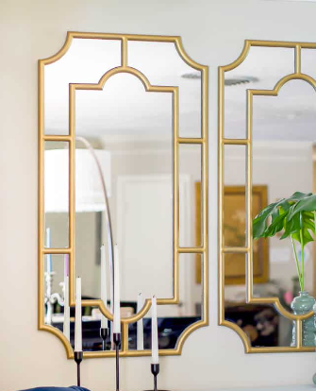

1. Juniperprintshop.com has stupid cheap large scale prints that fit into some large (cheap) ikea frames. Check out their Instagram for something that fits your style.
2. Many times. They just started printing oversized prints and it\u2019s cheaper than my local print shop, but I can get 20x30 prints from Costco for $10, which is a steal. The quality is really great and the prints scale beautifully.
3. I would love to know where you got your table!! And RugsUSA.com, they have tons of great prices and nice looks as well.
4. I\u2019m definitely going to have to check them out! I\u2019ve wanted a table like that for so long!!!
5. I love the stuff they have at Structube but the reviews are horrible. It sounds like they have poor customer service and you could end up with something that\u2019s broken or defective.
6. That\u2019s a great price! It definitely is very good for solid wood!
7. A geometric painted pattern- maybe a single large square, or a diagonal or a triangle? I would personally do it in a grey (a shade darker than your present grey maybe) or a complimentary colour.
8. industrial shelves that go along with the changing width! I'm sure it's easily customizable or diy-able
9. Honestly, you've got such an interesting vibe going here, I'd get a little crazy. Don't just put a mirror there, put a [HUGE mirror]([URL] there, really open up the space and make it look large and luxe. You're no longer backed up onto the stairwell, you're backed up onto an arched window into another room. \n\nPaint the wall itself a solid, bold color, maybe something like [Railings]([URL] by Farrow and Ball to really tie in the industrial vibe.\n\nFor the rug, consider something like [this one]([URL]\n\nI'd stick to putting framed artwork on other walls nearby, but a simple runner on the table might look nice, with a small centerpiece. You could do a single small plant in a nice container, or maybe even just some fun/interesting salt and pepper shakers that sort of double as art.

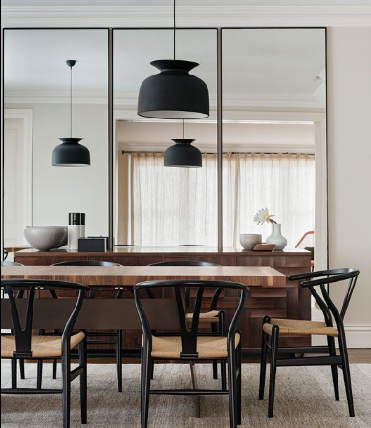 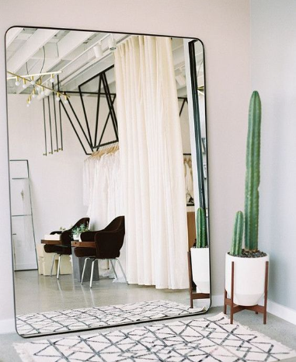

1. Get an eye-popping [pink kilim rug]([URL] then a simple rope hanging shelf with a plant and some books  ([inspiration]([URL] on the wall that centers with the table. Use [geometric-shaped planters with faux succulents]([URL] to complement the shape of your lighting fixture, as well.\n\nOr, you could do an entire wall of geometric planters with faux succulents, using something like [these guys]([URL]
2. Wall plates artwork will looks awesome on this wall

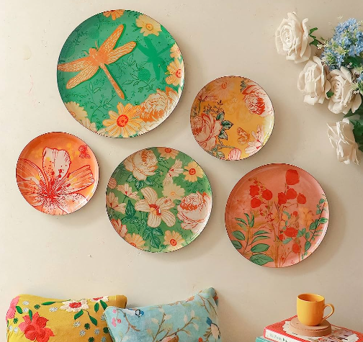 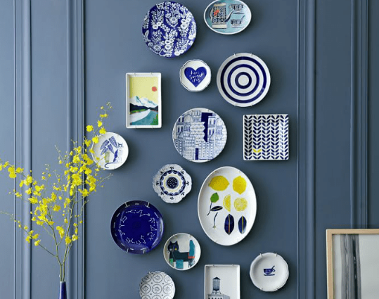

1. Some round things on a wall.\n\n[[URL]
2. This looks nice
3. Ooooo get some faux wall plants like these. The modern look of them would fit your rooms theme so well.\n\n&#x200B;\n\n[[URL]

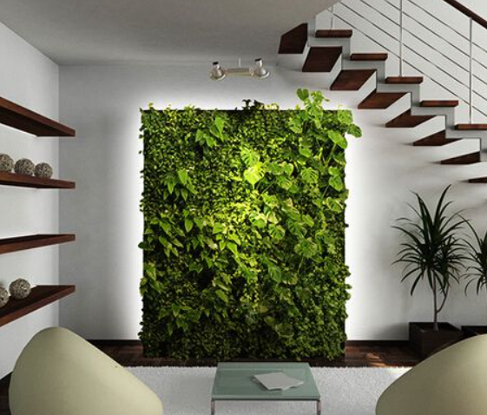

1. I\u2019d center a nice big rug under the table. Something flatwoven with great colors like rust and mustard. Then a nice big palm or other type of tree in the corner. You could hang a small picture next to that, but I think the plant alone would add so much to the space.

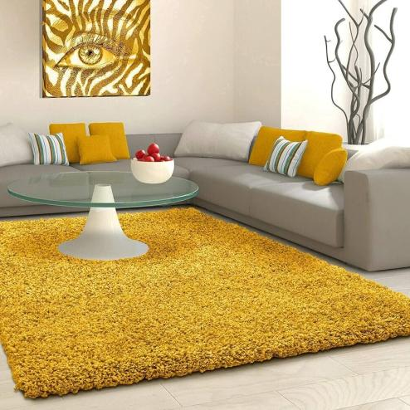

1. Put something colorful. Right now, I\u2019m getting an HGTV snooze-fest vibe. How about something with your personality in it? Color? The combo of the light fixture, floor, farmhouse table, and those chairs... it\u2019s every staged-for-sale house on the planet right now. \n\nWhy not a very bold piece of graffiti-style art? Maybe this, if this was my room...\n[URL]\n\n



1. I would do an industrial clock on the left.\nSomething like this: [URL]\n\nA set of floating gallery shelves: [URL]\n\nThen you can make it a gallery wall and the shelves can hold small nick knacks.

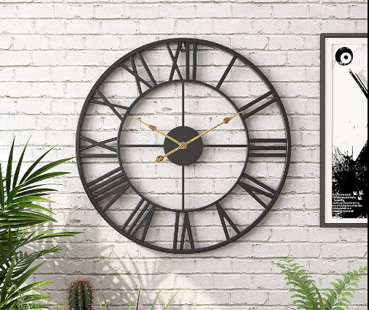

1. Paint it a dark color or use wallpaper with texture to make it a feature
2. Paint the wall black.  There are some decent rugs on wayfair in that price range,  also if you have a liquidators check there.

**Post 23 _(Line 9565)**

**Url : https://i.redd.it/x9z66xemfbk41.jpg**

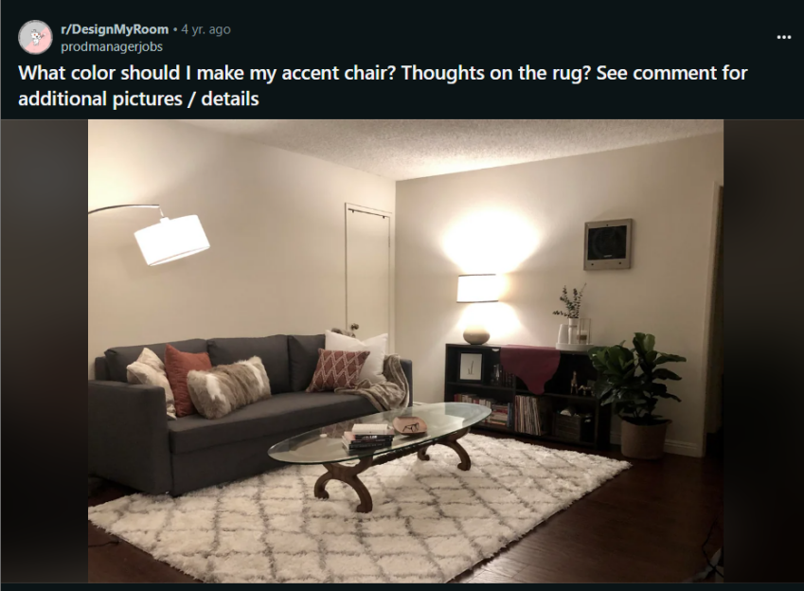

Comments :

1. I second the suggestion about continuing the rusty red color.  You already have dark gray, cream and wood tones...I don\u2019t think teal is needed.  At all.\n\nRug is a good scale, and echos the color of the couch. Looking good! Can you hang some large scale art to echo the colors some more?

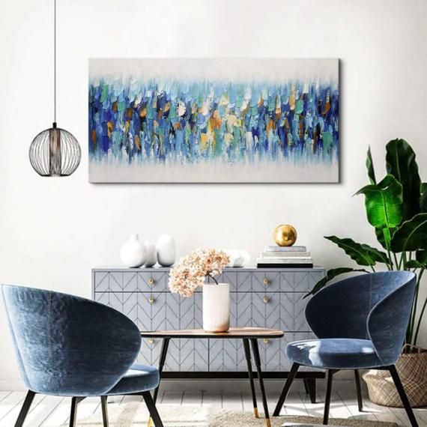 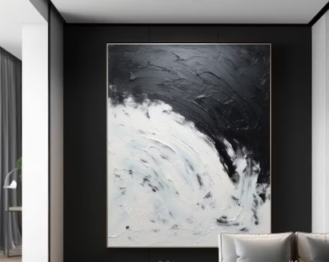

1. Yeah, fabric stores don't have upholstery fabric usually. If you have a furniture store (Ethan Allen, etc) they usually have fabric to purchase, but sometimes have rules about buying pieces there. Also, look on Etsy and EBay. I have another source online...cant recall URL at the mo. Maybe do a search for \"wholesale upholstery fabrics.\"\n\nWondering how a cognac leather would work for your accent chair? Takes real skill to do yourself, I'm told. I do NOT have those skills! But could be gorgeous in the rusty tone.\n\nAnd, yes, I like the line drawings idea BUT this might an opp to be more freeform, express more of your personality. This space is in scale and colors cohesive, but it could maybe use some \"soul\"... Maybe a pair of enlarged photographs of a place you love, matted with lots of white/cream, and framed. Fave band? Flowers? Whatever.  Can be something that a visitor might wish to comment upon!

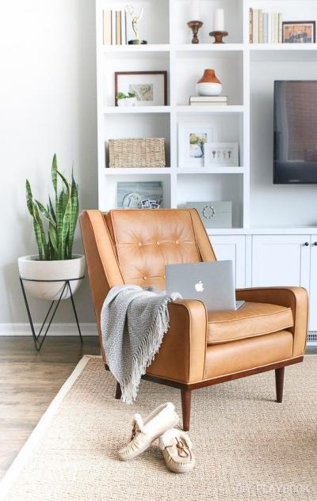 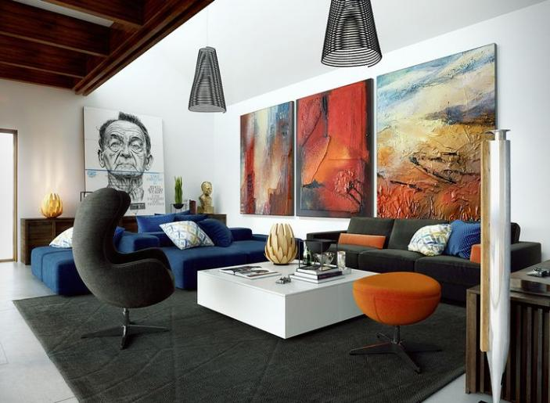

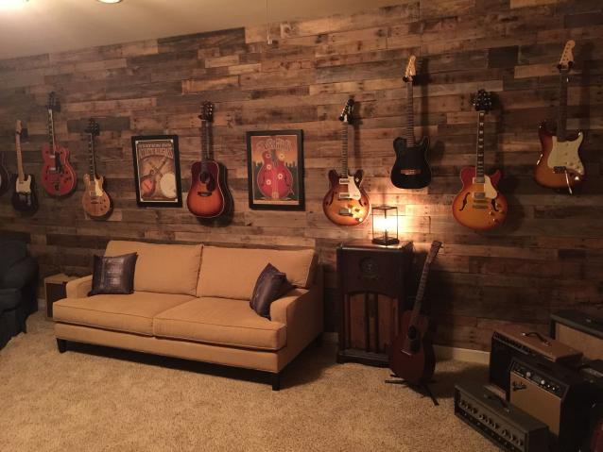 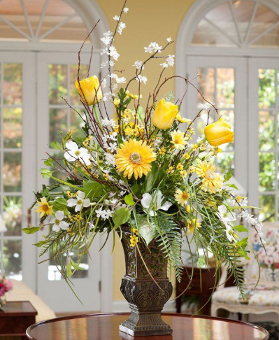

1. Very much disagree on the teal suggestion, unless you're willing to add some additional teal accents.\n\nI think you should go with that rust red color most of your other accents are - I think that will give you a healthy mix of neutrals with your accent color.\n\nI think the rug is up to taste. Personally, I think a more subdued rug would make it look more \"updated\" and modern, but if you're going for a more traditional look, this rug fits that.

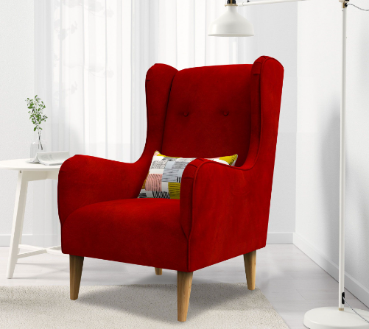

1. I love it! Honestly this is what I think would look best. Keep in mind it's more difficult to keep light carpets clean, but other than that, I agree this looks the best!
2. I think a teal accent chair would compliment your rusty throw pillows. I like the rug

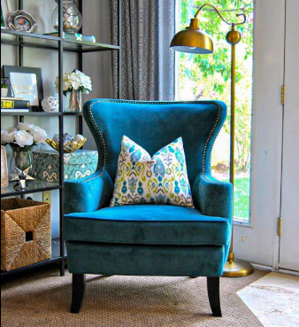

1. Thinner rug if possible. Accent chair should be dark, with narrow lines. Like a low sitting metal and ivory colored Tweed chair for example. Perhaps with a touch of the rust somehow nearby

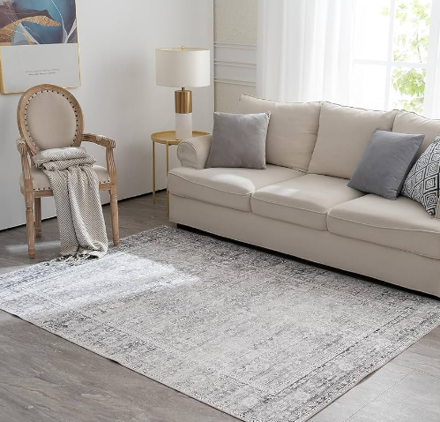 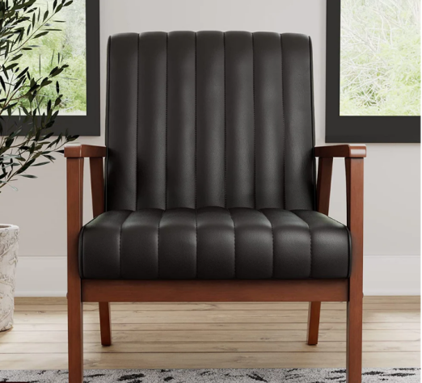

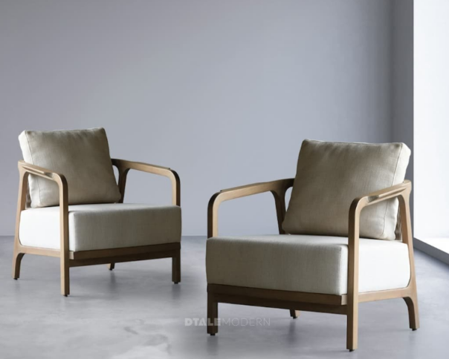

**Post 24 (Line 9743) - Deleted**

**Post 25(Line 9966)  
  
URL : https://i.redd.it/s4ew1m3ptcq71.jpg**

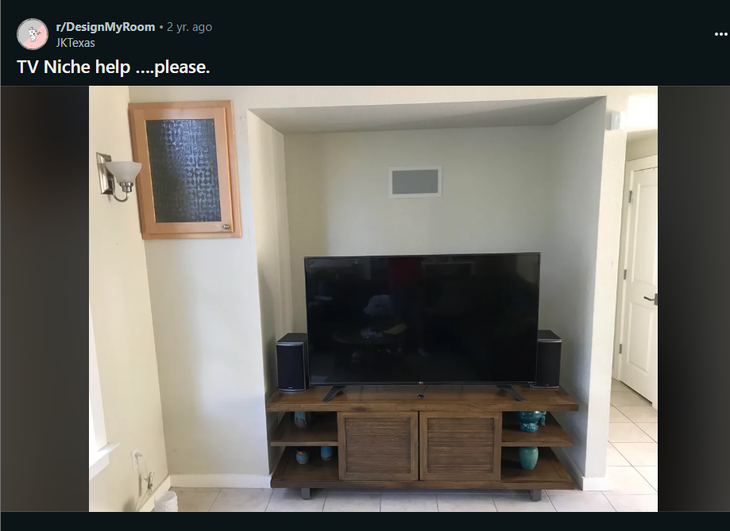

Comments :

1. Would you consider built ins? Get some storage out of the deal and don\u2019t steal square footage from the room if you walled it off.

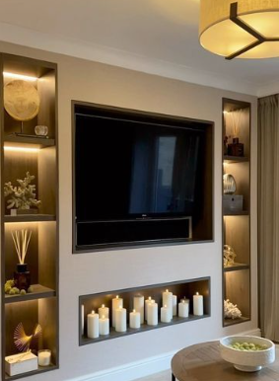 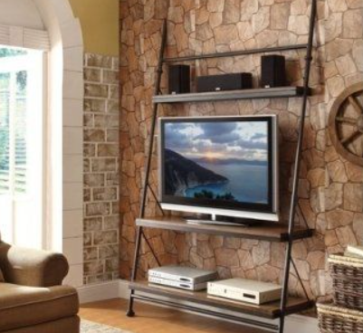

1. I'd consider something along these lines - I'd make the niche a bit more shallow, add some sort of built-in storage at the bottom, paint the wall a contrasting color, and mount the TV on the wall. \n\n[URL]
2. Get rid of the tv stand and build wall-colored shelves directly into the niche.

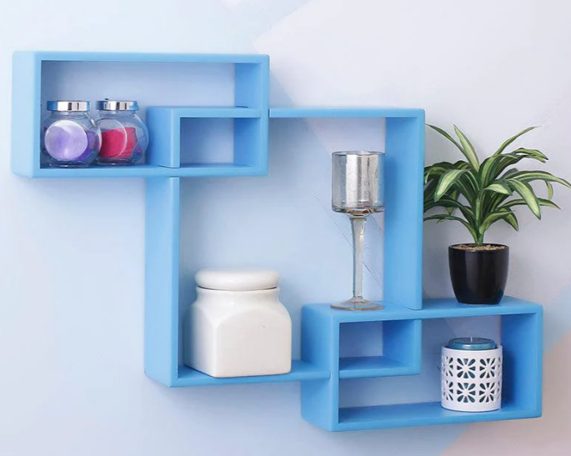

1. First put the tv on brackets that attach to wall. Discard the current wooden tv stand and instead under tv place same color as wall shelving . Some people will paint the interior a darker shade like a muted gray, or grayish purple. \nTv should be higher than it is in picture, to cover up the rectangle (vent?).

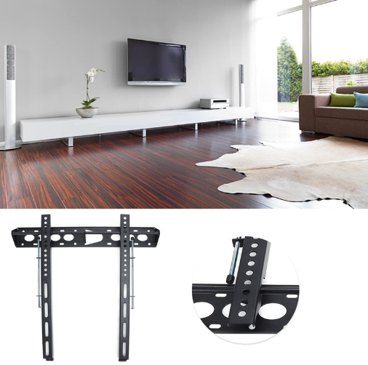

1. Then OP can post the results on r/TVtoohigh.
2. You might just paint the base you have to match the walls.
3. I\u2019d measure and cut two huge shelves, put the tv on the top and make the bottom shelf your entertainment center. I\u2019d put lights above and below each shelf and paint behind a funky color or do some wallpaper. literally a $200 job that will transform it
4. I'd cut the space in half by adding storage with an access door in the hallway. I would then wall mount the tv and add built in drawers or cabinets for video game accessories, DVD'S or toys. You could also add a frame around the tv so it hides all the cables.

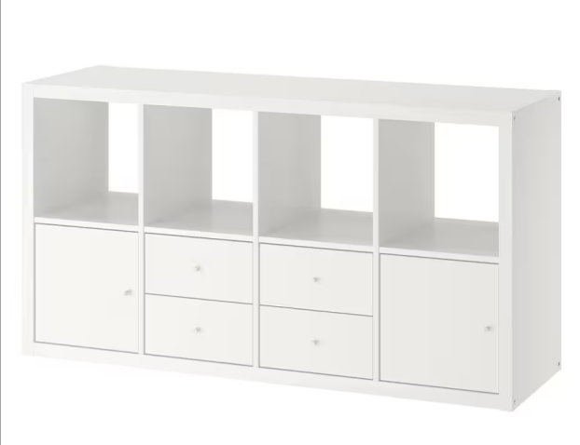 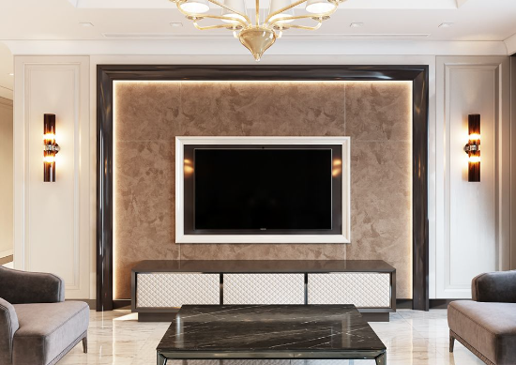

1. Are you able to remove the wall on the left to line it up with the indent?
2. Can you post any other photos of the room?
3. I'm curious, if you walled it off, could you extend the closet, that way you aren't wasting space. Also, what is the cabinet on the left?
4. Is that a vent above the TV? If you walled that entire area off, you could make it into a closet so you aren't losing that space. Personally, I like the idea of walling it off, getting a larger vintage credenza to center on the wall

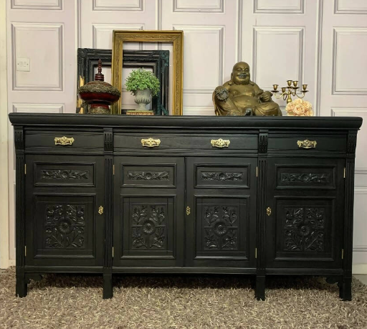

**Post 26 (Line - 10239)**

**URL : https://i.redd.it/zr132n08igx71.jpg**

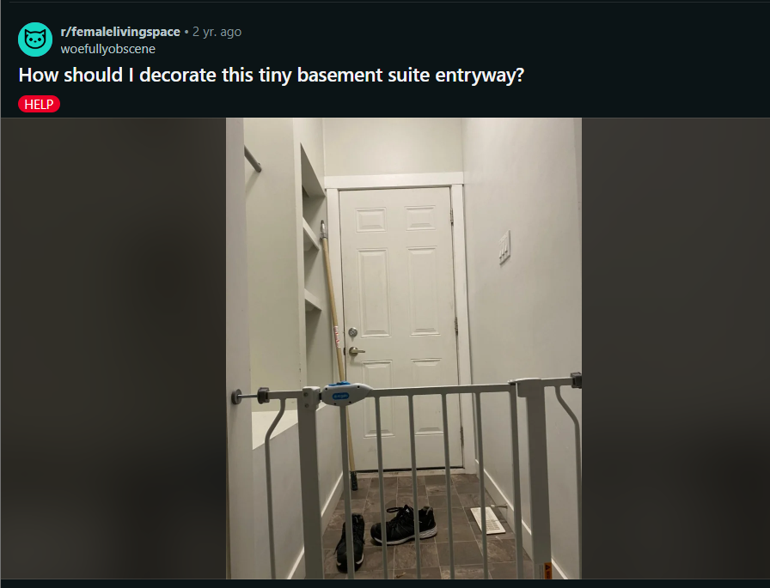

Comments :

1. I've lived somewhere with a very similar set-up, and would be happy to help! \n\nA light sage green sounds perfect here. Given that this is a smaller space, I hesitate about the proposed dark walnut color though (that may make the space feel heavier/smaller); have you considered cream instead? \n\nDo you have any more pics of the bench and shelves?
2. that sounds great! \n\nOur biggest source of clutter was always shoes at the entryway. Highly recommend using the bottom shelf for shoe storage - even something as simple as one or two baskets would go a long way.\n\nSimilarly, if your dog is prone to getting muddy/dirty, I'd get another basket for the top shelf to store a few towels. Extra dog items like poop bags, treats would be great here - so they're easy to grab when you're running low and heading out the door.\n\nA statement mirror [like this]([URL]) or [this]([URL]) on the blank wall could help bounce off some light in the area, too.

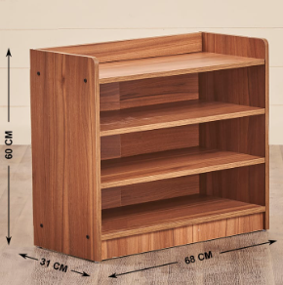 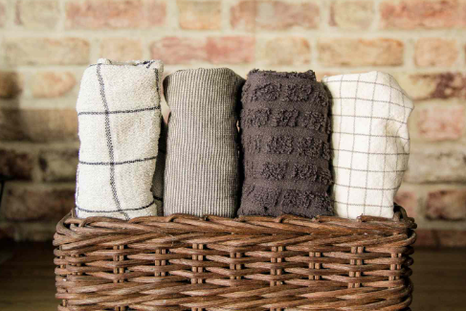

1. A DIY shoe cubby drawer sounds like an excellent solution! \n\nI found these mirrors on Etsy - just Googled cottagecore mirror and went down a black hole browsing all the fun choices. \n\nHave a great week, op! Good luck getting everything set up.

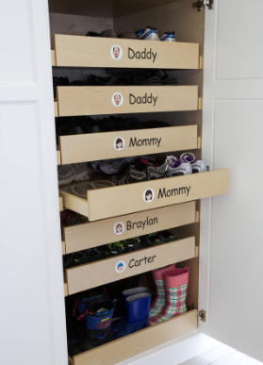 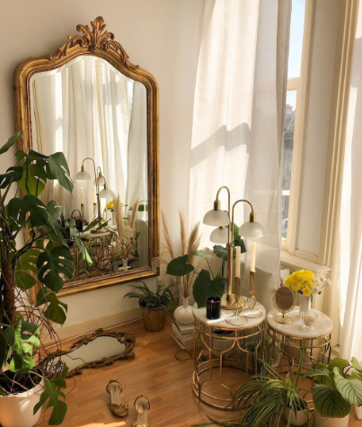

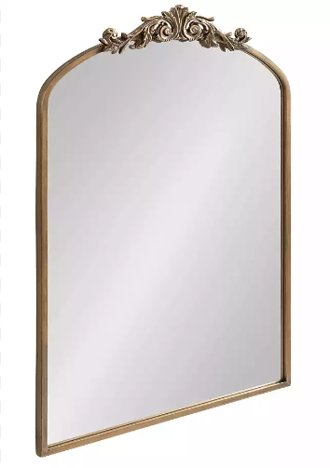

1. Instead of trying to open the space up you could lean into the tinyness and make it like a hermit in the woods kinda vibe. Coincidentally goes great with the colors you already picked, and I feel like it could look really cool
2. You could get a doorsticker with scenery.\n\nSince your door isn't flat you could just stick parts in the rectangles so it looks like a glass windows in the door looking out into a forest .  It will open it op and give an illusion of space. You will have to pay attention to pick the right picture though that fits with the squares.

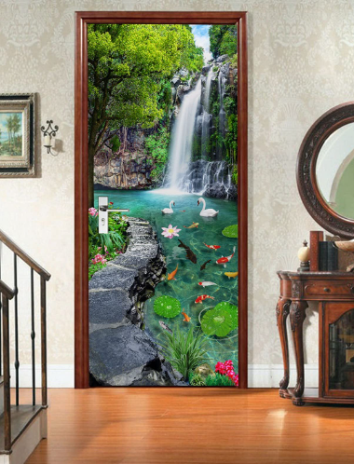

1. Yea stained glass could be very lovely as well :)

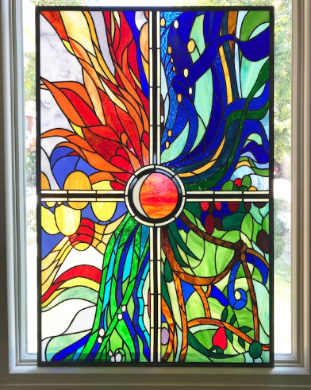

1. More fancy foot shoe placements should do the trick.
2. Maybe some cati or succulents that you can move into sunlight when you need it, and some bright art in dark frames?

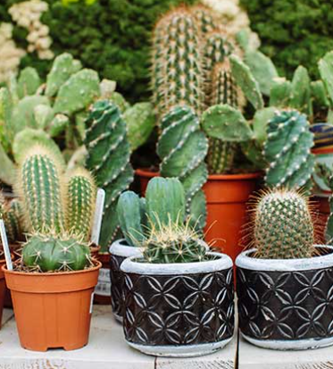 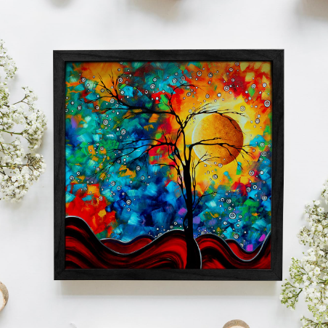

1. I would decorate the heck out of those shelves!! I love shelves!!!\n\nDo you actually hang your coats above the bench? If you have space to actually use it as a bench, I would make or buy a bench cushion that fits in that space. I think the whole space just needs more soft textures. I could understand if it gets in the way of the utility of the space though. I\u2019d also get a nice cute doormat, or maybe even a runner that goes the length of the space, if you can find a nice sturdy one.\n\nI would also get lots of small art and do a casual gallery wall on the right wall. I think the space is too small for any large art, though.

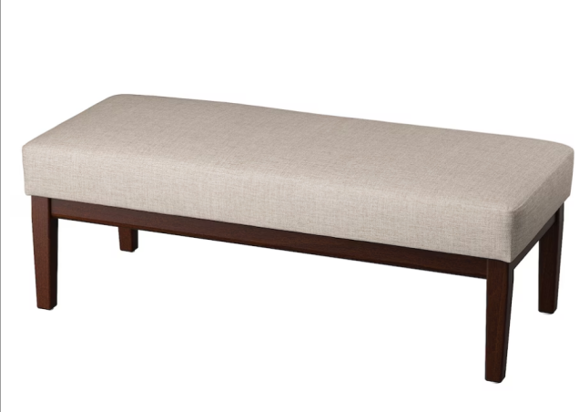 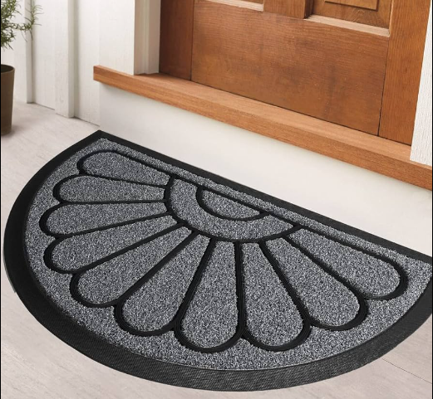

1. Add a small runner rug or doormat and then hang a cute piece of art up. I think that would be so easy to brighten up the space

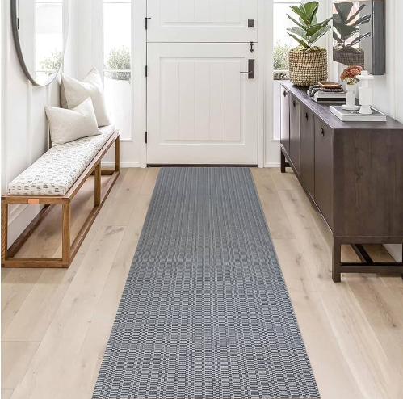 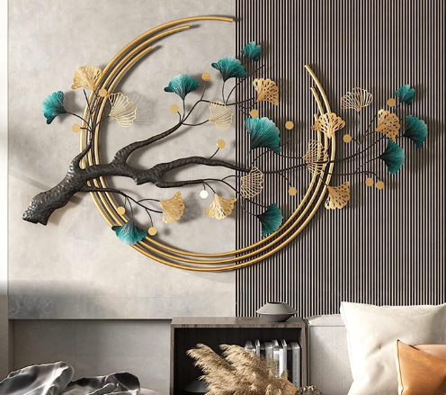

**Post 27 (Line 10488)**

**URL : <https://i.redd.it/4kwhl7munu571.jpg>**

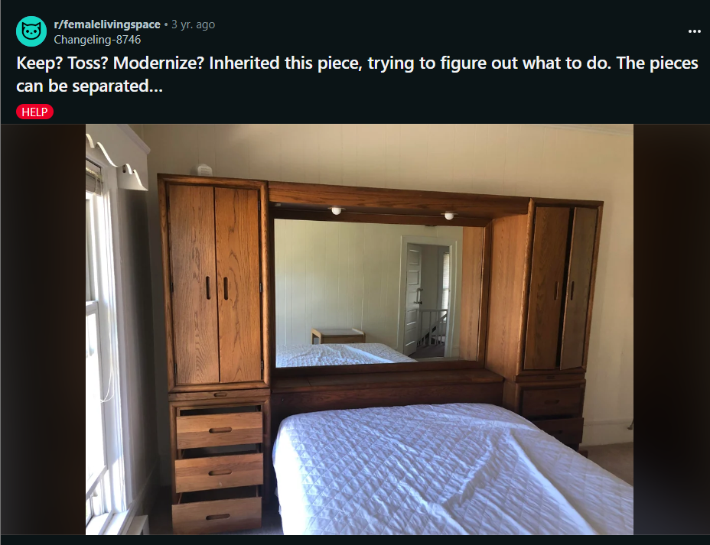

Comments :

1. I think that if you have room for it, keep it! It\u2019s amazing!
2. I kind of like it. I'd suggest either separating it and keeping the two drawer/wardrobe units (if the wardrobe size is useful for your, uh, wardrobe) or keeping the whole thing. If you keep the entire unit, you might want to refinish by lightly stripping and waxing the wood to bring back some luster.  I'd also replace the two lights with something a bit more sleek and personally I'd use removeable wallpaper to cover up the mirror because I would hate having that in my room, but mileage may vary on that one.

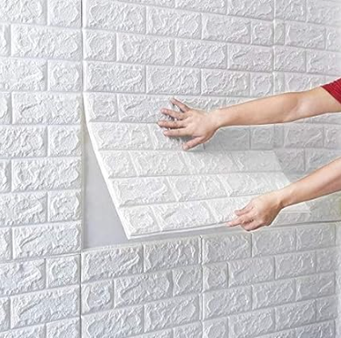

1. I was going to suggest covering the mirror, too!
2. Don\u2019t separate. The wood finish is awesome the wallpaper and lighting could really make this amazing

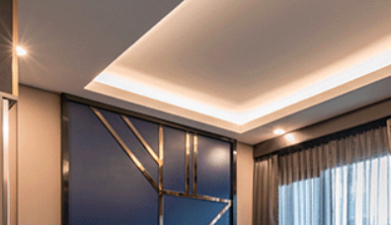

1. I would suggest just propping a large canvas over the top of the mirror if you don't like it. Doing anything permanent to it will affect the resale value. \n\nI would keep it. It's beautiful and the wood grain is amazing \ud83d\ude0a

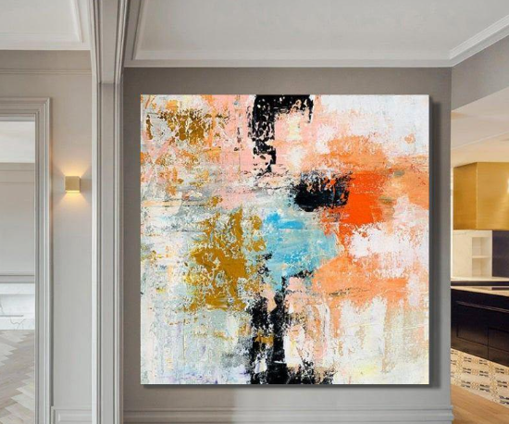

1. It\u2019s beautiful and amazing!\n\nI think messing with it too much would be a mistake. If it were me, I would \u201cmodernize it\u201d by adding some colorful and statement-worthy handles./knobs. \n\nI would add a frame to the mirror. And I would move the bed so that it\u2019s not under it.

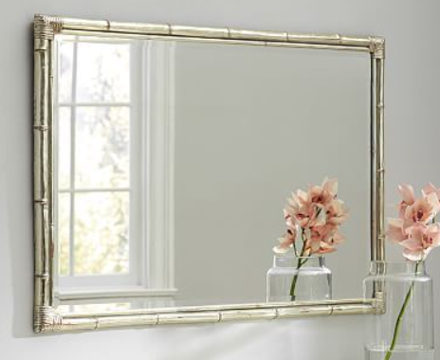

1. Add plants to the top.

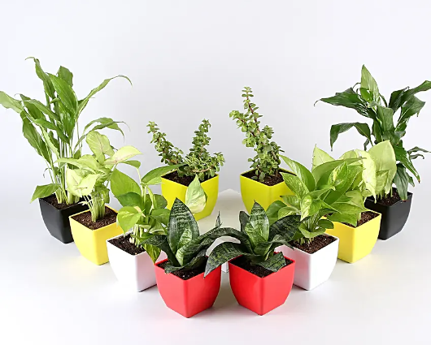

1. This is my dream headboard situation. I would probably lean a big piece of art over the mirror because I'm a not a huge mirror over the bed kind of girl but, other than that, this has so much potential.

 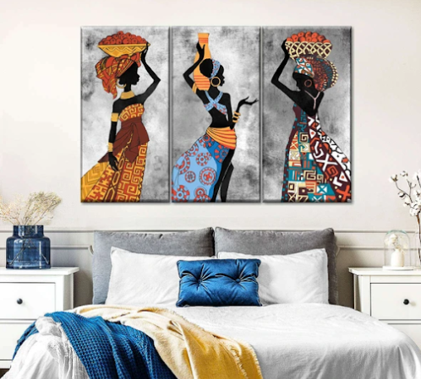

1. I like it! It is kind of old school, but it seems to be in good condition and it looks really usefully as well! I say leave it as is and just enjoy it!
2. Toss
3. I would keep it but modernize it a lot. Painting it a different color will help (I would prefer white), different light fixtures too. I would also suggest to get rid of the mirror and replace it with something colorful.
4. Does the room have a closet? I think that the headboard/ wardrobe is very over powering in this space. I would either keep it but paint it white and change out the door handles, or get something smaller instead.
5. In that case, I would say pick a color that you like and paint it. Unpopular Opinion, but I actually don't mind the mirror too much. I would get a nice comforter/ sham set and load the bed up with throw pillows. I saw some really adorable dragonfly string lights at Ikea recently, you could drape something like that around the top of it. What is your style? I think that you could make this suit just about any kind of decor style by painting or refinishing it.

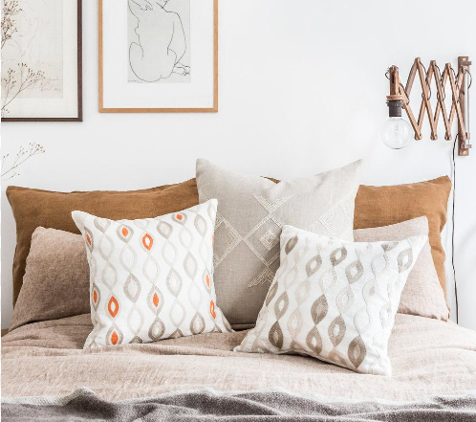 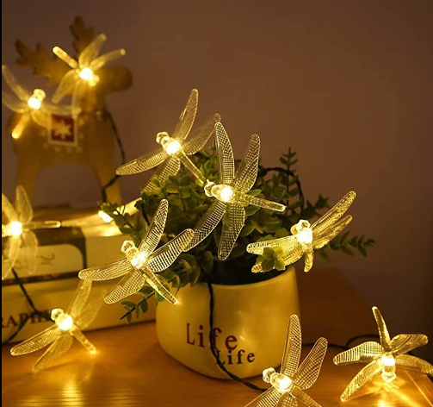

1. Keep it! I\u2019d put a LED strip light inside. I\u2019d remove the mirror and use it probably to renew the bathroom\u2026 nice abstract modern art picture \u2026
2. Keep it!!  That is one solid piece of furniture.  Clean/wax it with 0000 steel wool or a 3M superfine pad.  Do NOT remove or paper over the mirror!  Hang a painting, a wreath, a starburst mirror or something right on the mirror with a 3M hook. It will add depth and still retain a bit of the sparkle around the edges and reflect daylight back into the room.  Get a blank canvas and paint your own or have an artsy friend do it.  I would add linen drapery underneath the curvy valance using a tension rod.  I would add a similar fabric valance at the top, again using a tension rod or self stick velcro.  You can mimic the curves in the window piece or just do a straight panel and fringe the ends.  I'd like to see some ROUND shapes to contrast all the straight lines.  Def do a round accent pillow.  Put lanterns up top w/battery operated candles on timers.  Some greenery (round) balls and some paper poufs in all white in various sizes.  I'll try to attach a picture of my sketch because too many words here.....   Good luck!! It'll be adorable.  Also, trick out the cabinets with motion sensor lights (Amazon) to make it as functional as possible.  This will be adorable.  Choose your color scheme and keep it tight.  Mostly white/neutral with accents in art and pillows/throw.\n\nI made a pinterest board for you with my sketch... I hope it works.   [[URL]

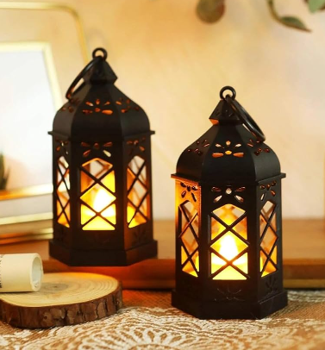 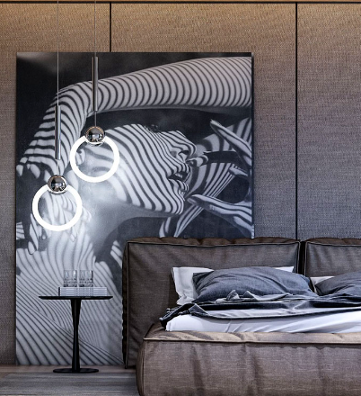

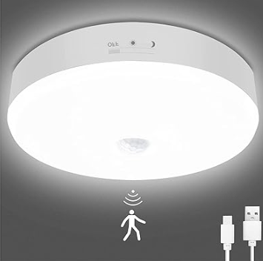

1. I\u2019d paint it light pink and get brass hardware but that\u2019s just me.Even if not painting I think brass hardware would really make it look amazing
2. Also if you don\u2019t like the mirror maybe you could cover it over and face it with some shelves for books

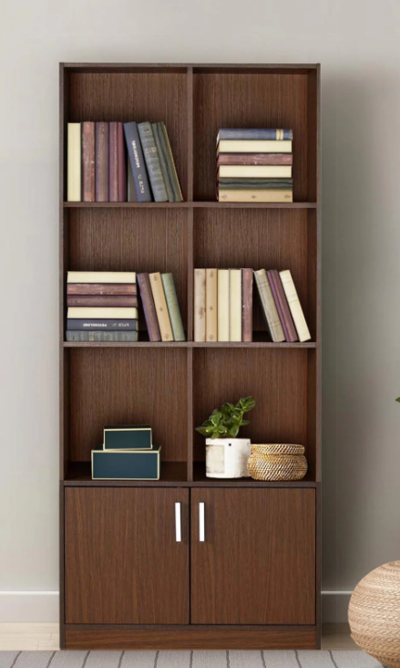

**Post 28 (Line 10800)**

**Url : <https://i.redd.it/cuch2hskusm71.jpg>**

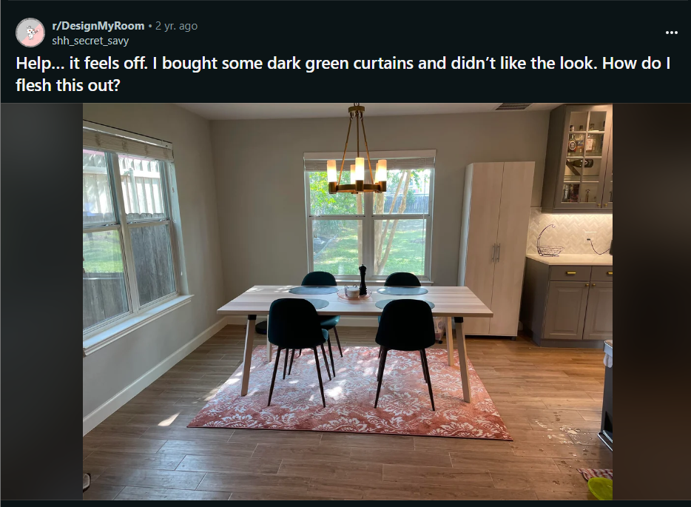

Comments :

1. I agree with others about the rug, I\u2019d remove it. The small pantry cabinet is throwing me off. It\u2019s out of place with the kitchen cabinets to the right. I\u2019d also remove that. If you need storage maybe install some shelves on each side of the window? Curtains would also help a ton, I\u2019d go with bright prints.\n\nETA: try changing the orientation of the table.

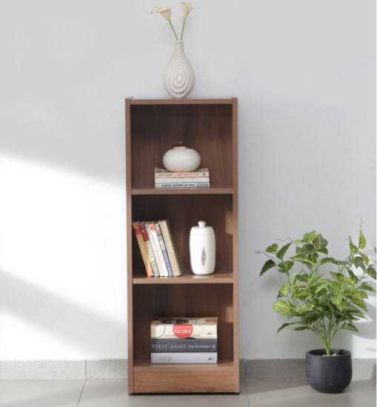 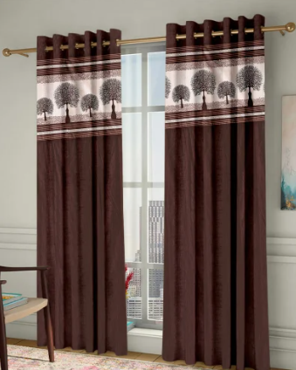

1. Maybe put a nice basket and plant up there? To help it become visually taller and match your other cabinets more? Can also change out the handles for a more sleek look :)

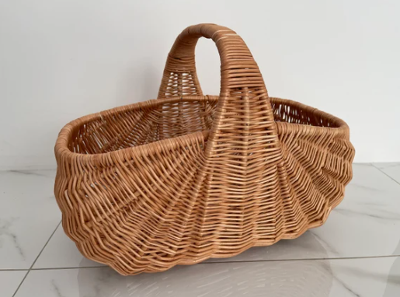 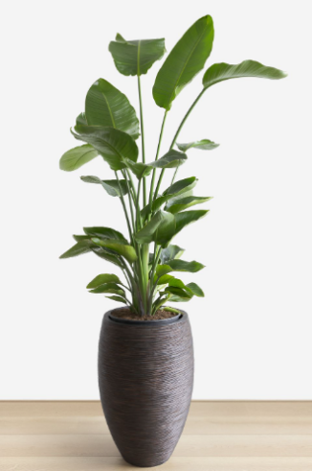

1. If keeping the cabinet turn the table 90 degrees.
2. Someone mentioned angling the cabinet in the left corner of the room. I think that would look great. I repurposed a bookshelf/cubby into a sideboard and I\u2019m really happy with how it looks. I can link a photo if you\u2019re interested. Maybe you already have a piece in the house that will work!

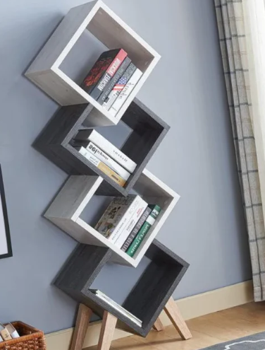 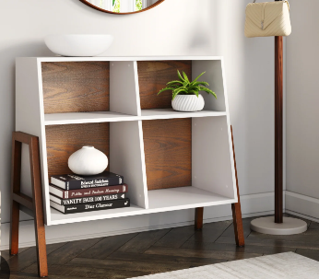

1. I\u2019m not a great photographer so excuse that \ud83d\ude02 several angles of the [dining area. ]([URL]
2. That looks amazing! Well done!
3. Could you paint it?
4. I agree with the others; the rug should be bigger, semi sheer curtains or shutters would be good, the storage cabinet stands out awkwardly and you need a big plant in the corner. Also, the chairs are too small for the table..so maybe get two more for the ends or pick bulkier ones then rotate the table. And I feel like the chandelier could match the aesthetic better.
5. New light fixtures are affordable and replaceable - you could store the chandelier somewhere safe and put it back when you move, but maybe check with the landlord first.
6. What a beautiful dining space! I love all the natural light.\n\nI see what you're saying about something feeling off, but I can't put my finger on it. Have you tried rotating the dining table?\n\nMy only immediate recommendation is to remove the rug.\n\nSorry I can't be more helpful - I hope someone else with better design skills than me is able to provide feedback.
7. I totally get it - it's a lovely rug. Glad you still have the option to return if it doesn't work anywhere else in your home (maybe an office or bedroom?).\n\nLooks like there are some great tips from other commenters - I LOVE the idea for shutters by u/Aggressive_Dinner_15 \n\nGood luck and hope you have fun playing around with this space.
8. I think a bigger size would work if you want to try again
9. I don\u2019t think the rug is an issue. You just need to find a greyish curtain with a hint of the rug color. Presto! You\u2019ve tied it in and the rug will look great! It\u2019s actually a beautiful rug and looks good with your cabinets.

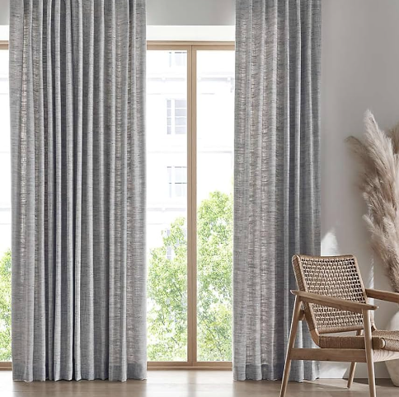

1. Yup, the rug could go. Also, white sheer curtains might be a good addition.

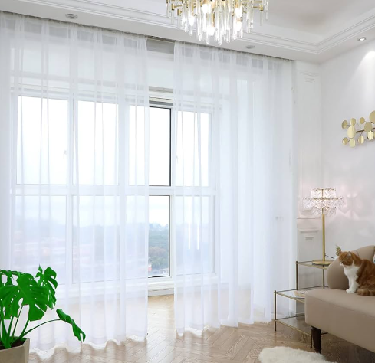

1. It sounds like you already moved the rug, I think that was the biggest culprit in throwing this area off for you. I might move the freestanding cabinet to the left corner at an angle, and perhaps place a hanging plant on top. I also agree that sheer white curtains with a simple and dainty rod would look great here. They would provide some more texture and depth without taking away any light.
2. Rug is too.small. Pantry cabinet is in a weird place in relation to the kitchen. Add something colorful to the walls. It looks.very beige.
3. Turn your table long ways that will open it up a bit...add greenery, plants

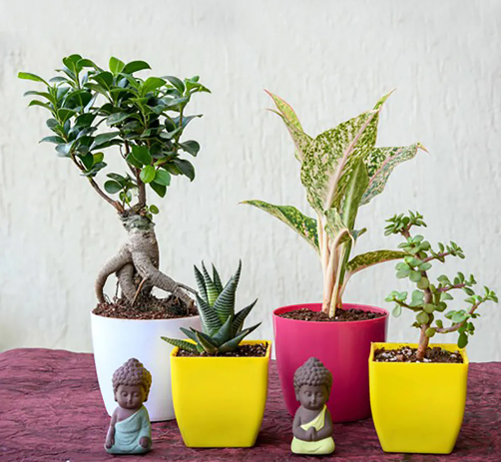

1. I think what\u2019s missing are some curtains. Some have said the rug is off. I would say it\u2019s too small. The colors work fine, it\u2019s just the size. That table could easily fit 6 people, but if you wanted to put people on the end, the chairs would hang over edge.
2. You need plants.. good basics but it needs some \u201clife\u201d. Plants.
3. Wooden plantation blinds-
4. Lovely space. Agree that plants will help fill the space (the bigger the better) and another thing to consider could be a different lighting fixture, one that mirrored the length of the table so filled the space above it a bit better. \n\nDiscrete uplighters on the walls around the table (just a couple) also can warm a space and allow for nice lighting at night when people eat at the table
5. What about a banquette bench?

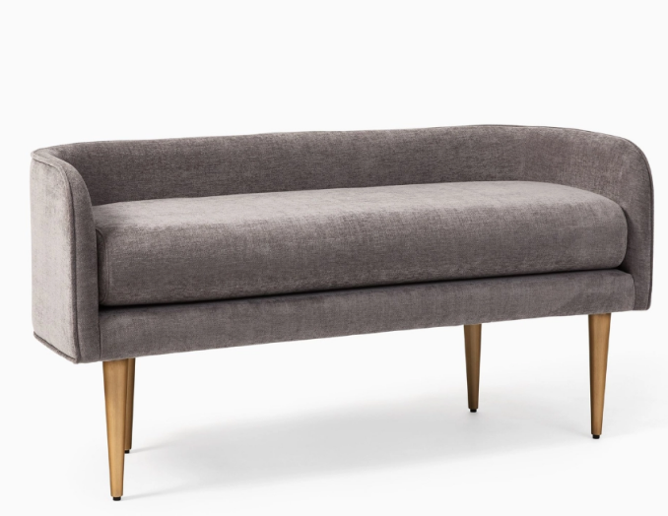

1. It's a great space! I would change the direction of the table and remove the rug. Adding long curtains would work great to help out the space. Add a centerpiece to the table, a real plant, a few candles or even a faux plant. Helping center the room a little more around the table and lighting above the table. White or off white curtains to help light come in but have some texture or subtle pattern to them. If you wanted some color to the curtains having some pops of green or orange would work as well but keep it simple. Can you paint that cabinet? Having it match the kitchen cabinet could help it blend in a little more. Is it possible to change out the door hardware? Change it gold like the kitchen hardware? Put some small decor items and/or cookbooks up there. A big plant in the corner between the two windows would be a beautiful use of that corner. Love the kitchen cabinet color! \n\nEventually you could add a narrow bench under the window on the left side. Have a few throw pillows on it, maybe a seat cushion to add some softness and warmth to the room.

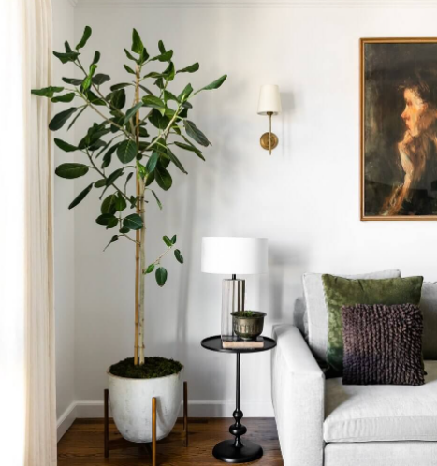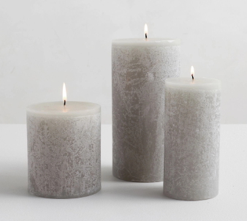 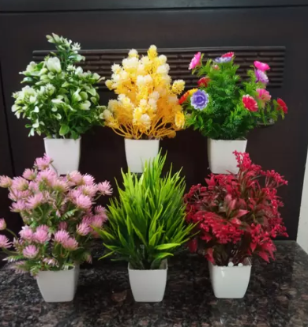  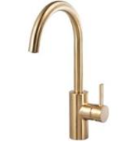 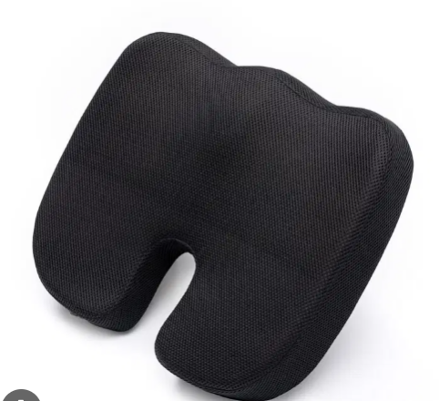

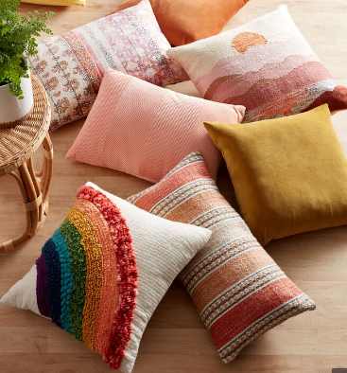

1. I would start by removing the rug. I think it's a little too small. Maybe rotate the table to see if that orientation works better in the space. I'd put a plant in the corner to balance out the cabinet. And then maybe sheer curtains with a subtle pattern.
2. Agreed with others here for changing the orientation of the table. Also if you are looking to add more cabinetry. You could add one to the left and the right side of the middle window (in line with kitchen). One could be a bar and other a coffee station ? A chandelier that\u2019s longer in the size orientation of the table will look better IMO. I\u2019m a big fan of benches for the dining table but I think it might look good here as they won\u2019t obstruct the outside view and make the space look more open

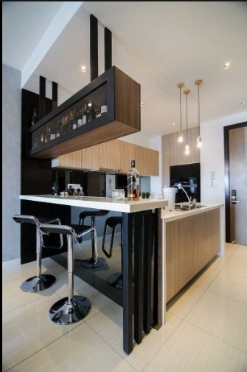 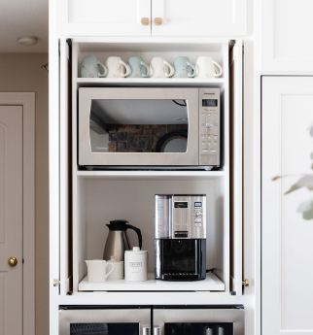

1. Get a Neutral rug, rotate table 90 degrees
2. Fill in the far left corner with some corner floating shelves and add some plants!

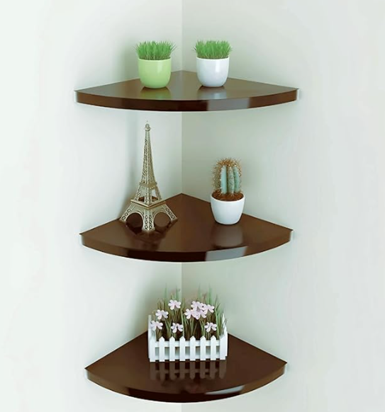

1. Also the white in your rug would pull out white curtains...I think that would be a great start... curtains (white) turn table and center add plants and other decor, maybe a bench with throw pillows

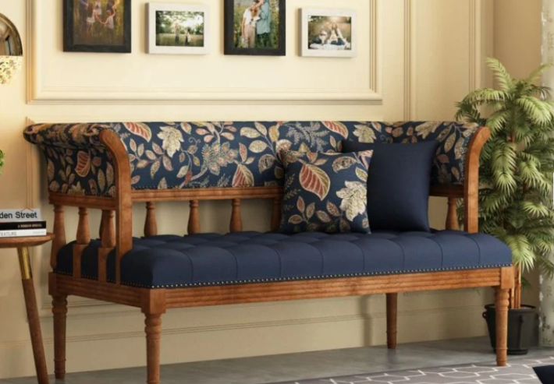

1. Point the table in the other direction
2. I'd recommend a neutral rug at and least 8x10. You want the legs of the chairs to remain on the rug when you pull them out. Also like others have said about the pantry, see if you can find another place for it.
3. Plants
4. I would do sheer curtains and maybe an ottoman or low bookcase by the window. Also agree with the rug...you would need a larger/more neutral toned rug maybe? Also turn the table 90 degrees…

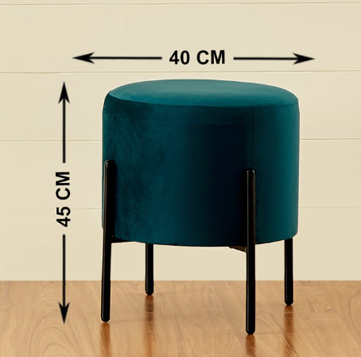 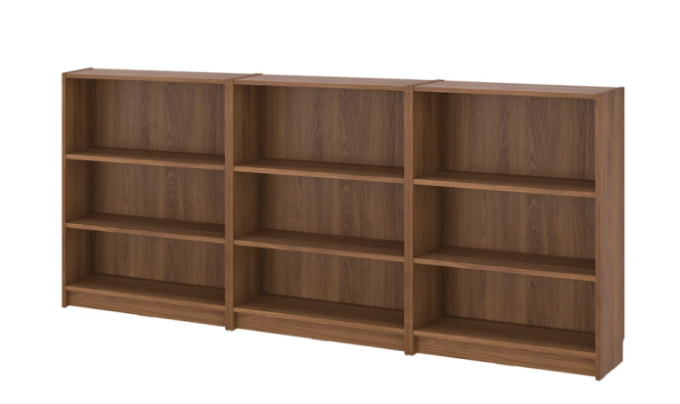

1. Can the rug work in the kitchen btw the cabinets to the right? Agree with some other comments here.  Sheer curtains on windows, turn the table, large green plant and planter on left corner.  Something tall.
2. I think larger chairs, re-locate the cabinet, and depending how much privacy you need/want maybe cool blinds/shades/shutters. A larger rug would certainly help.
3. The pantry feels out of place.
4. cream-colored translucent curtains, maybe a plant or two? add a decoration on the wall.

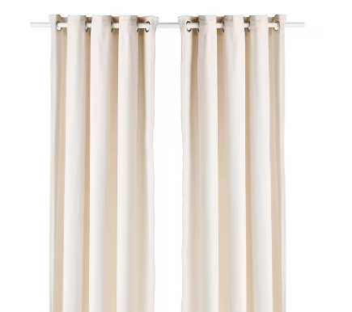

1. Try turning the table the other way. But also you need a bigger rug, it is hugging the table too tightly. I think if switched you those two things it would change ya life
2. If you replace the blinds with honeycomb blinds that will help. the rug is too small and I would just skip it. You need a large plant in the corner I think also. Home depot for blinds (just regular off the shelf, cut to size) and plant.
3. Consider patterned white sheers topped with a fabric box valance. Swag the chandelier with a similar sheer material. Possibly adorn the blank walls with interesting \u2018found\u2019 items - metal or wood pieces, old industrial salvage - to add interest.
4. I would go with a grey and white print with maybe a hint of the orangey-red of the carpet. If you prefer solid, then dark grey.

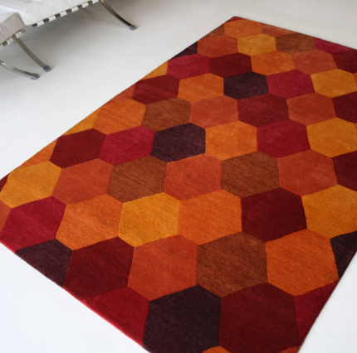 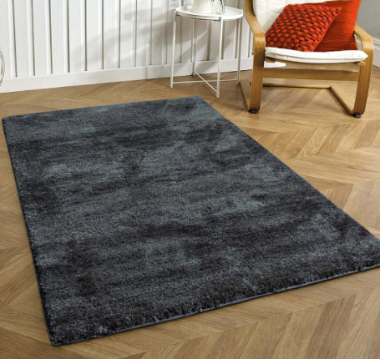

1. I'd do roman shades

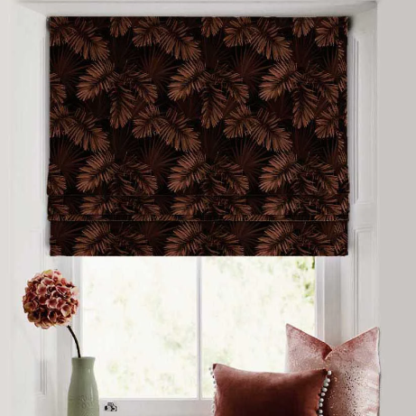

1. If you go dark green you need a rug with some dark green. Cream with a hint of green. I\u2019d avoid dark green curtains unless they are a very light fabric.  I\u2019d lower the lamp a few inches. Add plants.
2. Turn table if storage cabinet stays dress up the larger rug or no rug and  curtain panels need to have pattern or floral to tie the rooms together
3. Use the rug in kitchen area

**Post 29 (Line 11548)   
  
Url : <https://i.redd.it/m94id2emt0r41.jpg>**

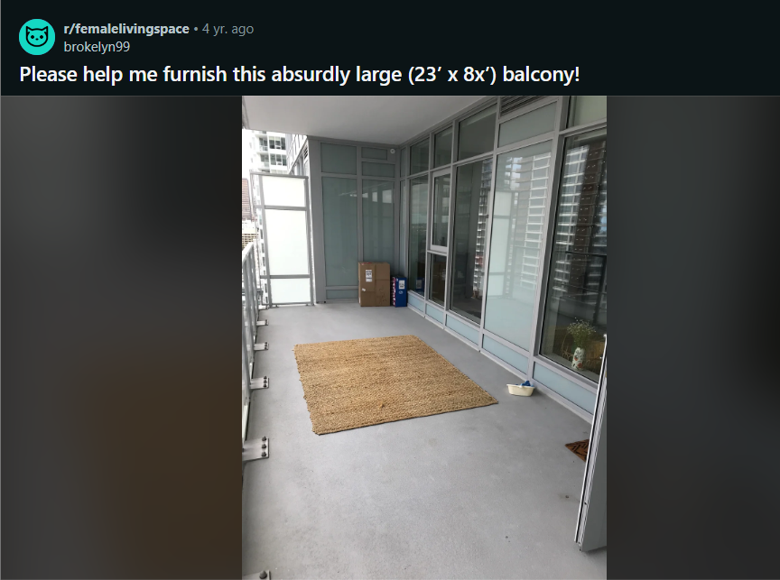

Comments:   
  
1) Patio furniture and workout equipment! Maybe a reading nook\n\nP.s. I'm pretty sure I recognize that apartment complex! Even if it isn't that place, we almost lived some place very similar and the oversized were a bit weird esp at like 12 stories up and we did not dig the price.

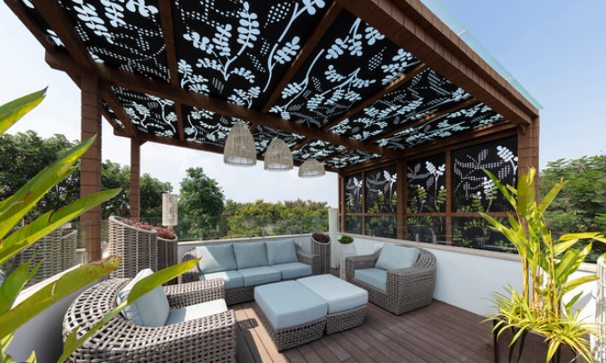

 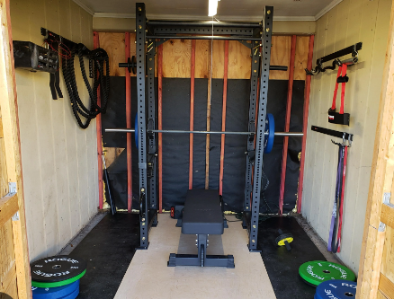

1. Damn, that looks just like this place in San Mateo!\n\nIf money is not an issue, I'd make a small L shape outdoor couch set up, with a little coffee table or mini fire pit/grill in the middle and a fire resistant rug under it. Ideally the whole thing takes up at most than half of your space, so as not to overwhelm and the other half could be devoted to workout/mini garden/open space

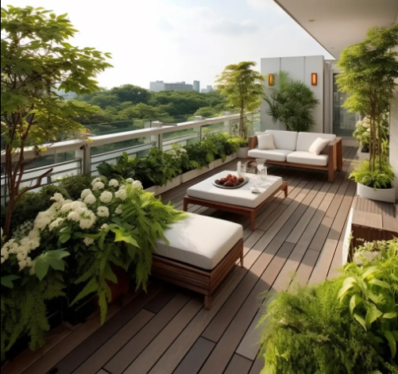 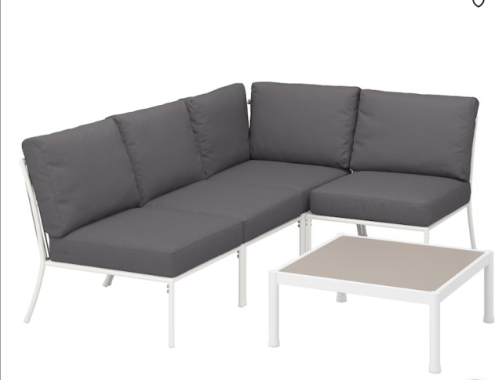

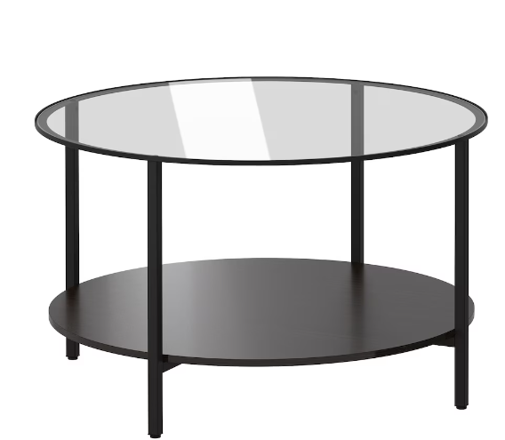 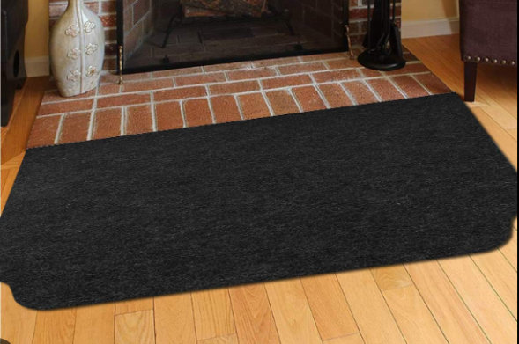

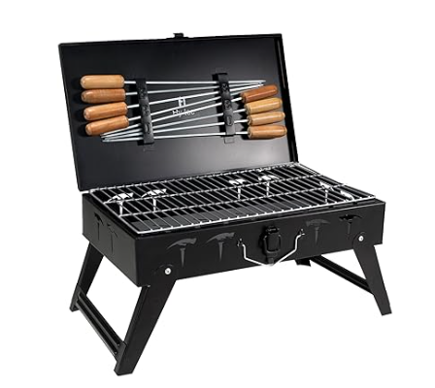

1. I thought it was for sure my parents\u2019 place in SF. Either this style is really popular or it\u2019s all the same developer.
2. There are a few lovely ideas over on r/cozyplaces you can check out. Globe string lights, some greenery, an indoor-outdoor rug, and the furniture can be whatever you like but I bet IKEA has some solid choices!
3. I adore IKEA! It's my happy place. LOOK AT [THIS]([URL] THING\nand [this]([URL]
4. It is modular, too, so you can set it up as you like AND made of steel. I love IKEA...you should post images when you have it all set up!
5. I have the KOLBJORN (green); it looks fab indoors as well.
6. I\u2019m so glad you said it\u2019s in LA! You can really do some outdoor living there. I would make it into a dining area at one end and a cozy lounge at the other end. It\u2019s what I did with my long living room

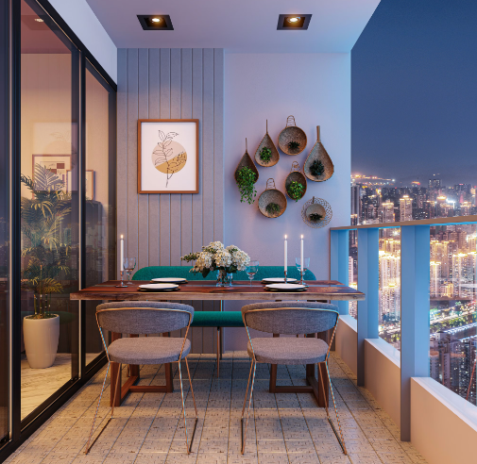

1. It sounds like a super fun project!
2. I know that you're probably looking for furniture suggestions, but this could be such a beautiful green space.  You could do an herb garden if you like to cook, you could do some lush tropicals since you're in L.A., or you could go with succulents and cacti.  Plants will really help bring whatever you choose to go with to life, and can provide a bit of extra privacy as well

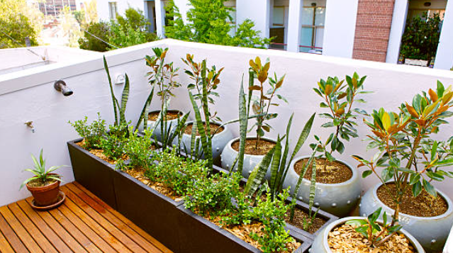

1. You should look into the design team The Horticult.  I'm pretty sure they're based in L.A. (or at least somewhere in southern California) and they have a ton of really incredible inspiration.  Even if things don't get direct sunlight, there's still a lot you can work with.
2. Ah lucky you! How wonderful to have this much outdoor space. \n\nEsp in LA.
3. Go with a bench for at least one side of your dining table.  That will let you put it under the table when not in use for a big group and save yourself some space.I would 100% make that my dining room. I\u2019d also get a bar cart and put a phone dock with speakers so you can push the bar out there whenever you\u2019re entertaining and have music! \n\nI\u2019ve seen people recommend a hammock and that would be a must-have for me. They sell free-standing hammock frames so that you don\u2019t have to attach the hammock or anything! They\u2019re pricey, but that\u2019s something you could have forever. I\u2019d maybe do a vertical garden as a room divider to make the relaxation nook separate from the dining room.

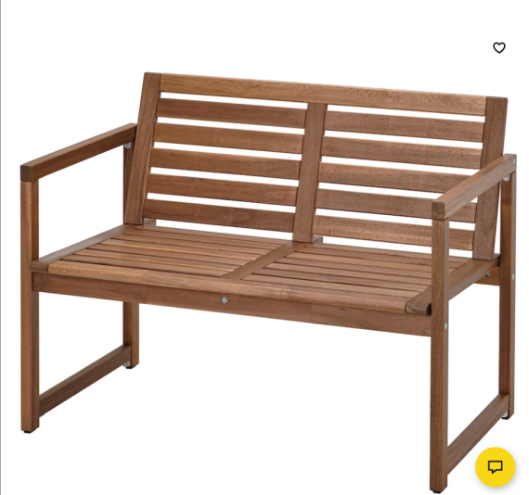 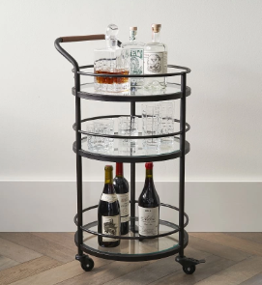

1. See meanwhile I'd trade the hammock for a comfortable couch/lounge so that it has dual function for guests to maximize the space.

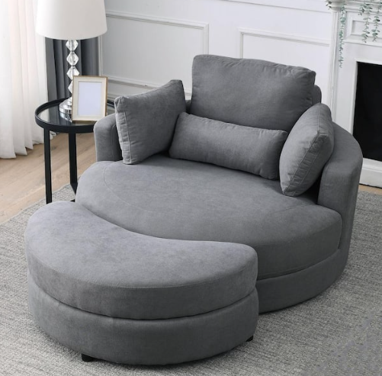

1. I don't have much to add beyond all the plants you can go wild growing with that space and light! But as a new yorker I almost instinctively downvoted your balcony out of annoyance and jealousy haha
2. Hammock! I found one on Amazon.ca for about $120 CAD. Just check in the reviews that it's weather proof

**Post 30 (Line 11931)  
  
Url : https://i.redd.it/ocxky9hro4091.jpg**

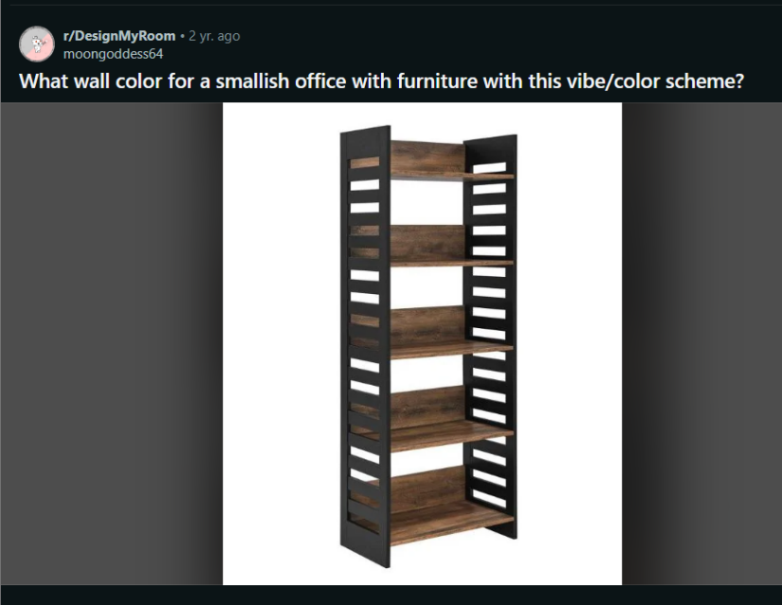

Comments :

1. Any neutral would go well with these tones, lighter or darker shades of grays / beiges. For a more calming feel for the space, maybe something like a grayish sage green or even a light aqua/teal. Rainwashed by Sherwin Williams or something similar would pair well.\nAlso, love that bookshelf btw. May I ask where you found it?

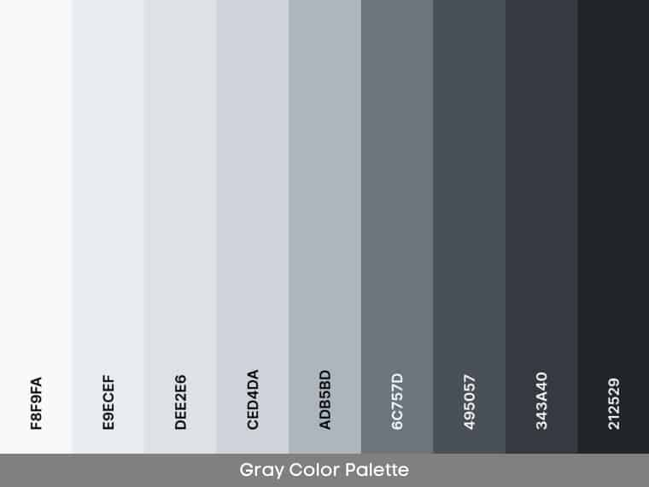

1. Yes SW is great stuff
2. I'm thinking sagey. Check out backdrop paints (online)

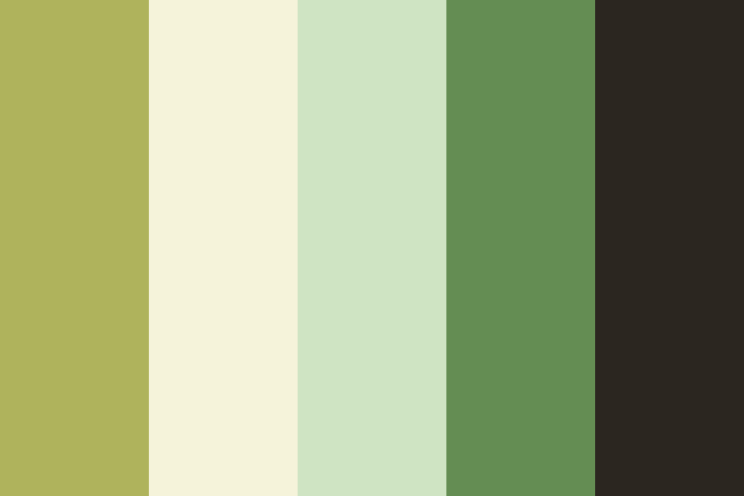

1. Navy blue.



1. Forest green, burnt orange or a mustard yellow with golden tones

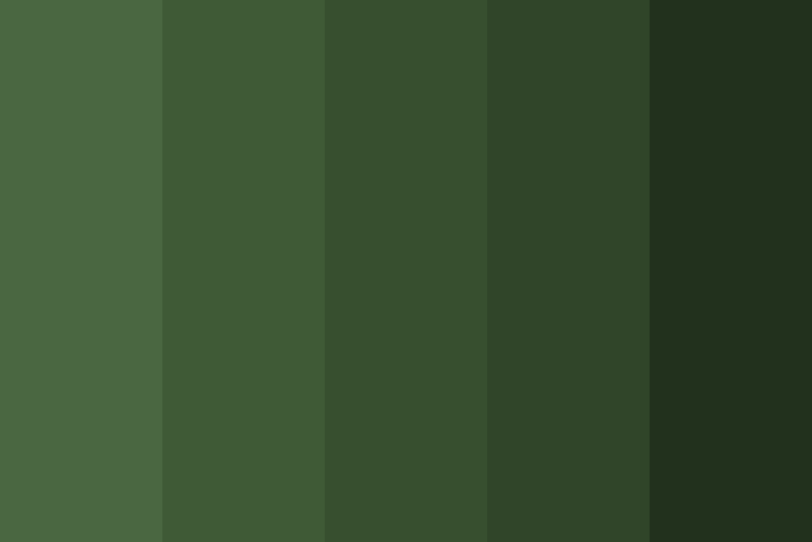

1. ooo a burnt orange is always my favourite suggestion
2. mint, like a light minty green



1. A light sage green or something like Sea Salt by SW



1. SW can color match any other paint colors\u2026Ben Moore, PPG, etc

**Post 31 (Line 12145)  
  
url : https://i.redd.it/hhr9c8pu5bg91.jpg**

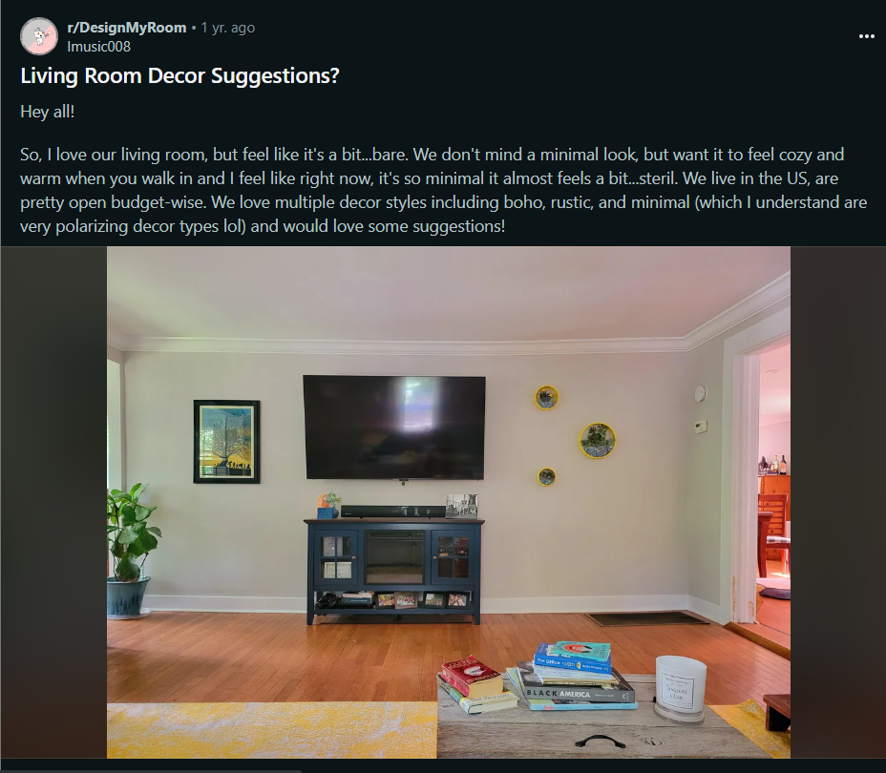

Comments:

1) It's already pretty cute, but indeed a bit bare. If I were you, I'd get a long low console for your TV to fill in the space, something 5 feet long (or longer) with doors that can conceal your stuff.  I'd also lower the TV to just above the console or sitting atop the console.  Then I'd scoot that plant closer to the console so that it fills the space under the painting. \n\nThe above suggestions will still leave a void on the right side. I'd then rearrange your three circular artworks so that they're closer together, and then I'd get [a standing lamp with a large round shade]([URL] to fill up some of that void in the right corner. This will mean placing a lamp over that grate, and I don't know if anything can go over that grate.

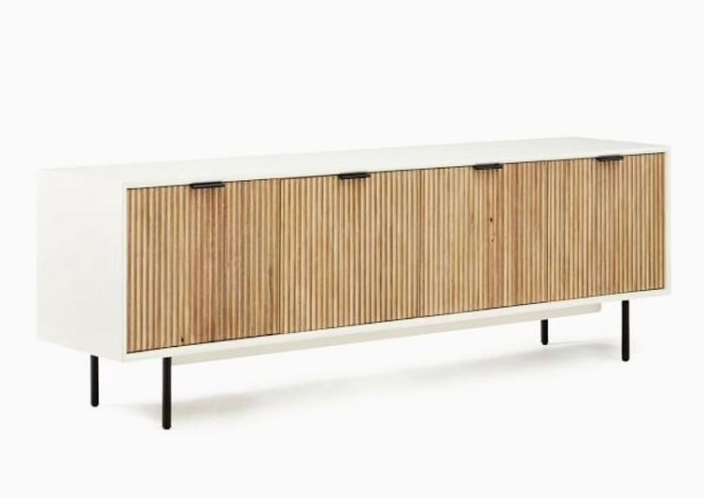

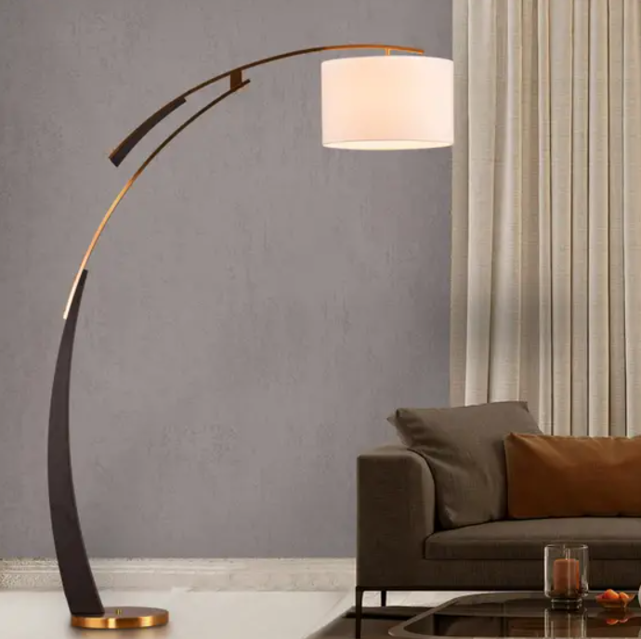

1. The lamp is only $100, so if you scoot the plant under the picture and place the lamp in the corner, you're done!
2. Awesome! Glad I could help, and you don't have to spend any money!
3. Can you move the current console to another room or maybe sell it on Marketplace? I agree, it's just not wide enough for your tv.
4. Eh, greenery would help \"widen\" it, but I don't know if I would add smaller tables on both sides to extend it. I think it would make it more obvious the console isn't wide enough.

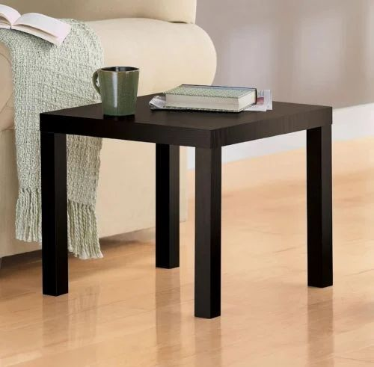 

1. If money were no object, [built ins]([URL]) would be so lovely in your room!
2. That would be okay, but I would go with something wider to fill up the space more. [option]([URL] [option but get a different basket]([URL] You have the height with the tv and console, you need width!

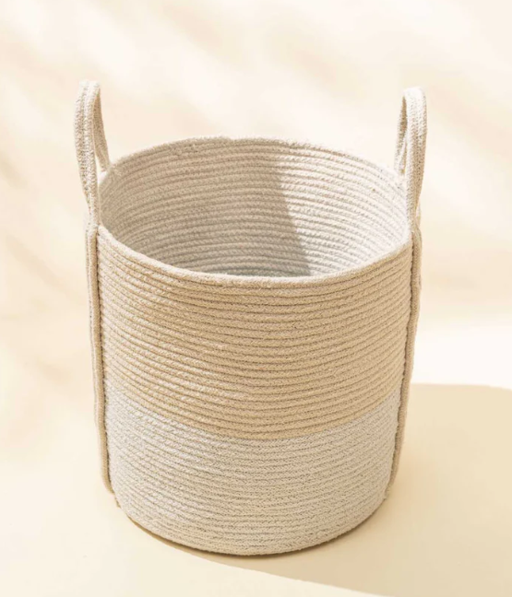

**Post 32 (Line 12329)  
  
URL : <https://i.redd.it/7m10mduhln951.png>**

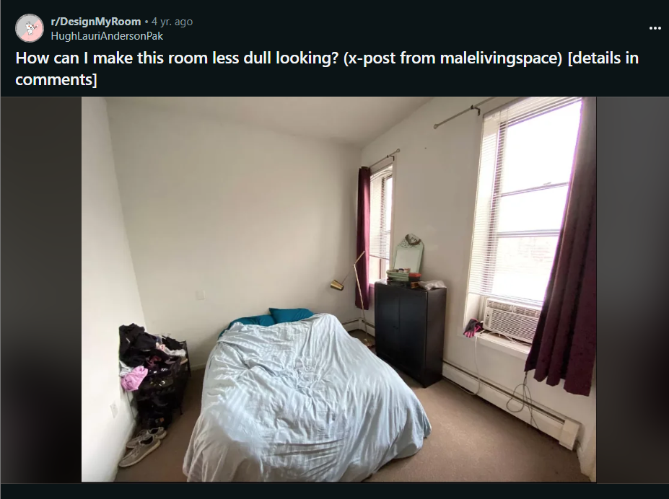

Comments :

1. You just need some furniture in the room. So a headboard and nightstands with lamps.\n\nThe dresser you\u2019re bringing with perhaps a nice mirror somewhere in the room.\n\nA few pictures and great fun linens and you\u2019ll be all set.

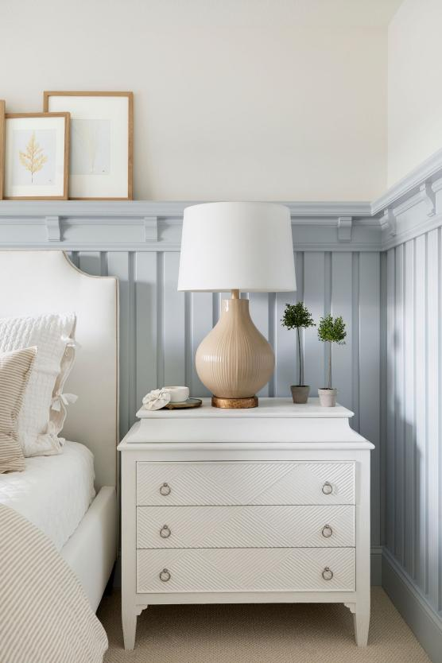 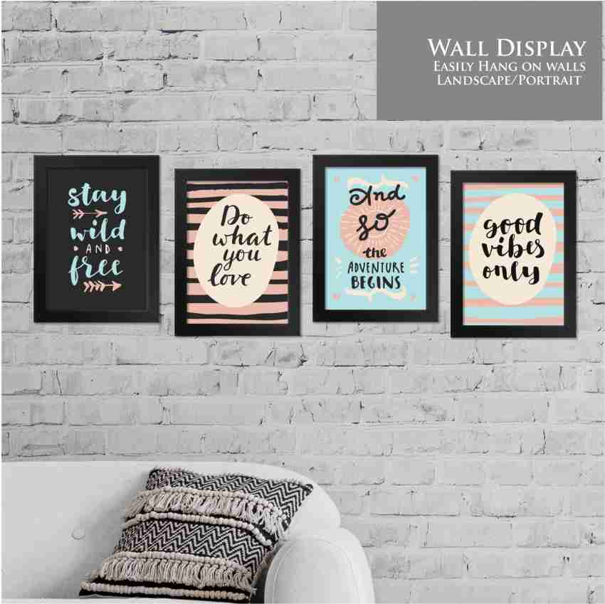

1. I agree with all these suggestions and would add that you should rehang the curtains higher, and get curtains that are long enough to brush the floor.
2. probably not a good idea, they'll touch the base board heater and may catch fire"
3. That's a good point! probably better to keep them a good distance away from the heaters. Would still look better hung higher up, I think
4. My advice for the curtain situation is that each window needs 2 panels, insteqd of the 1 they currently have.

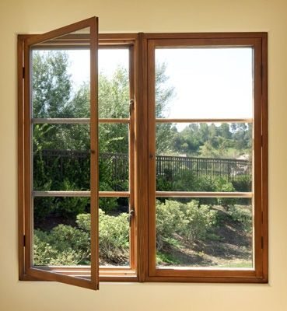

1. Yes, that too!
2. Yes. That\u2019s a good way to fill the space with more light, by bouncing it.
3. My friend and I found a giant framed mirror set out to be tossed, so we took it home, cleaned it up, and our roommate used it as a headboard. Wasn\u2019t the best for viewing her outfit, but she liked it.\n\nEditing to say that it was a small room and it did have great lighting from the windows, but she also had curtains so it wasn\u2019t too blinding.

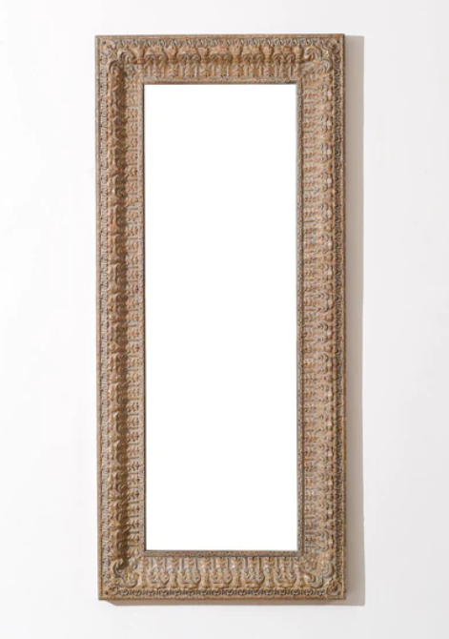

1. If you're up for a DIY here is an simple [bed frame & headboard]([URL] look that I would stain to match the color of your dresser. Maybe make some simple, [small night stands]([URL] Not a huge fan of the carpet, so I would buy a nice [area rug]([URL] that you like to fill up that space. Buy a nice [duvet cover]([URL] in a solid color. Change the [curtains]([URL] to accent the color of the duvet/rug you pick. Make or purchase something that can store your shoes, but is easy to access, similar to [this]([URL] or [this]([URL] Add a plant on top of your dresser for a pop of color.

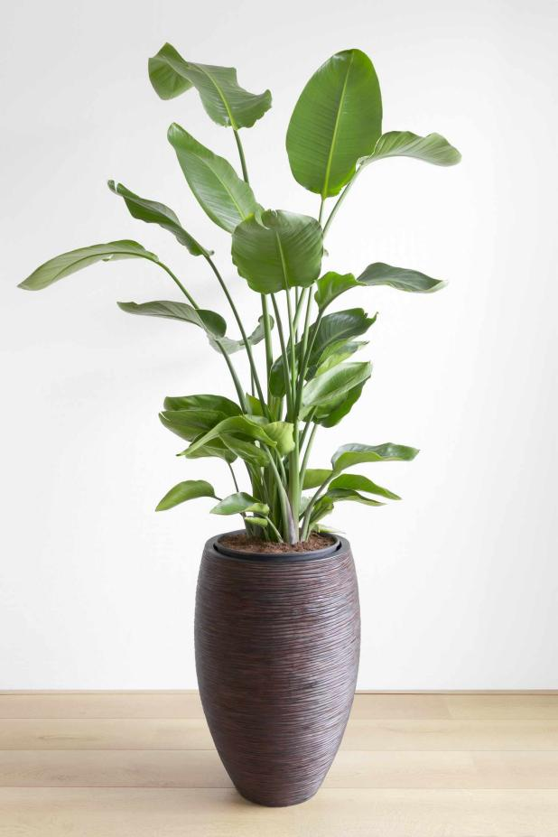 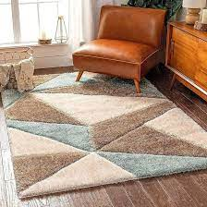

1. Hang art on the wall between the windows that pulls together all the colors in the room. Use the 57-inch rule for hanging art.

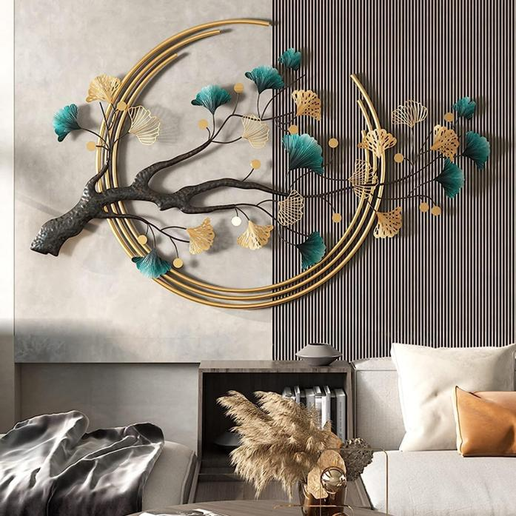

1. What is the 57-inch rule?
2. They use it in museums. Google is your friend. (Sorry, can't link right now).
3. Ah alright, I will use my friend. Thank you.
4. You have amazing sunlight and nice wide windowsills maybe some succulents or other easy maintenance plants in the windows

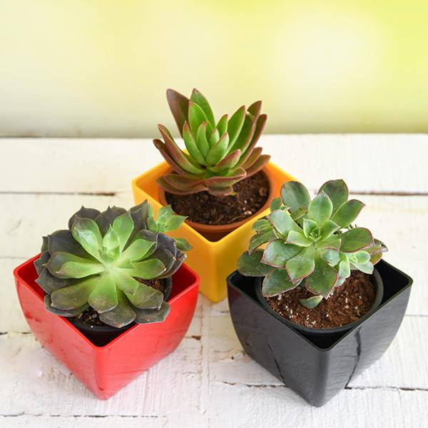

1. I killed my first ever succulent too, if you can drill into your wall I\u2019d say go for a pothos hanging in the corner across from the windows. They\u2019re near impossible to kill
2. Also another thing to consider- you have great light and bare walls- get some art, posters, flyers- anything up and even maybe an accent wall with a fun printed wallpaper? There are all kinds of renter friendly wall papers out there if that what you need

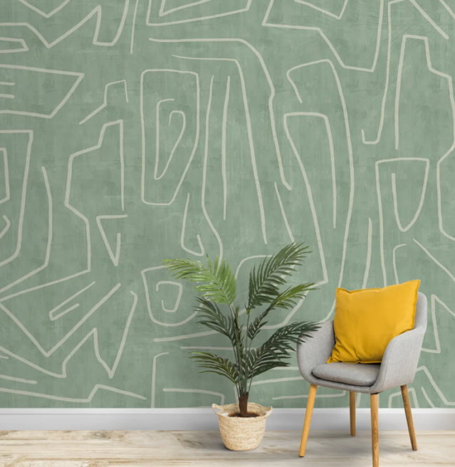

1. I don't know if this is your bed, but I would put a colourful comforter on top of it so it looks tidier
2. It looks like a beautiful flat! My advice is to take it slow, move in the furniture you have and the decoration will come with time - some plants, maybe little pieces of extra furniture, etc. It's difficult to design a room from scratch I find!
3. If you\u2019re on a tight budge, my \u201cbiggest impact for lowest price\u201d suggestion is: \n\n1. First get one of these basic metal bed frame bases from Amazon (I had one for years, was a great buy) which go for about \u00a350-55 ($65) \n\n2. Then get a roll of peel and stick removable wallpaper (so many choices, great for rentals) to DIY a headboard on the wall behind your bed. I also did this in one of my old rooms and you would be shocked at how awesome it can look. \n\nAnd there are a ton of very affordable options out there you can pick from, like this pack from wall pops ($15 /per pack, and you\u2019d need two packs so around $35-40): [URL]\n\nYou can find great sales on this stuff too. Previous bought a beautiful roll via amazon for $18.\n\nFew additional examples here (you can find tons more on Pinterest):  [URL]

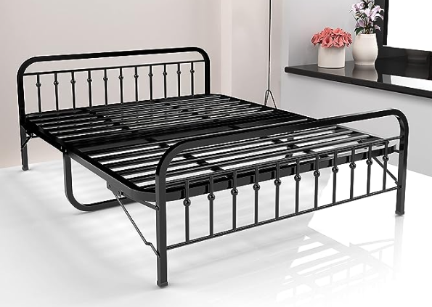

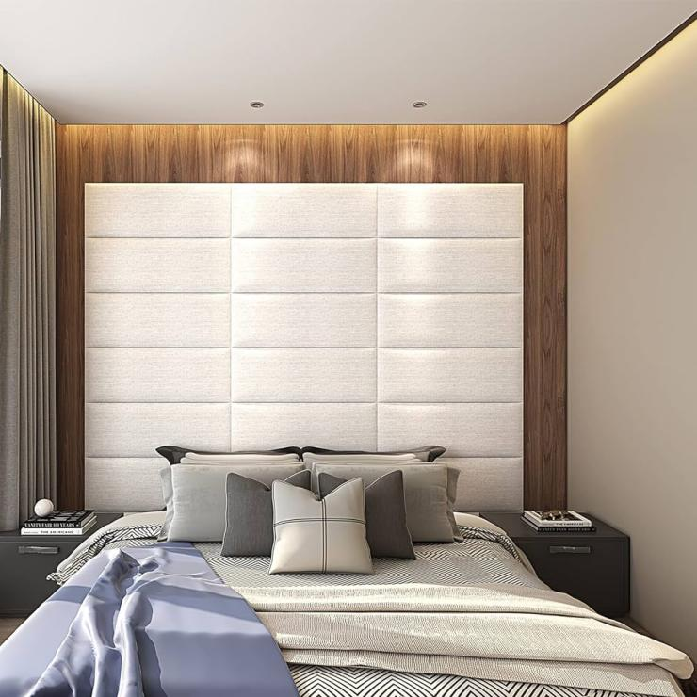

1. About the mirror placement, yes, across from the windows because that doubles the amount of light. \nYou can buy upholstered headboards. Mine was from Costco and not expensive. You will see some very expensive so don\u2019t let that frighten you away.\n\nI\u2019d also suggest that things don\u2019t have to match, like your nightstands, for example. You may find that lends interest. To me matching and symmetry are dull, but some people like it.\n\nDon\u2019t overdo it on anything, like too many plants. You can always add things later.\n\nDefinitely some art on the walls, stuff you love that reflects your interests.
2. I\u2019m gonna suggest something a little out there, but a huge (I\u2019m talking almost the size of the back wall) canvas with colorful art on would do wonders for the space. Temporary wallpaper may be a smarter idea though. Like others said a. Good bedframe, a rug, a mirror and a stool would help fill the room and make it more lively

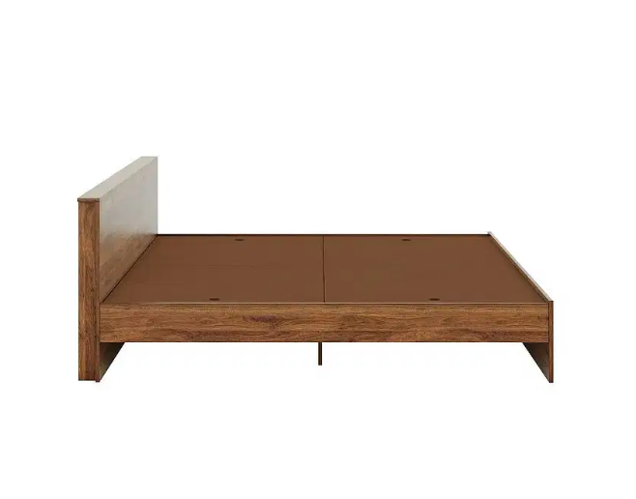

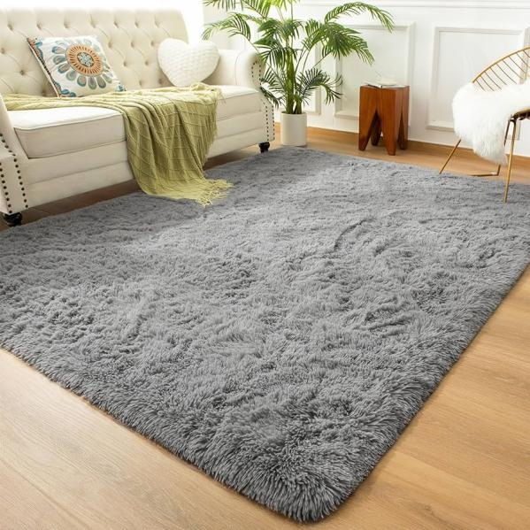 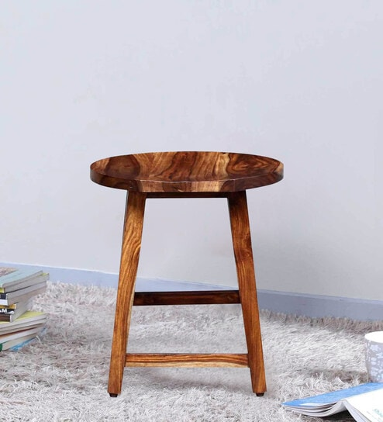

1. A big canvas art piece in lieu of a headboard could also work.  That's what I\"m planning for my room anyways, hahaha.

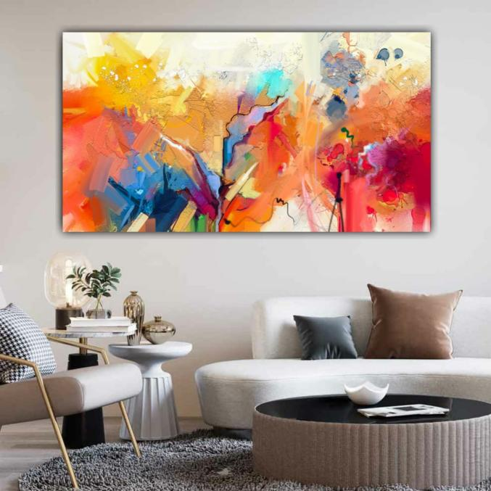

1. For starters grab a bed frame setup if you have the money.
2. Hello! Love that lamp, show case it! \n\nYou need floor length curtains, 2 panels per window. It looks a bit short and bald. Curtains are the eye brows or bangs of the room. Also I\u2019m in the desert and not familiar with those floor heaters, so if not floor length then as long as safely possible.\n\nYou need either a bed or a headboard. Choose this first, then get printed curtains that \u201cgo with\u201d (that doesn\u2019t mean the same as match) the headboard/bed. \n\nThen get a long shorter mid century dresser for the wall opposite the windows. \n\nGet under bed shoe storage containers. And a tall fiddle leaf fog for in between the windows (Lowe\u2019s/Home Depot).\n\nAnd if you wanna spend even more money a large rug that fits with lots of room to spare under the bed. And a simple plain colored duvet. Tan, white, black your choice. And a small side table with a small plant on top for the space where the lamp is now.

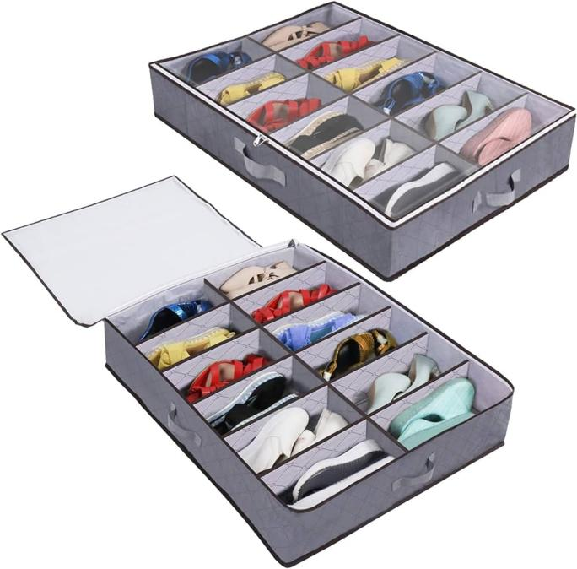

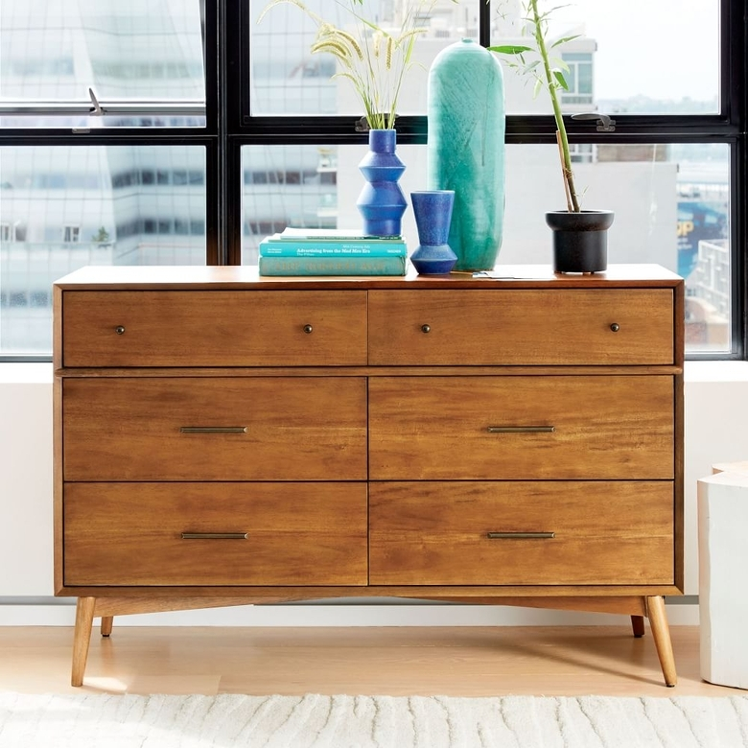

1. I know it's a bit different from other suggestions, but I'd suggest rotating the bed 90\u00b0. The way the room is now, if you walk or look in you immediately see the entirety of your bed and that's where the eye goes to first. If you put the top of the bed against the wall with the door, a first glimpse into the room only shows half the bed, but the eye goes towards the windows instead, making the room look bigger and probably neater.\n\nI'd personally do that first and then work on everything else from there. It would give more space, apparent neatness, and just a touch more privacy. You'll also have an outlet right next to or behind the top of your bed.\n\nFrom there, a bed frame (I got a Zinus upholstered grey one that was not super expensive but it's been amazing), a small bedside table or two (depends on your relationship status I guess), and for the mirror suggestions you could hang an artistic mirror above the headboard of your bed to bounce light.\n\nI'd also suggest a tall but square bookcase for the far corner next to the windows - no need to drill into the wall to hang a plant, just put them relatively high and close to your window on a shelf. \n\nAs for your dresser, if you still have the AC unit I'd move it to the far window and put the dresser under the first window possibly. It would block some light but it would be a good place for watches, keys, etc without being too close to your bed (making it more accessible). The way the dresser is in the current room, it creates a tight walking space and a pretty inaccessible corner as well (while also detracting from how nice your dresser will be). It's that, or I would shift your bed over and possibly put it on the far wall. I think it comes down to putting your bed how you see fit, and walking around the room a few times wiggling your hips everywhere to see if you hit into stuff (to simulate when you are tired or something).

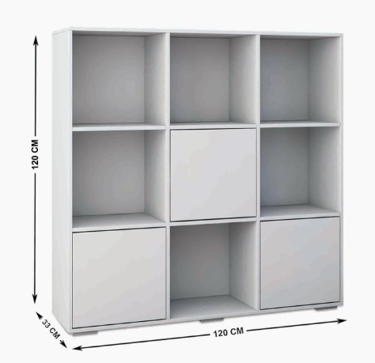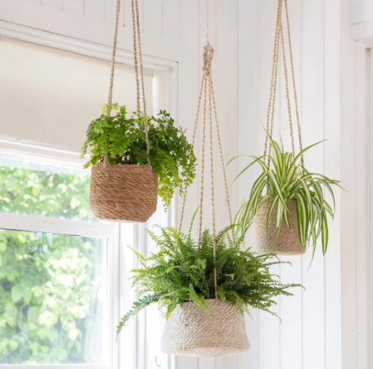

1. I'm glad you like the suggestions!\n\nI don't know how long you plan to be there, what you like in a room, or how much money you are willing to spend, but let me know if you have any concerns or thoughts! To me a lot of suggestions are a bit superfluous in my eyes (like you don't need bedside tables with lamps for a place you are renting for a short time) but your design needs would obviously be different depending on those factors. \n\nAlso this is the [bed frame I got]([URL] it's a big more expensive than a diy, but it's lasted perfectly over the past year I've had it. Plus everything packs into the headboard, so if you move again soon it's not too much of a hassle.
2. Don't go crazy buying decorations just to fill up wall space or knick knacks to make vignettes. Wait until you've been in the space awhile and pick up things that you really love. This is probably a temporary home for you so don't pick things that are perfect for this space but that you won't like once you move. \n\nUse pinterest, instagram, houzz, to find photos of bedrooms that inspire you. Notice the styles, cllors, themes, that appeal to you and use that to guide your choices for bed frame, bedding, storage, curtains, and lighting. \n\nWhen it comes to lighting, I like to use daylight bulbs in the main ceiling fixture but incorporate warmer lights through sconces, lamps, or even something like fairy lights if that fits your vibe.\n\nIf you post an inspiration album along with what your needs are (desk? More clothes storage? A tv? Etc). People could make more specific recommendations.

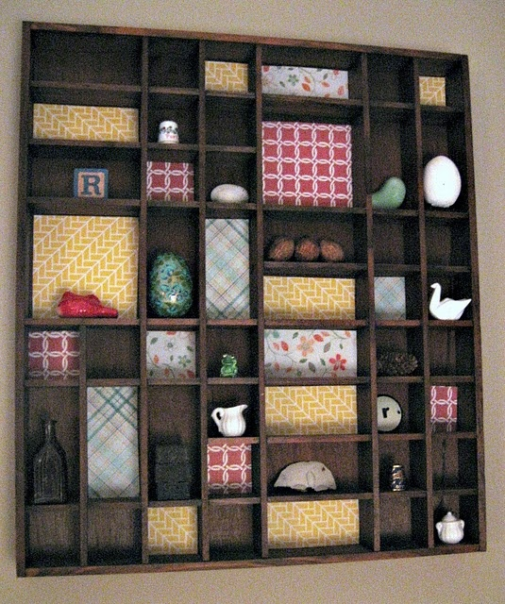

1. GIANT PRINT over the bed.
2. Not sure if your open to actual furniture but as is; put the bed balanced between windows. Move chest to opposite wall. Really what you need is a headboard & a y\u2019all 5dwr chest. And that\u2019s minimum. Have fun!\ud83d\ude03
3. Make the bed nicely - fold the top for effect, fluff and prop the pillows up, put a tall mirror by the left side of the bed, face the lamp towards the bed properly - like a plant with leaves in the way you want them to go almost, tidy the dresser put a plant on it, a piece of decoration \ud83d\uddbc in the middle above the bed, buy a collapsible ottoman for the end of your bed, stick your shoes in it.\n\nImprovements: get a couple of euro pillows to act as headboard, decorative pillow with pops of muted shades of the curtains, more sophisticated duvet with a few muted colours, bedside tables.

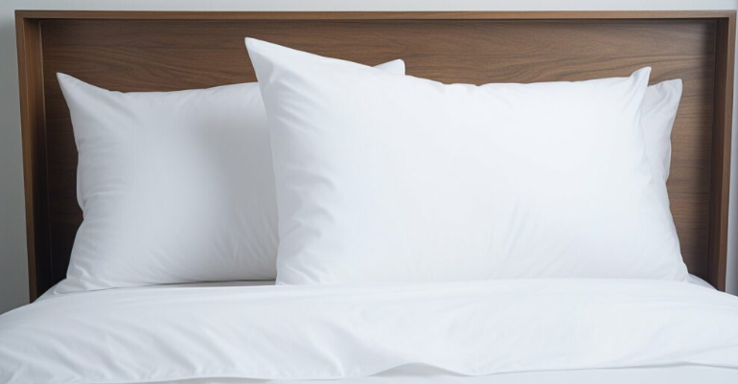

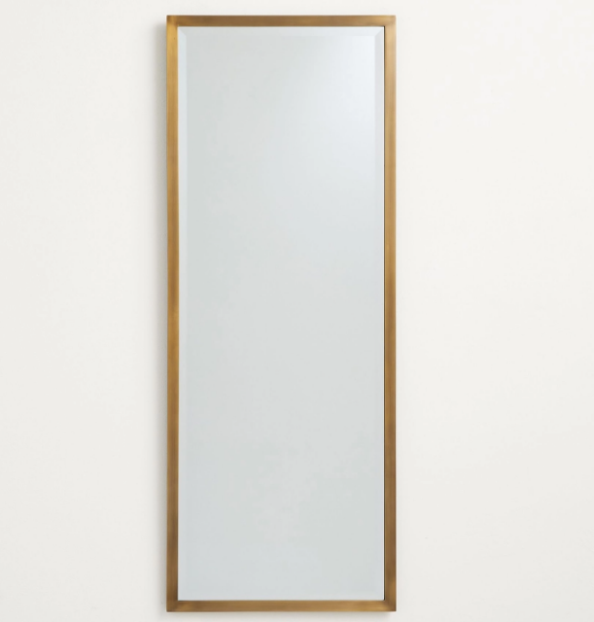

1. Look online for 2nd hand ikea items.\n\nNot having shoes and a dirty pile of clothes next to the bed would probably help too.\n\nTry a different bedroom arrangement. Have blankets and sheets that fit.

 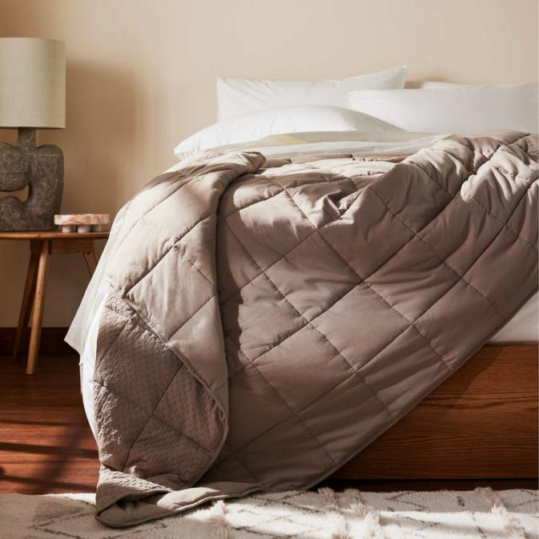

1. Wall art!

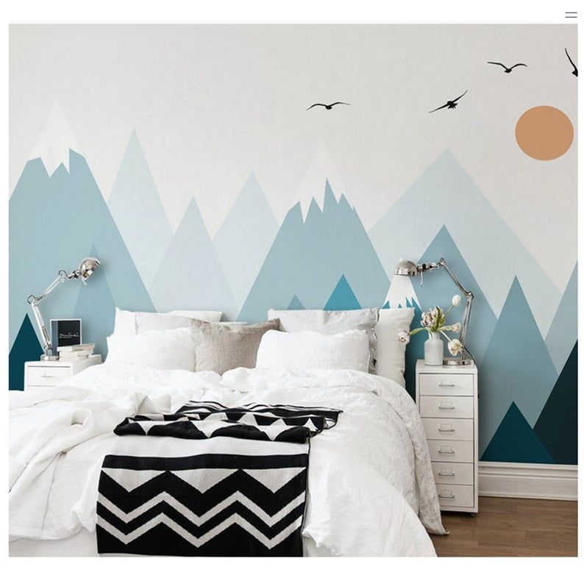

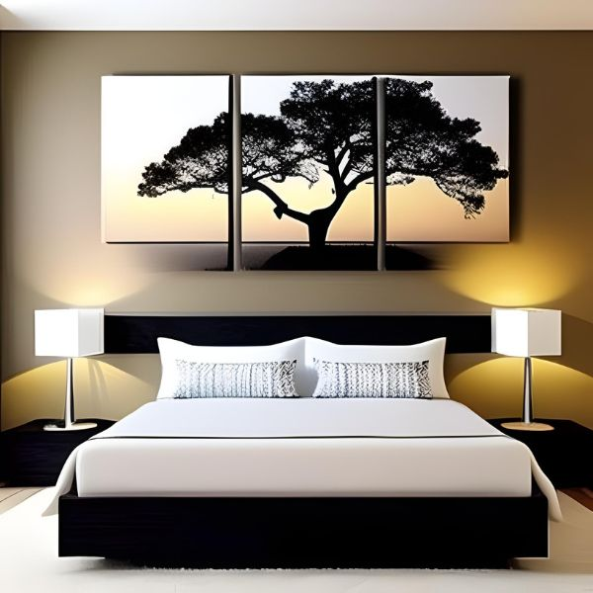

**Post 33 (Line 12932)**

**.**

**.**

**.**

**.**

**Post ( Line 937548) last 1**

**Url : https://i.redd.it/gwduew0kaj571.jpg**

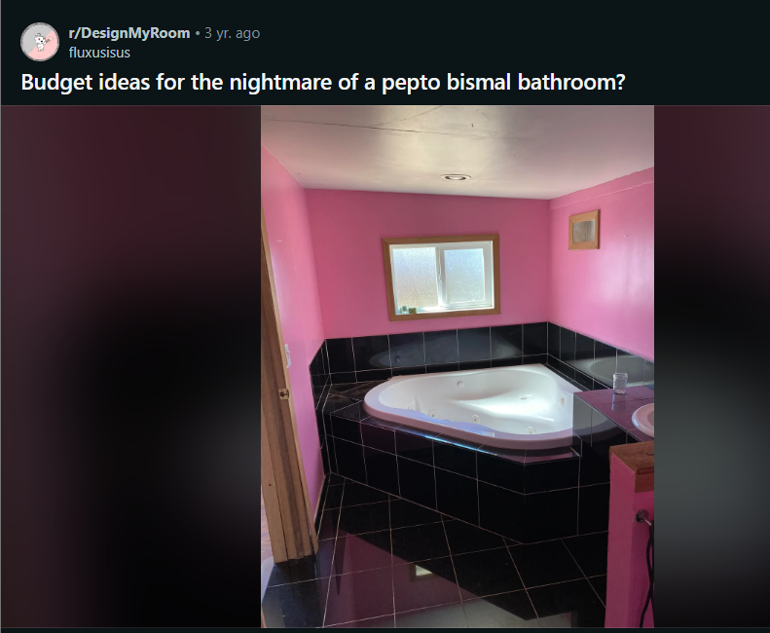

Comments :

1. I think painting over the pink alone will be a drastic improvement. I would recommend throwing a large, cute towel or bath mat over the side of the tub to break up the black. \nOn a positive, looks like the room has amazing natural light! If you\u2019re a plant person, you could put plants along the side to break up the black too.

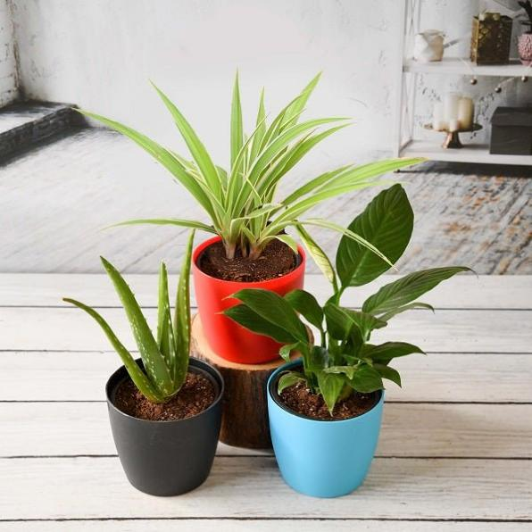

1. Just painting it white and a large plant in the corner would do wonders.

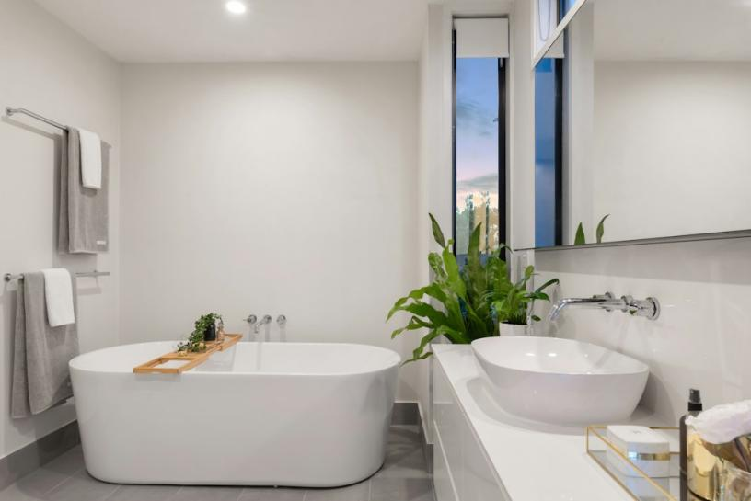 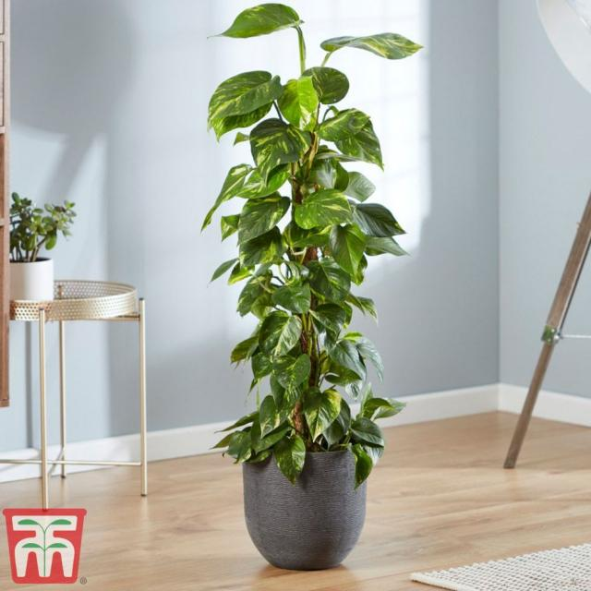

1. Haha - seems like the last owners really tried to make a statement! I personally would go classic white \u2014 black and white bathrooms look great in any style, including retro, modern, and would be a nod to the 80\u2019s homage. \n\nJust had another thought - a circle bath mat would break up not only the black, but also all the squares -[Example]([URL] showing a circle mat draped on the side of a tub.

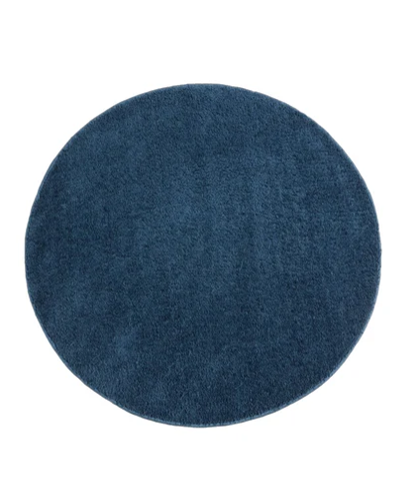

1. So we can blame the kids for the pink, but what about the high-gloss black tile? Is there an 80s Italian mobster I can blame for that?\n\nI do think white paint and plants will make a huge difference in the room. I also really like the natural wood trim despite it being a risky choice in a bathroom. Maybe try and find some natural accessories, like a wooden towel rack or shelf, and a wooden or faux wood soap dispenser. \n\nThough I do think I would un-frame the vent. That\u2019s a little odd.

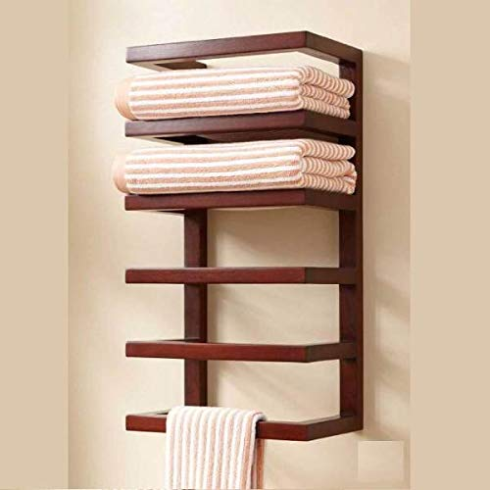 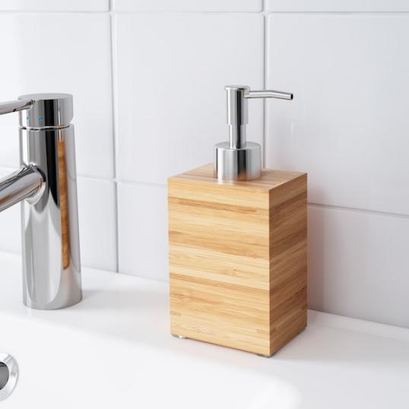

1. White walls with gold accent wall decor would look fun and modernize this!

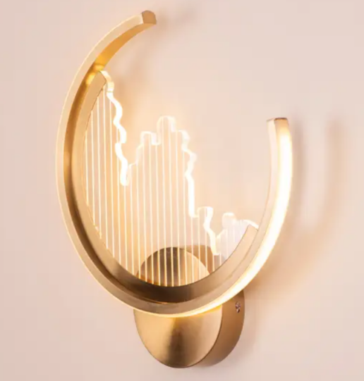 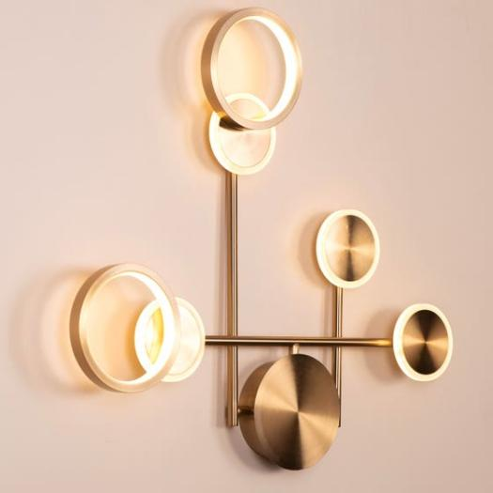

1. I mean, Nagel in the 80s was a good vibe...but paint the walls and trim white and get a different mirror. That cantilever set up is awesome.

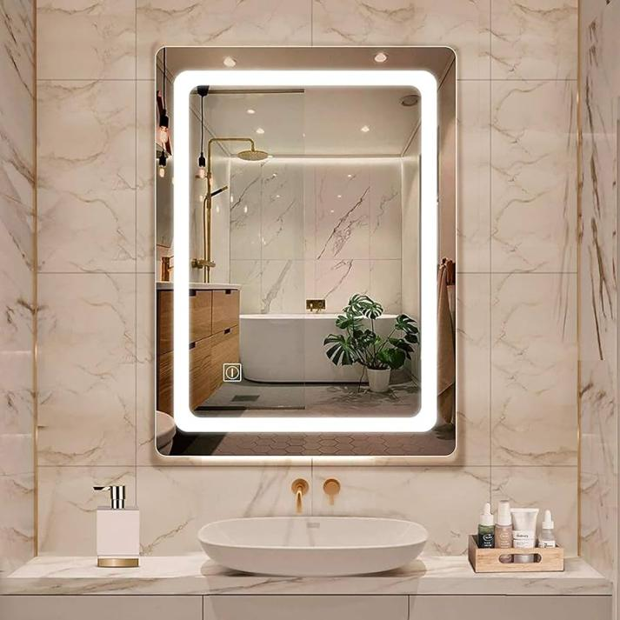

1. Was gonna say this myself. Paint the walls white, because you cannot look at pepto walls every day..but some retro nod to Nagel...yes! You'll find plenty of Nagel prints at the local thrift. Change out the cheap frame tho. Maybe add towels or rugs in mint green. Could look really neat!

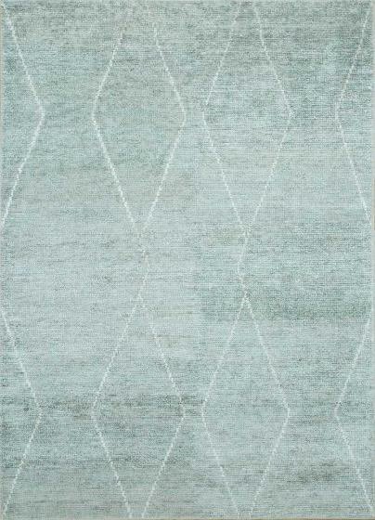

1. Lol. You had me at black panther statue.
2. Work with it and go for a synthwave look
3. I think a cheap, easy way to keep the tile and make this bathroom look more current would be to go with a mid-century vibe, which is popular now. Paint the walls white, get white bath mats to bring white down, and get touches of black decor on the walls to bring that up. Natural wood shelves (think like walnut tone), brass hardware, globe style sconce lights, etc

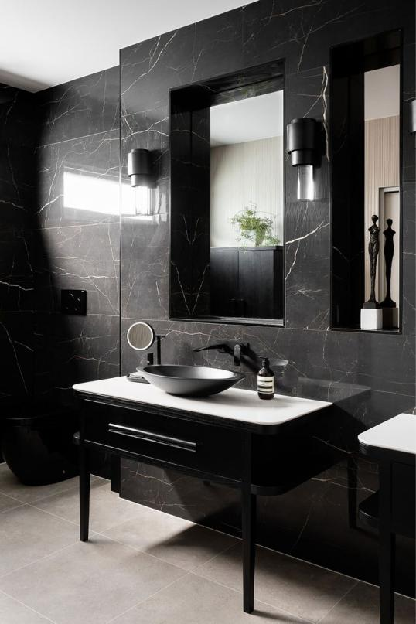 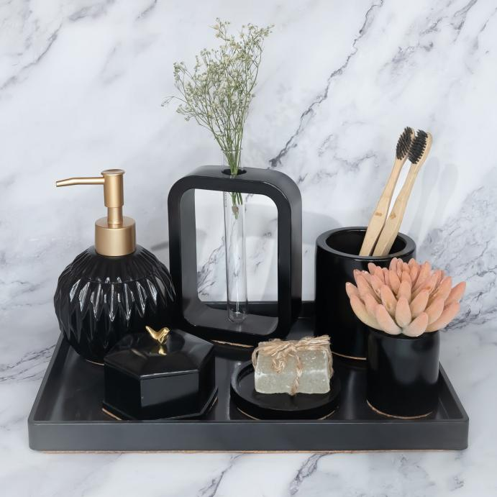

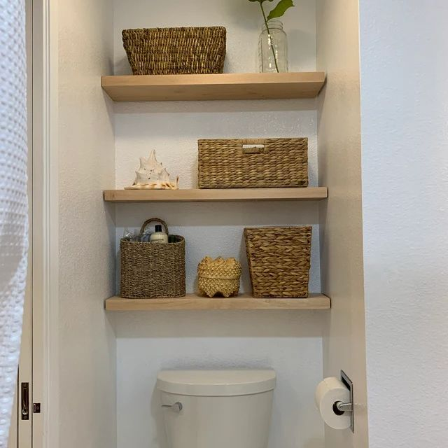 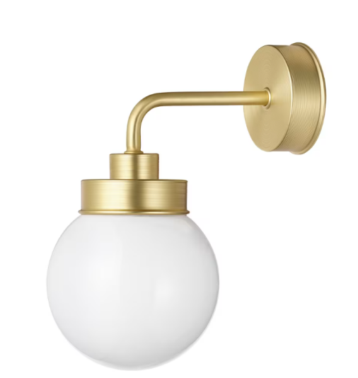

1. Everything pink should be painted a neutral color. If you choose to paint it white, consider adding some modern wood tones to tone it down, starting with cladding over the half wall between the toilet and sink.  Along the tub area, either a 4 inch wide plain chair rail just above, or a 'picture ledge' about 1/2 way up the wall on which you can put pictures or other decorative items.  New mirror and light combo.
2. I\u2019m not the person whose comment you\u2019re replying to, but I was going to say a round mirror with a black rim.  Even just painting and getting rid of the medicine cabinet will make a huge difference.  And like others have already suggested, some wood toned shelves would look nice too!



1. Neon sign, remove wooden stuff, greek pillar in the corner, small plants scattered. Vaporwave heaven right there

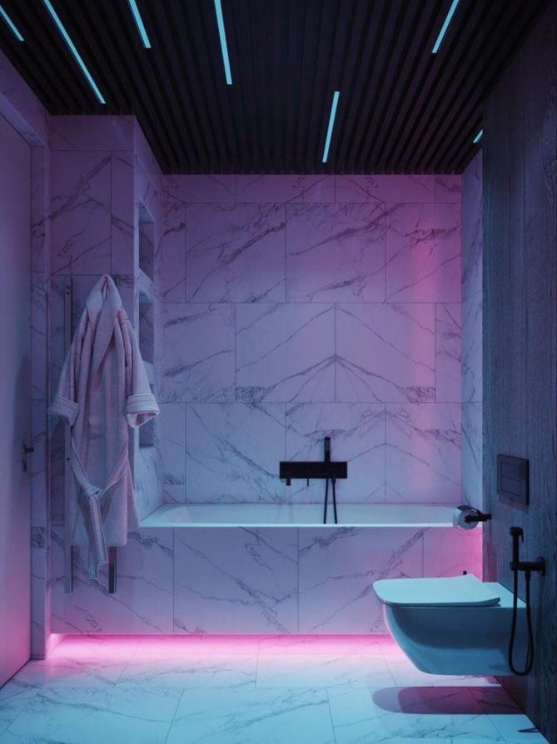

1. it's cool, cyberpunk-ish
2. +1 for keeping the pink and going all out! Tropical plants, statement neon/pastel candles and bath mat/hand towel. FUN!
3. I feel like the tile could be a really cool element if you changed the paint, added some curtains and maybe a couple hanging plants in the corner!



1. I'm with the others, paint the pink either to white (which might make the vanity mirror work more) or a warm gray. Really any soft muted tones would work for you. If you don't want a fake plant and maybe don't want one that will require a lot of upkeep maybe try a sansevieria? Super simple plant that is pretty hard to kill but will add Life to the mix.\nIf you have it in the budget change out that mirror/light combo to something more modern. Maybe: [URL]\n\nSince you seem to have no storage, maybe some storage under the sink or above the back of the toilet might be useful? \nHere's a simple cupboard from ikea that might work well under the sink: \n[URL]\nOr if you don't mind open shelves: [URL]\nHere's an over the toilet option in black that would go with the tile \n[URL]\n\nHere's another idea: since the door jamb is a brown wood, if you kept that and painted the walls white or another pale colour you could add more bits of brown for accent, to make it seem like a purposeful choice. \nHere's a chair/towel ladder combo in bamboo: [URL] or, you could try brown shelving underneath the sink:  [URL] ( flip through the ikea website pictures for the product placement photos for a better idea of how it would look in a space)\nMy default is IKEA since it seems to be in alot of countries and I'm not sure what your budget is.\n\nGood luck with your remodel! You've got this and whatever you decide, it will definitely be better than it is now- even if you do decide to go full 80s. Send photos of the leopard statue if you do! Maybe: [URL]

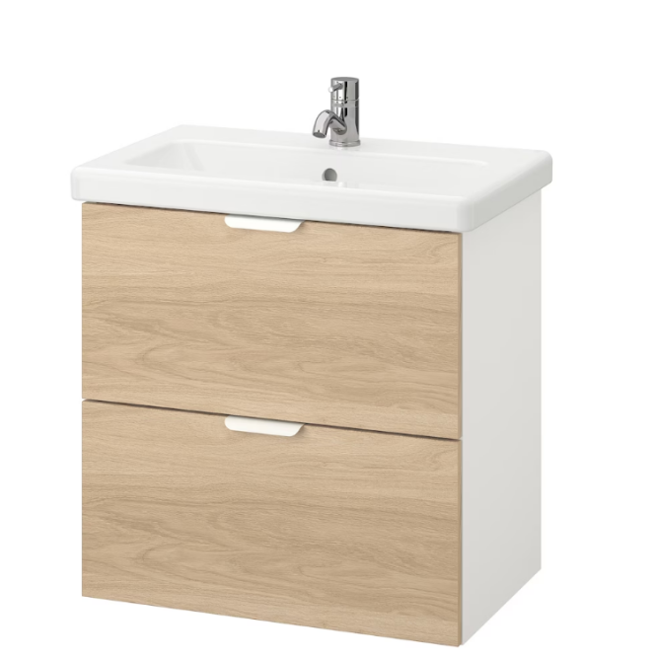

1. Pepto Dismal.
2. Pepto Dismal.
3. Have you thought about a dark, emerald green instead of the pink? Restaining the wood accents and adding gold trimmed mirrors would give it a rich, high-class look.

 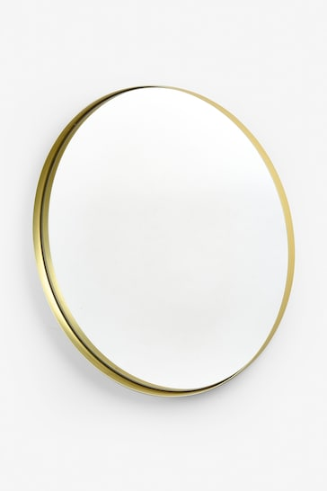

1. I just have to say I loovvee the pink, if that were my house I'd just be keeping it as-is and just adding some gold colored hardware, painting the wooden bits white,, add some plants, maybe some teal rugs or wall art.... but it's definitely a bold style, not for everyone I guess

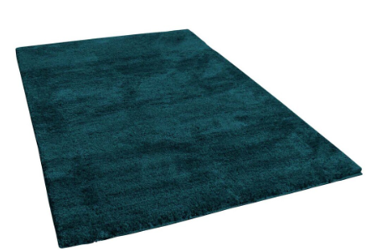 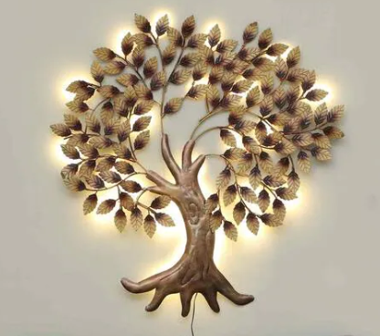



1. So pleased to see how many people feel that the mirror and paint are the main problems\nA and everything else can be made amazing.
2. I think you have gotten some great suggestions here, but I thought I'd throw my 2 cents in since I haven't seen this mentioned. Personally,  I would consider staining the grout black as well. I feel this would tone down the squareness of the tiles and make everything more seamless. I think the suggestions of white walls, gold accents and plants is great! I think some other natural elements such as wicker storage, wood, and je would also help warm up the space

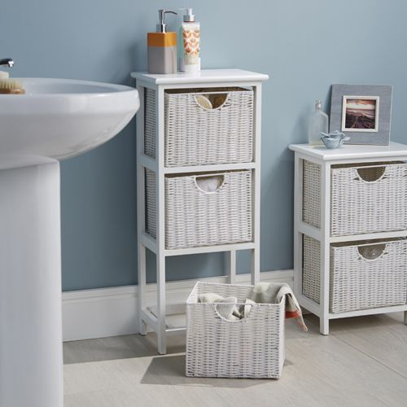

1. the ideas here to paint white over the pink (and the trim) and include gold elements seem like the best.  \n\nI'd also consider a charcoal or black grout stain instead of the present color.  I think it could help it look a little more modernized if the grout lines are less noticeable



1. how would you feel about a [Tub & Tile kit?]([URL]  the bathtub tile and countertop tile can be painted a nice clean white colour, and you can paint over the pink with any colour....but pink.
2. Yes, I just watched DIY Danie paint her tile on her YouTube channel
3. Oh sweet Jesus, tell me the *grout* isn\u2019t pink!!!
4. Paint pink wall. Add plants.
5. Knock it down and begin again!
6. 1) Change the pink to white.\n\n2) Add plants since it seems like you have good light.
7. I like this, honestly haha ^^ before you paint it, maybe see if it can grow on you
8. someone thought that looked good : /
9. I like the black tiles
10. More like pepto abysmal
11. Add gold; make it bold.
12. Lean all the way in? I don't actually hate the black tile and the solid wall color idea, it could be really cool and vaporwavy! Throw some statuary in there and brass fixtures and go really 80's with it.

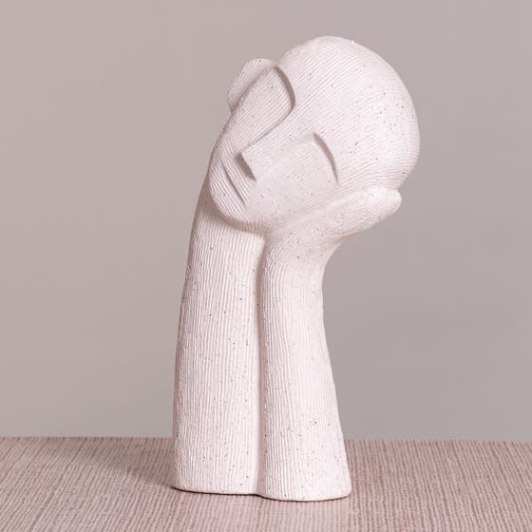 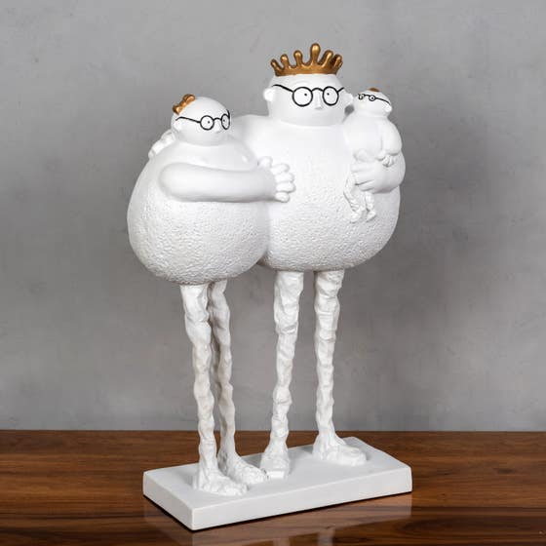

1. It looks perfect
2. Please post a before and after!\u2014I feel like this bathroom is going to be totally transformed with a couple of small changes recommended here, either repainting or leaning into the 80s vibe. I also love a budget reno, so great to see what you can do with a space when you work with what\u2019s there.
3. Fill the tub with actual pepto as to turn the tile into an accent!

**Post (Line - 937199) last 2**

**Url : <https://i.redd.it/sbqk65awyuw21.jpg>**

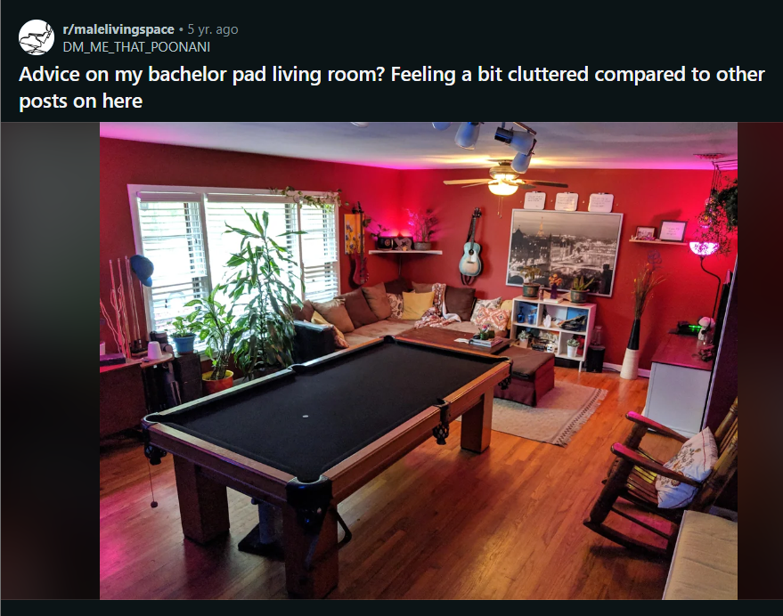

Commets :

1. I think the red paint is too bold for that room. I think a more calm, neutral color would calm this space down a lot. \n\nThe white storage cabinet looks like it\u2019s a little cluttered/busy. Can you move some things out of there?\n\nThere\u2019s a lot on the walls that doesn\u2019t look like it was placed purposefully. The white boards should not be decor. \n\nWhatever\u2019s on the left looks like it\u2019s taking up a bunch of space. Do you need those things or can you find a new home for them?\n\nThe rocking chair seems out of place both in physical placement and style. \n\nThe pool table is taking up a significant amount of space in your room, and looks out of place for what I assume is a living room. Is there another place you\u2019d be able to put it?

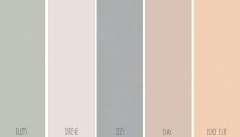

1. I think if you painted the walls a lighter color  like the white the mural is on it will make it feel bigger. You could keep the red on the tv wall and where it wraps around to the mural. I would also pull the corner shelf down above the couch and the one to the right. You could hang some narrow pictures or reordered them. I usually try not to have pictures wider than the credenza or book shelf below it. Or condense a lot of that into one area like a larger book case or one area of shelving but you need to free up some wall space and lighter walls.
2. I think it's an awesome space with lots of personality...busy, but not haphazard; seems like the kind of space that a very entertaining and/or interesting person would occupy, and a place I'd feel very comfortable hanging out in. Nice work! \ud83d\ude0e
3. Not a fan of the red paint for the space you have. Also it doesn't seam as though you put much thought into planning out your layout. Do you spend time looking at furniture, blogs, and other posts here before you purchase items or did you just throw it all together as you went?
4. Seem*
5. thank you spell check.
6. Personally l love the red walls and the mural. It's bold and works. Only real issue for me is the couch which reminds me of /toomanypillows. But looking at it you don't have any backing to the couch so it is more of necessity.
7. Maybe I could buy larger rectangular pillows and then have half as many on the couch. I'm with you that it looks cluttered like that. Really don't like the couch at all but it fits physically in the space more than most couches I've looked at



1. This room seems like a reflection of someone cool and interesting I would want to hang out with! But I deff agree that you could do a lot with this room.\n\nFirst I would declutter as much as you can and anything that can put in another room do so.\n\nI see that your moving the sentimental rocking chair to your office, awesome. Are those graduation frames on the shelves? If so maybe hang those in your office as well. \n\nI would hang the pool sticks onto the wall next to the low white shelf (that\u2019s next to your couch) \n\nYour hat and sunglasses I would have displayed nicely next to your door as if your exiting you can just grab and go, get them off your lamp and pool sticks it seems cluttered. \n\nDeff repaint all the walls a neutral color minus the one tv wall. It could be a light gray or a white  , doing so will make the room seem bigger, less busy and it would make those color bulbs pink light look better, right now pink and red is just an odd color combo. \n\nYou have a corner shelf and regular shelf (next to the couch) I would just have 2 matching flat shelf instead, (actually do 3) and have them vertical.  On a wall, maybe on the other side of that painting where the couch is. \n\nDeclutter declutter declutter lol\n\nTry to move some plants out, especially the one hanging on the ceiling, move it outside or to the kitchen. \n\nRemove the white boards, or if you want them replace the painting they are sitting on top of with a white board that size. Can be cool for friends to leave notes / keep score. \n\nTry to have like things together to have it seem more organized. \n\nKeep us updated OP would love to see the update and what else we could do further to the room!!



1. \tThank you! Cool, interesting and someone people would like to hang out with is exactly what I was trying to trick people into believing... I mean just what I was going for.\n\nHaha! \n\nNot sure, I think the best bet is to make a new post with the \u201cupdate\u201d and then in the comments have an Album with the rest of the photos showing before / after
2. I get that you want to keep the paint so I'm not going to comment on it, but I def would at last make sure the lampshades are all white/clear. Other thoughts: I'd recommend removing that corner shelf, the white/black cone shaped planter, that small shelf above the planter. The white shelving is good, but the colored images (maybe they're records?) adds to the clutter feel. I'd hang the guitars together one slightly higher than the other. Mount the cues under the pool table. Is that a golf bag next to where the cues are now? That goes in the garage. Smaller coffee table or just keep the foot stool and put a tray on top to hold drinks/food. Plants are nice but use them as decor - like, one of the tall ones next to the TV, one on the opposite side of the mural from the rocking chair.

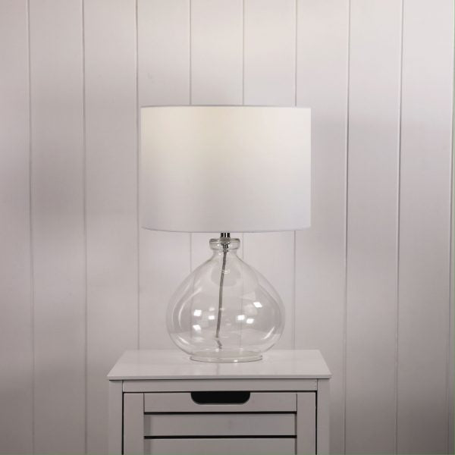

1. Get rid of the plants. They don\u2019t fit with the room and they\u2019re cluttering it up. Contrary to this sub\u2019s mantra, I don\u2019t believe plants belong in literally every living space.
2. Dude, that mural is fantastic! Do you have more photos of it?! Did you seal the charcoal and how did you prep the wall to be drawn on?\n\n  \nYou are right about the cluttered feeling. I think it has less to do with the arrangement of the furniture and more to do with all the other stuff in the space. The smaller stuff just creates a lot of visual noise. I'd try to pair down that stuff.
3. It's not an original. Its a Picasso\n\n[URL]
4. Yea, I'm aware it is a Picasso that he drew on his wall

**Post - last 3 (line 936926)**

**Url : <https://i.redd.it/nw2flr520xy41.jpg>**

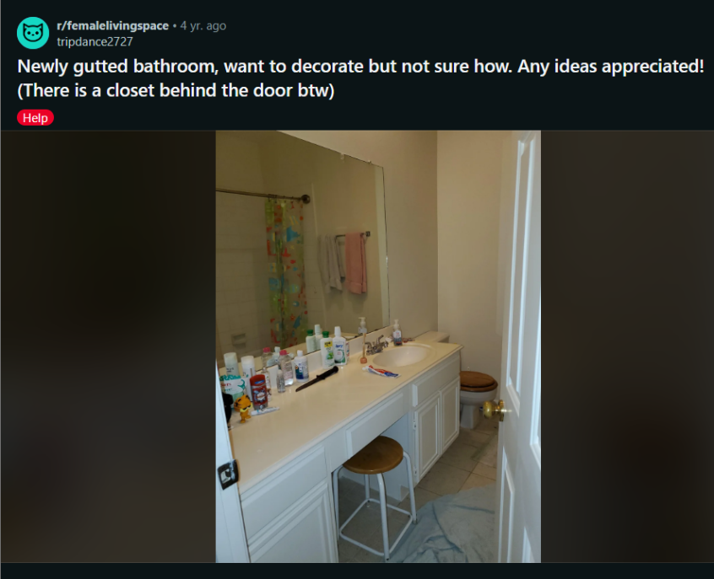

Comments :

1. Definitely keep the poop knife

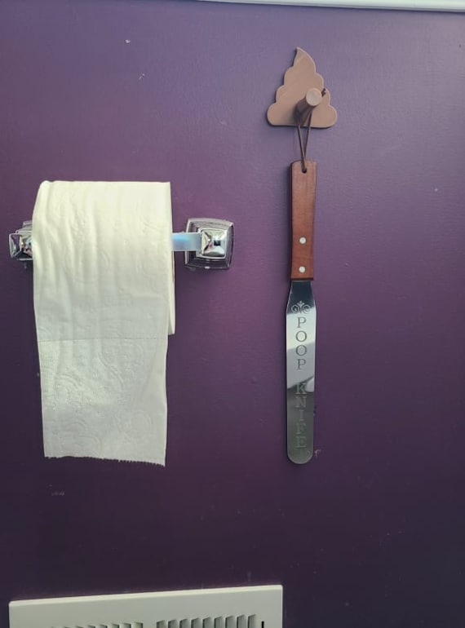

1. Good start! I would replace the toilet seat, paint the walls a bold color since your cabinets are light and decorate from there. Personally, I prefer less clutter and would opt for storing anything other then decor in drawers or whatnot.

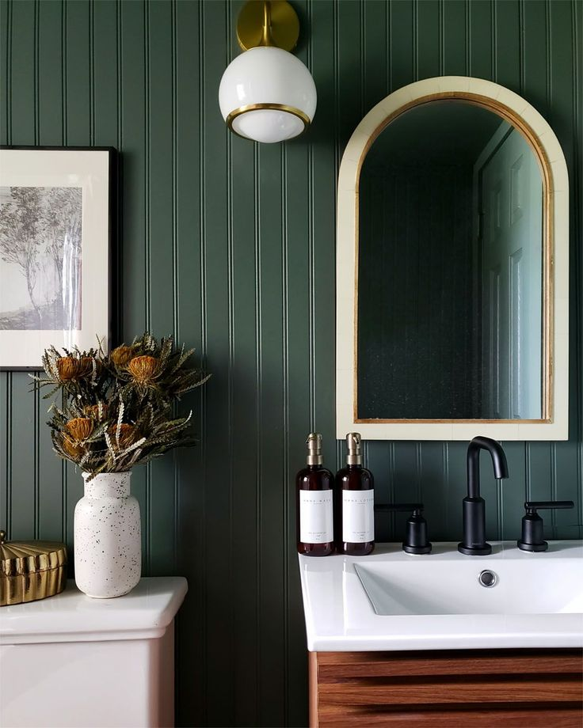 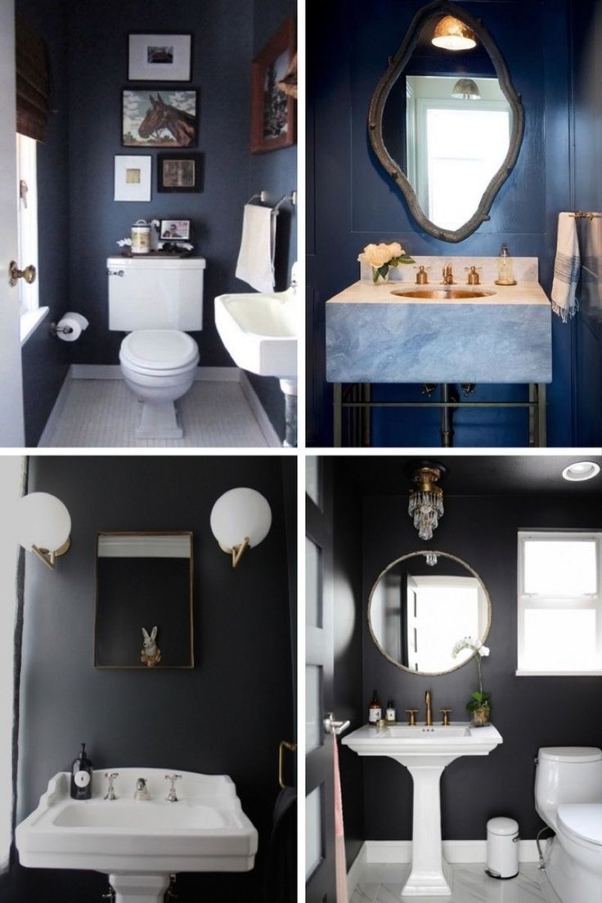

1. Is that a poop or a toe knife?
2. 1. Definitely de-clutter the counter, you have drawers for a reason!\n2. If you want to spend the money you could get a better looking mirror for over the sink.\n3. A simple and classy shower curtain would be a nice easy improvement. \n4. A few balanced art pieces. \n5. Rug. \n6. Some shelves above the toilet would look nice. For decoration!!!! Not to be cluttered. \n7. New toilet seat. That one really dates the room.\n8. Better looking towels.\n\nSearch \u201cbathroom decor\u201d on Pinterest! There are some great ideas to scroll through.

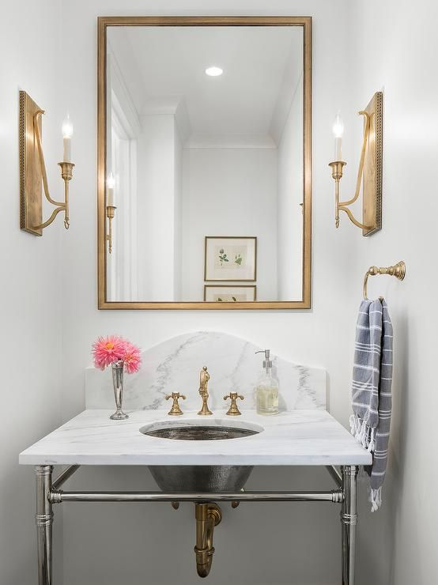 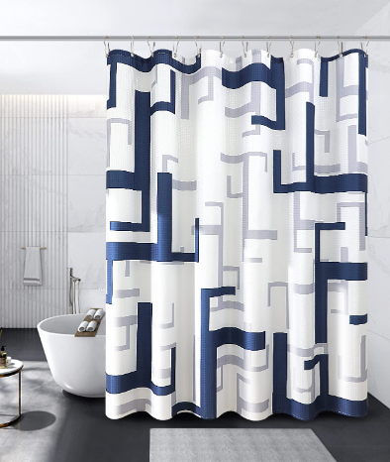

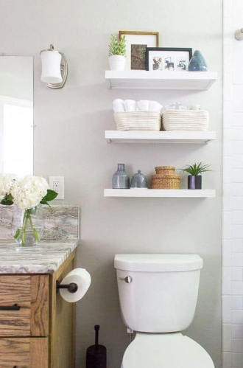

1. Substitute rug for bathmat and I agree.\n\nOnly things on the counter should be pretty.\n\nEither shelves above the toilet, but I'd prefer artwork on the walls behind and beside it.  My eyes went first to that corner before taking anything else in.

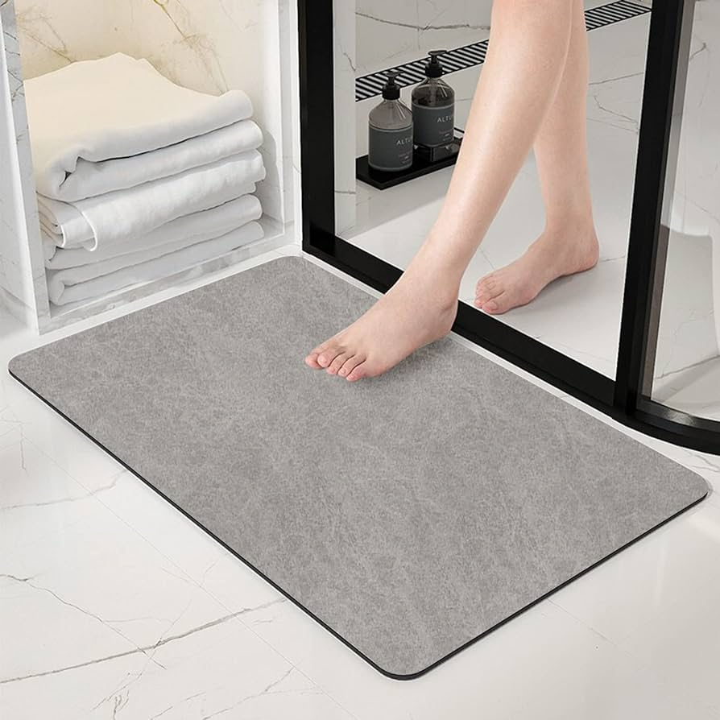 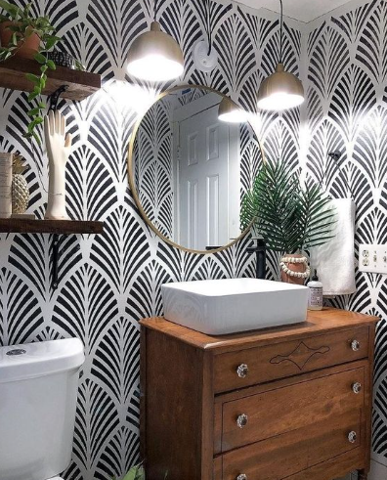

1. I have glued wide (prepainted) moulding on a frameless mirror to dress it up. Economical fix from your local Home Depot type store.\n\n\n[URL]
2. Get the bottles off the counter to either under the sink, or some sort of storage on the counters. You can remove the large construction grade mirror and switch it out for two framed mirrors, one for the sink and one for the vanity area. You have a blank canvas for the paint and decor!

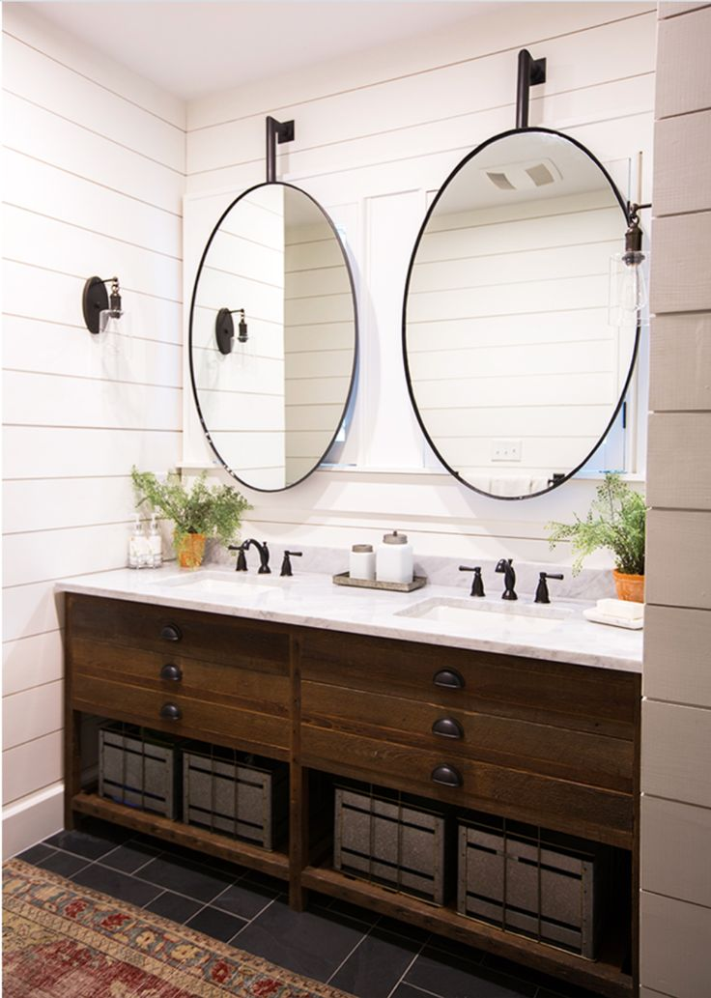

1. Even a nice wooden box or basket on the counter would work. You said there\u2019s a closet behind the door. Can you put all the counter stuff there?\n\nThen add matching new towels, replace the toilet seat lid, and a large framed print above the toilet. Some nice hand soap dispensers wouldn\u2019t hurt.

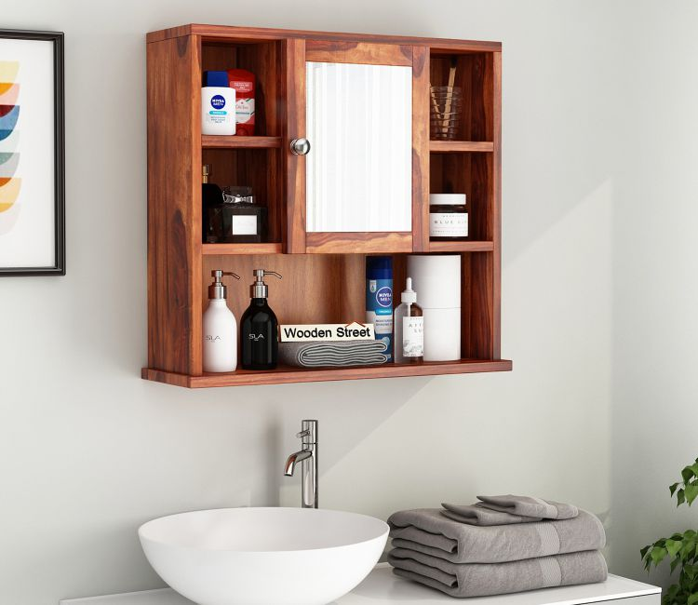 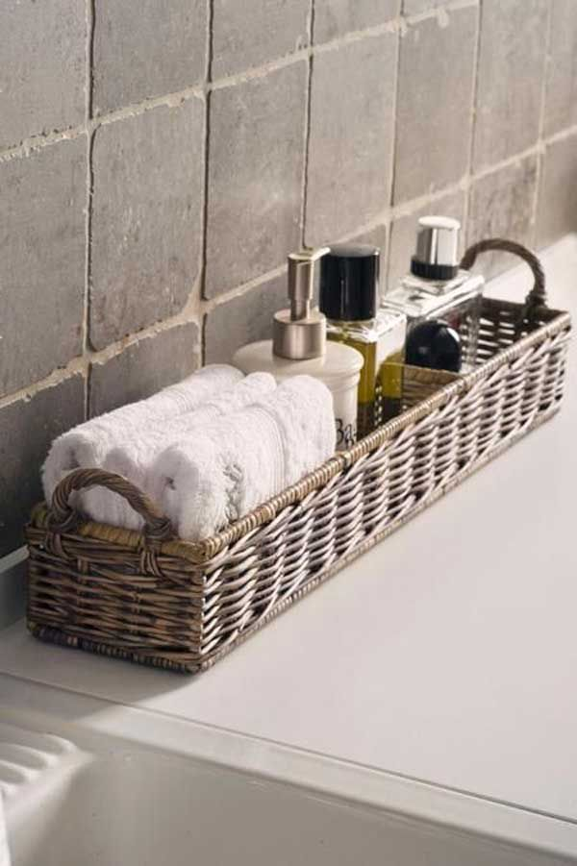

1. I was coming to mention many of the same above suggestions but a few more ideas I had :\n\n1. Yes declutter. \nI would eliminate the stool under the counter and add a laundry basket or create simple shelves for basket storage. \n\n2. Yes frame around/on top the mirror (I've done it using a double sided foam tape from the dollar store before and it worked well. just ensure you paint both sides of any wood you choose as there is a small 1mm gap between the wood and the mirror which is reflected).\n\n3.Lower the towel bar and add new towels to match your new classy shower curtain\n\n4. Paint or wallpaper a fun colour/pattern (but not too over-the-top unless you're committed to changing it again if you ever want to sell/move. \n\n5. Decorative details such as art or plants would add interest. \n\n6. For a few bucks more, add hardware to the cabinetry which you could find fairly inexpensively on Amazon.

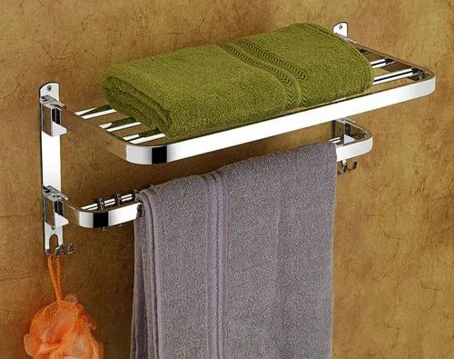 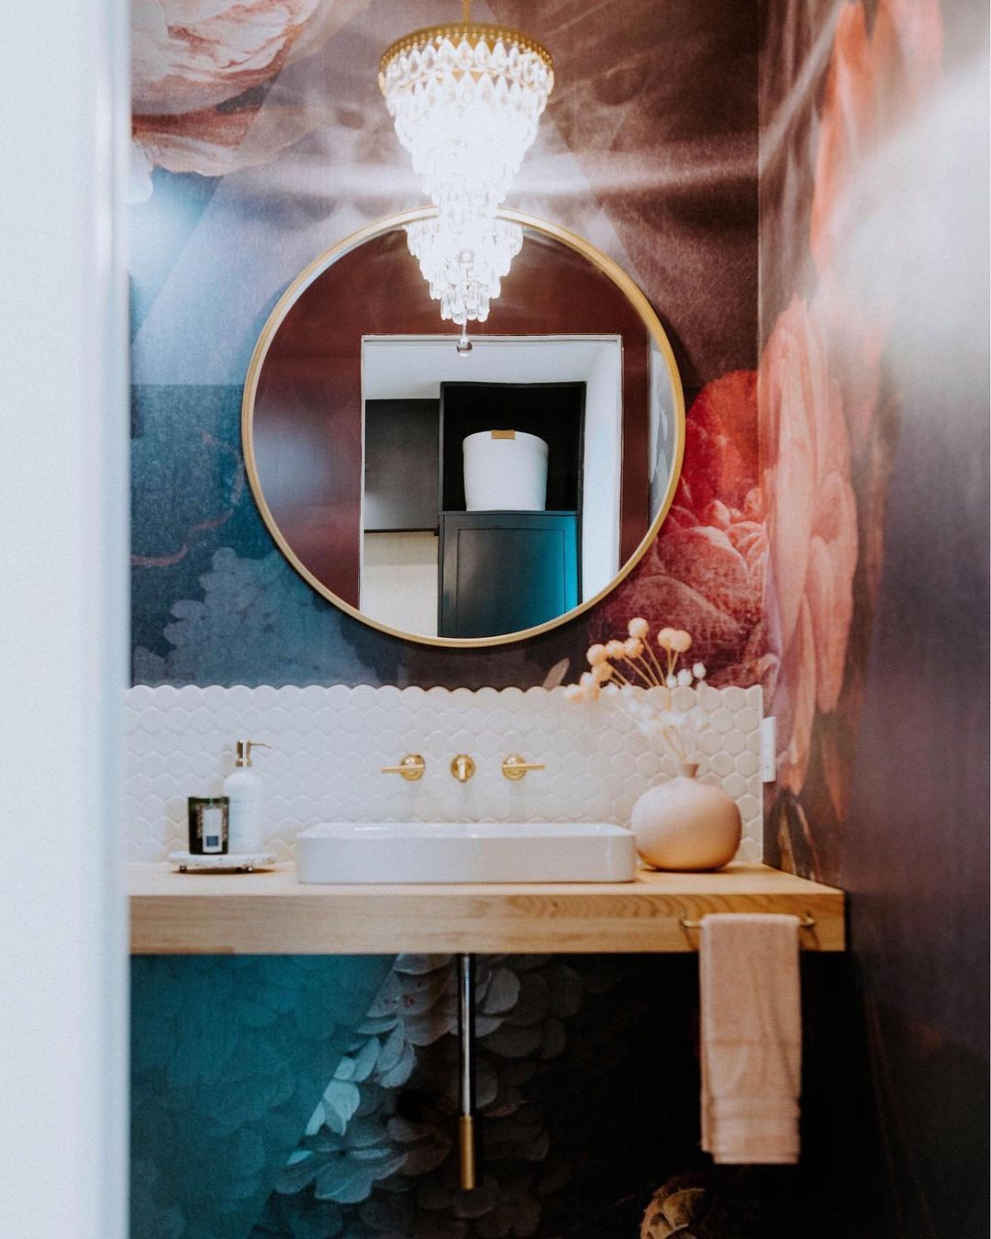

1. All that counter space \ud83d\ude0d
2. I would paint the walls a bright clean white or a light grey, and get some contact paper in a marble pattern for the countertop. \n\nMaybe some wooden or black framed prints with white matting. A little plant in a white pot for some greenery. A new shower curtain, either white or with a bold print, like green palm leaves. White candles, or a wooden tray to hold facecloths. Matching soap dispenser, toothbrush holder, etc.\n\n I would personally clear as much as I could off of the counter to give it a clean look.

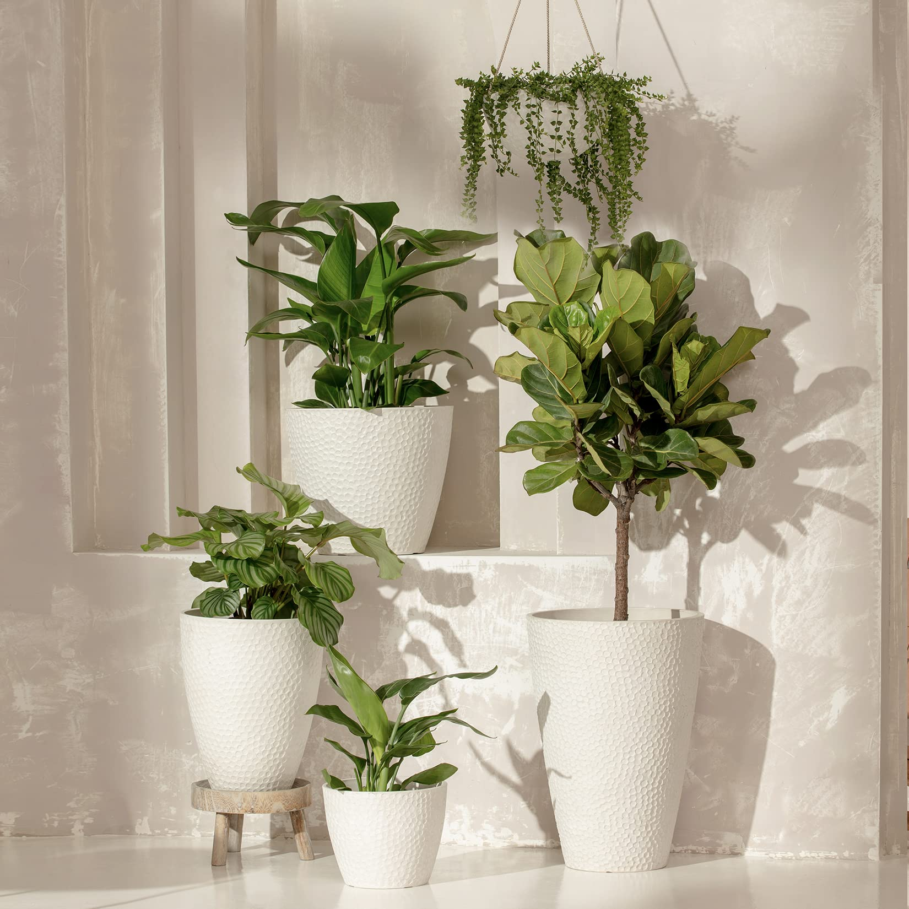 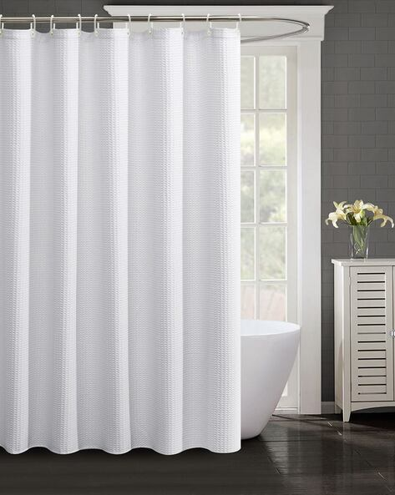

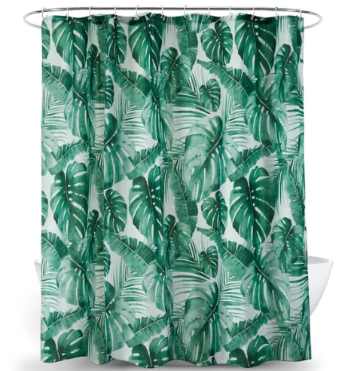

1. What\u2019s your style? I feel like I\u2019d want a floofy seat cover on that stool to look more like a girly vintage vanity and vintage trays to hold frequently used products on the counter
2. I personally like the wooden toilet seat, especially with it matching that stool so well. I think a bold paint color on the wall with the mirror would really transform the space, maybe orange or green? You could put a piece of art, shelves, a medicine cabinet, or some hanging plants in the area above the toilet, but it definitely needs something. I\u2019m leaning toward plants. Declutter the countertop and only place a few select \u201cpretty\u201d products on it. Change out the shower curtain and add a rug. I think a long rattan one would look great.
3. Maybe consider adding some floating shelves or picture ledges. You have a lot of wall space and can use the shelves for decorative placement. They might help you get some stuff off the counter (less frequently used items). \n\nAlso, if you\u2019re feeling brave maybe update the light fixtures and try some different bulbs. Lighting can make a big difference!

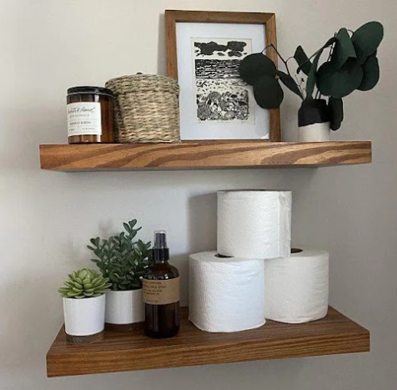

Post last 4 ( Line 936717)

Url : <https://i.redd.it/tb044859psh91.jpg>

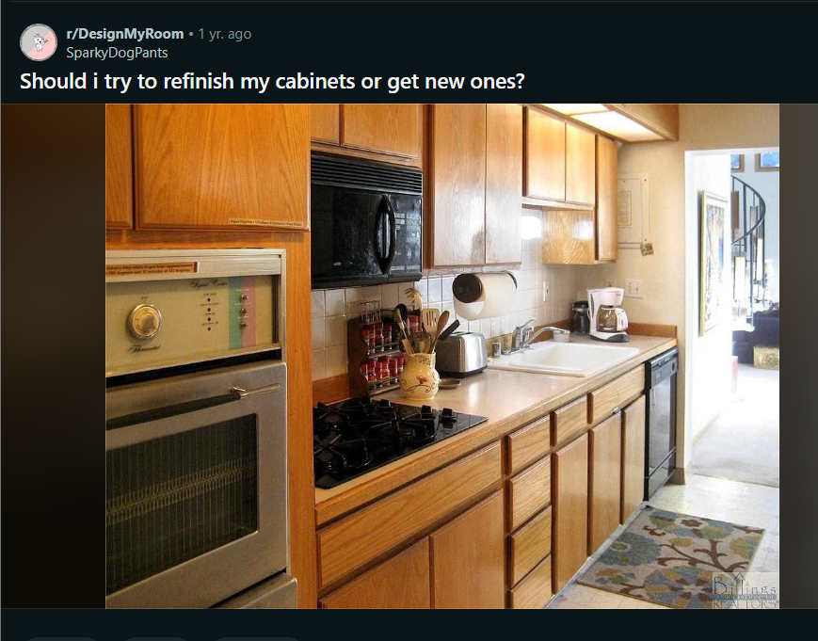

Comments :

1. I honestly think this is a stunning vintage kitchen. Leave it as is. If there's damage, sand it down and refinish. Its lovely
2. That sounds more like a simple fix with the hinges, and not the cabinets. The oven is a whole other thing, and replacing the countertop makes total sense. The cabinetry and colour itself is very nice though.
3. You replace cabs that are in such poor shape that refinishing or resurfacing them doesn't make sense.  And depending on quality, a mid priced kitchen your size with install is probably about $10k +/-.\n\nThere are two things here I'd do with your money.  The first is to invest in new flooring and backsplash...honey and charcoal or black would be stunning there... the beige..beige typically!...will always look \"OK\" at first but grate on your nerves after  awhile, it's just blah.    so, even after replacing or refinishing those cabs youd feel blah after the newness wore off.\n\nThe other thing I'd do..and is always a cheap way to really change a kitchen's feel..is new hardware, or in your case, just hardware.  Those cabs are just too severely plain to be left without  bit of interest and sparkle.

 

1. You could totally paint that and add hardware and see a huge difference
2. I think generally you lose a lot of storage with floating shelves instead of cabinets, but if you are okay with that it\u2019ll look stunning! I think white or navy lower cabinets would look great, probably can\u2019t go wrong with either.

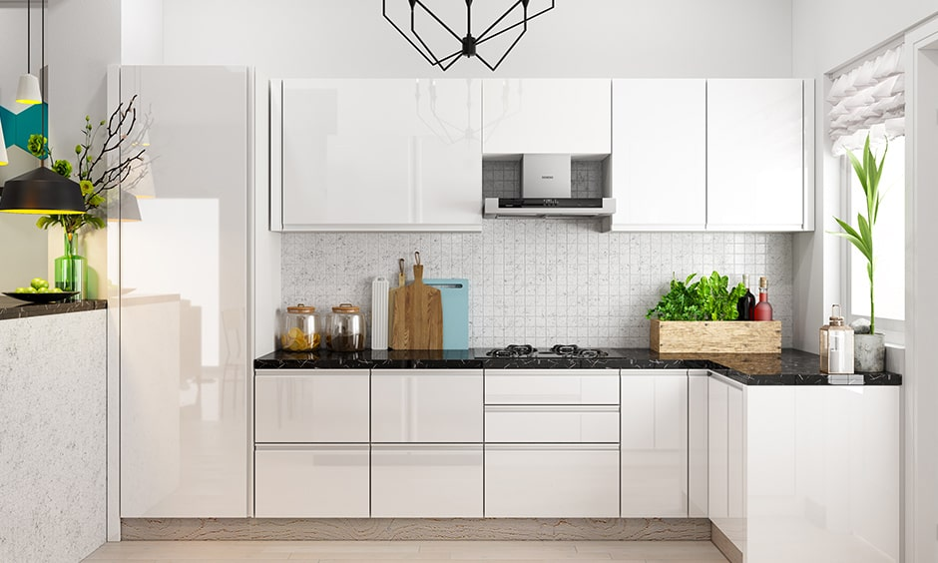

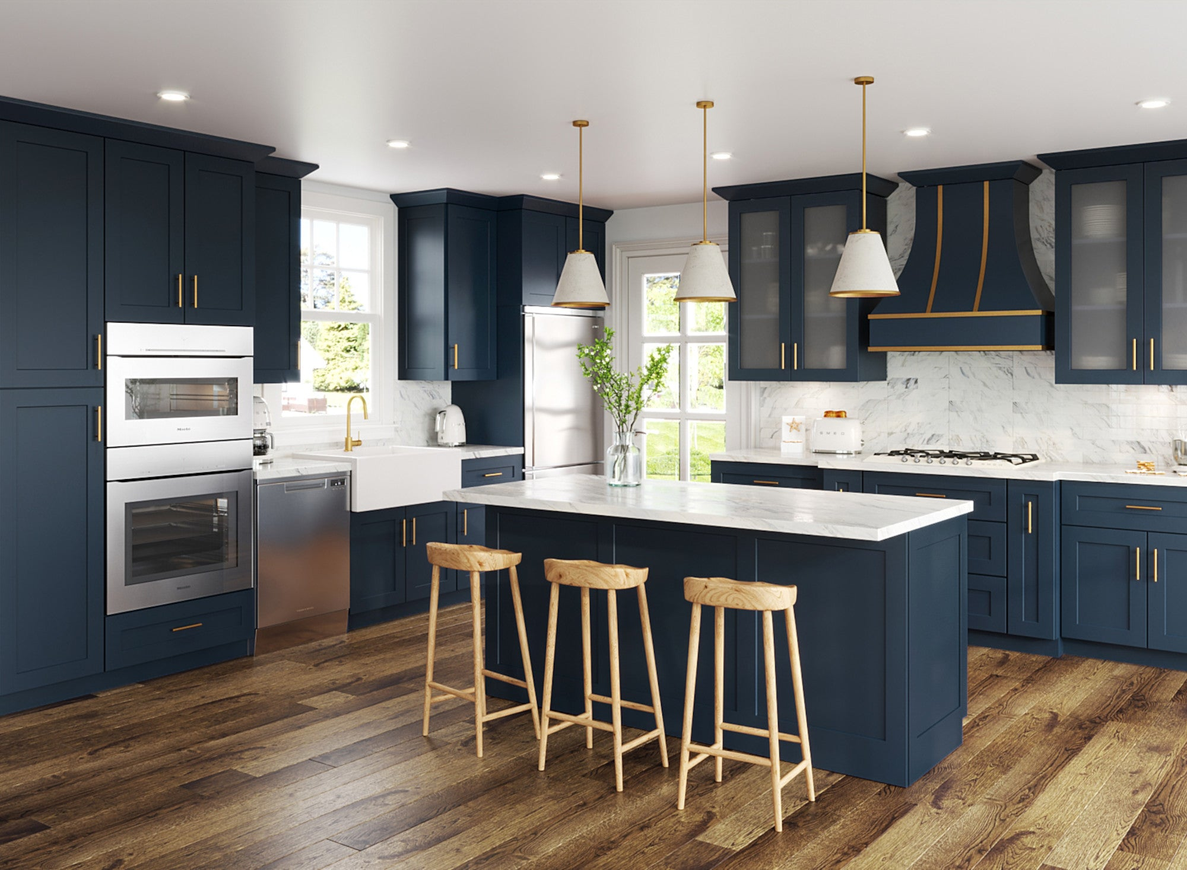

1. Also, with open shelves, everything on them becomes sticky or greasy.
2. I did a two tone but bottoms were left wood (more brown than yours) and uppers white.  Generally dark lowers and light uppers is trend, but I did it specifically because kids will get the white lowers dirty faster.  Painting the uppers gives you the time to fix them and then paint.\n\nI wouldn't do open shelves...good idea in theory and looks good at first, but you need to keep it really organized and free of grease.\n\nNew countertop would look good and ikea has laminate you could DIY and they look exceptional.\n\n&#x200B;\n\nI recently painted another kitchen, and it was a PITA but certainly saves money - proper prep, clean, sanding, shellac based primer, sherwin williams emerald urethane paint.  Since you have pretty plain faced door fronts, I think it would look good with new hardware.
3. It's always going to be awesome to recycle. Sanding and refinishing the cupboards should definitely be an option on your list.\n\n[URL]

**Post last 5 (line - 936609) ---> (archived - deleted )**

**Url : https://i.redd.it/xprcsw6rnv821.jpg**



**Post last 6 (line - 936193)**

**Url : <https://i.redd.it/9ap26szdacu81.jpg>**

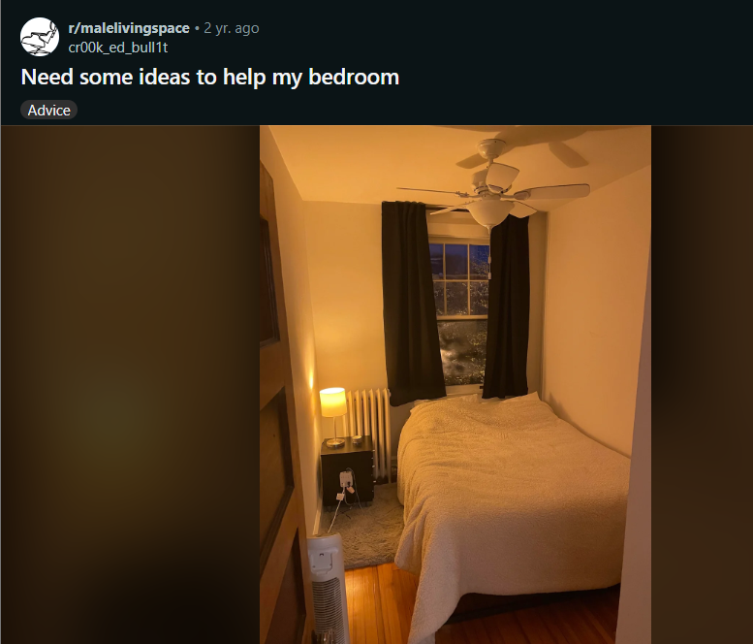

Comments :

1. Your bedroom size/shape reminds me a lot of [another post]([URL] here that I really liked!
2. I was going to suggest most of what was in that post.  An accent wall and some art.  Maybe a hanging plant.

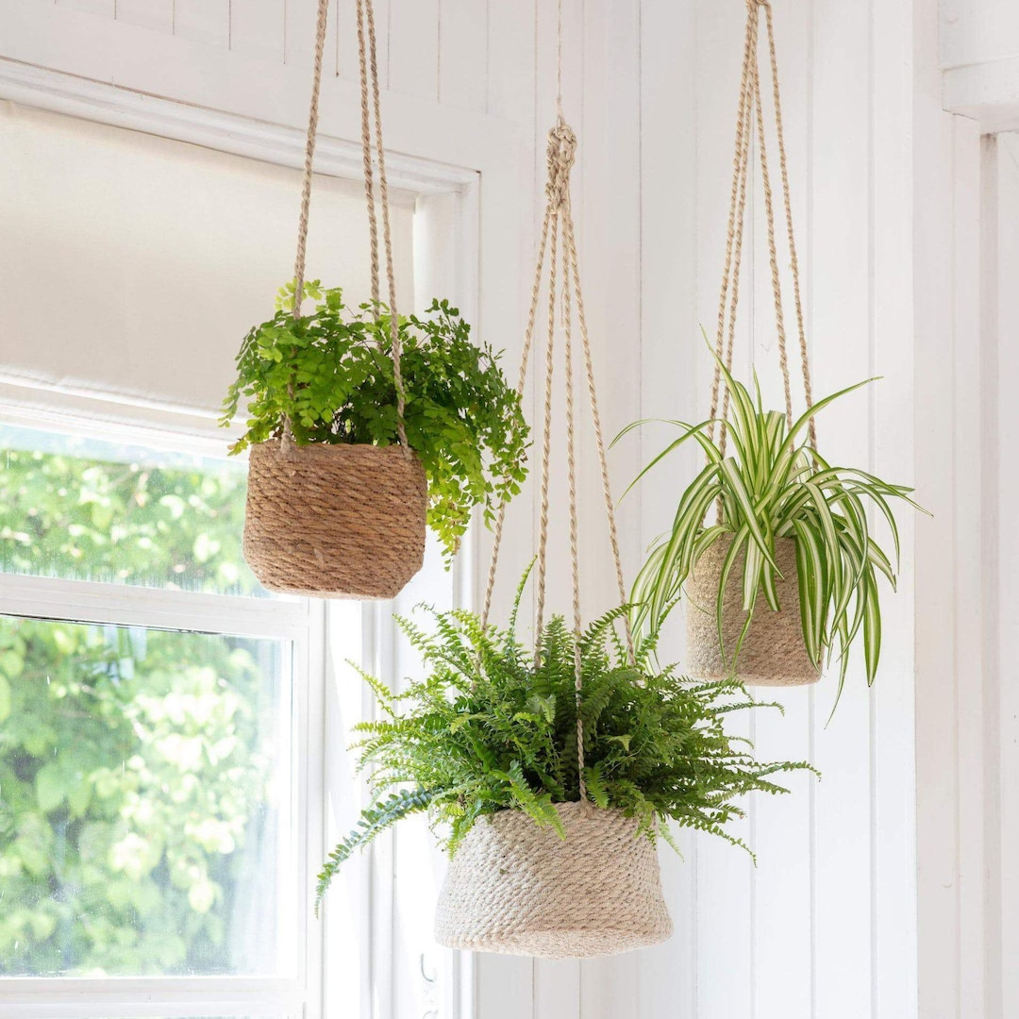

1. That space looks great! I\u2019d suggest OP copy and paste their design and just change up the color scheme as per their tastes.



1. Maybe you can switch out the curtains for a well fitting blind?
2. Yeah I think it would make that corner look more tidy! :)
3. Rotate the nightstand so the drawers face the door. It will conceal the socket extension and look nicer.
4. Make this your cocktail/smoking lounge and sleep in the living room
5. Great start would be sharing what your aiming for.
6. Plants only need indirect sunlight. As well as that some houseplants actually like low light \ud83d\udc4d
7. Move the rug out from under the table and pull it towards the foot of the bed. Put a couple of small potted plants on the radiator. Put a long landscape (orientation) art on the wall above the bed.\n\nEdit- if possible move the bedside table towards the bed and put the electrical extension box behind the bedside table. That way you can route the cables along the wall. It would be even better if the fan/heater was on the right corner at the foot of the bed but that depends on if you have plug points there or not.\n\nBuy a higher temperature bulb. This is extremely warm IMO. Go for something slightly cooler. This looks like 2000-3000K. Go for something in the 3000-5000K range. [Here's a chart]([URL] for reference.

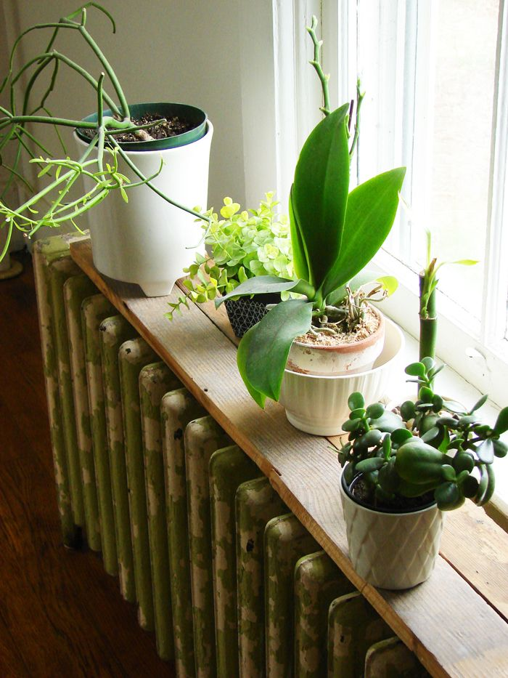 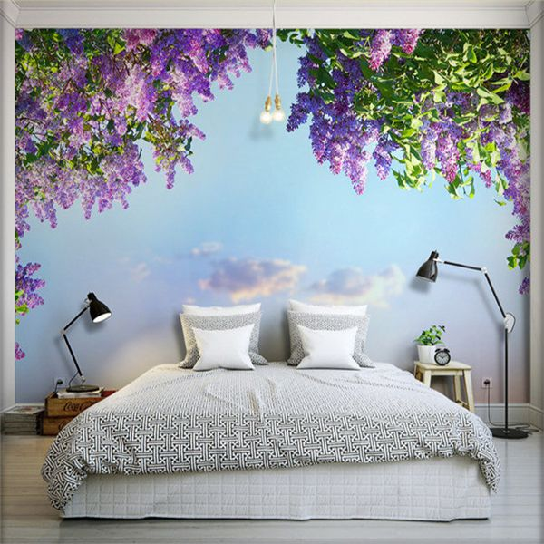

1. Can you put a hook in the ceiling? A swag lamp would look nice in the corner over the radiator, and would give you more light and more room on the table.

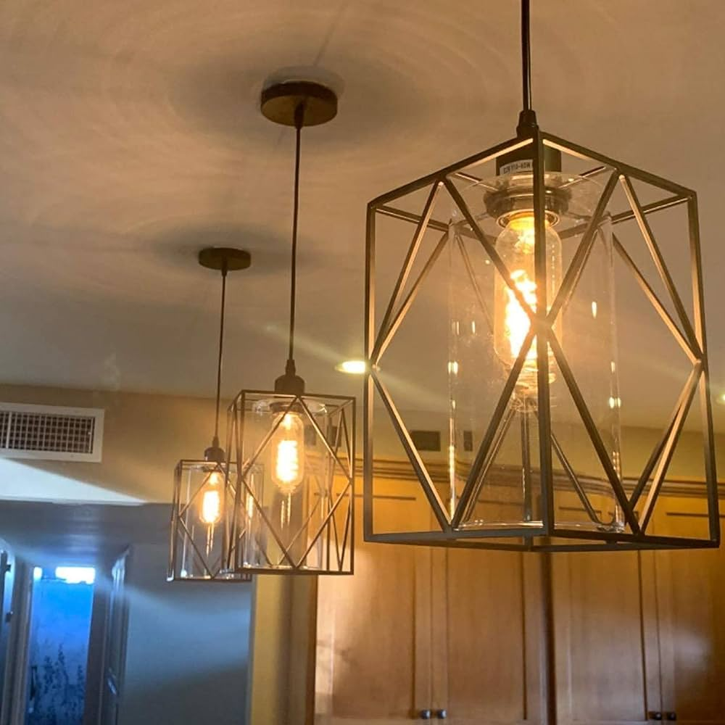

1. I\u2019d say wall hangings, flags, shelves, prints, posters, paintings, etc. could help make it feel a little less bare. I don\u2019t know about everyone else but I personally like to have a blanket chest at the foot of my bed, always had one growing up, well it was a trunk so I could store my toys which evolved into putting clothes or winter comforter in. So that\u2019s what I do with mine is I put my winter comforter in it. Perhaps that could be a nice piece to add?

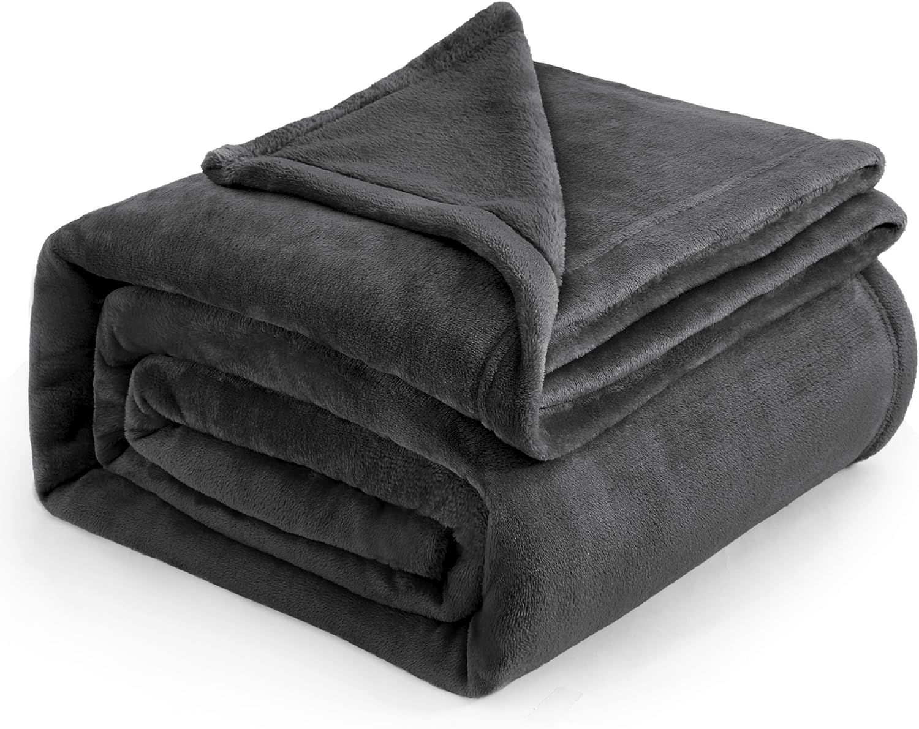

1. The only common houseplants that could safely thrive in here would be a Sansevieria or Zeezee on the radiator, or a Pothos hanging in the corner by the window. Most other plants will need to be directly in the window in order to get any good growth

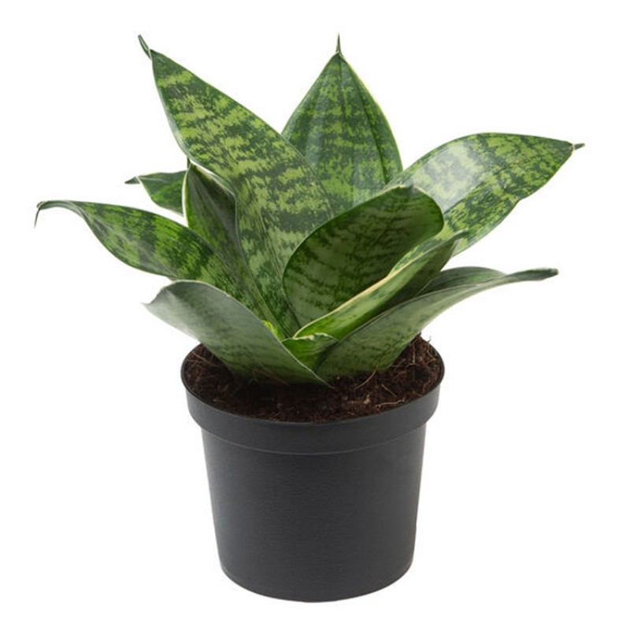 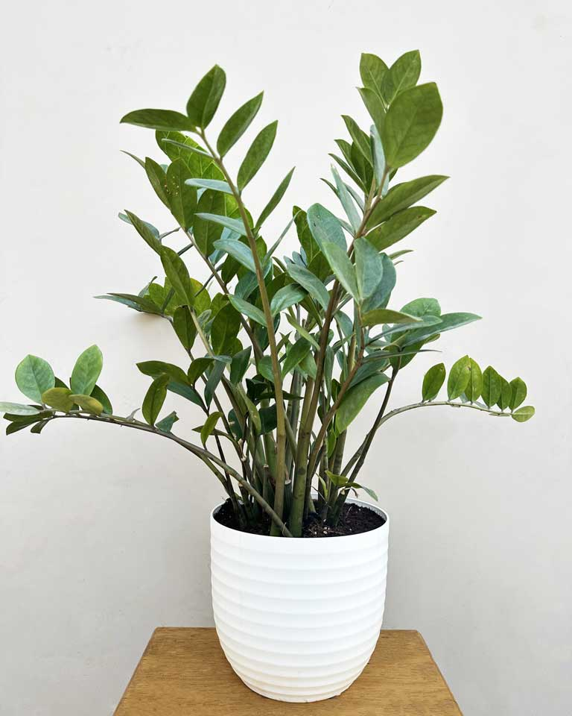 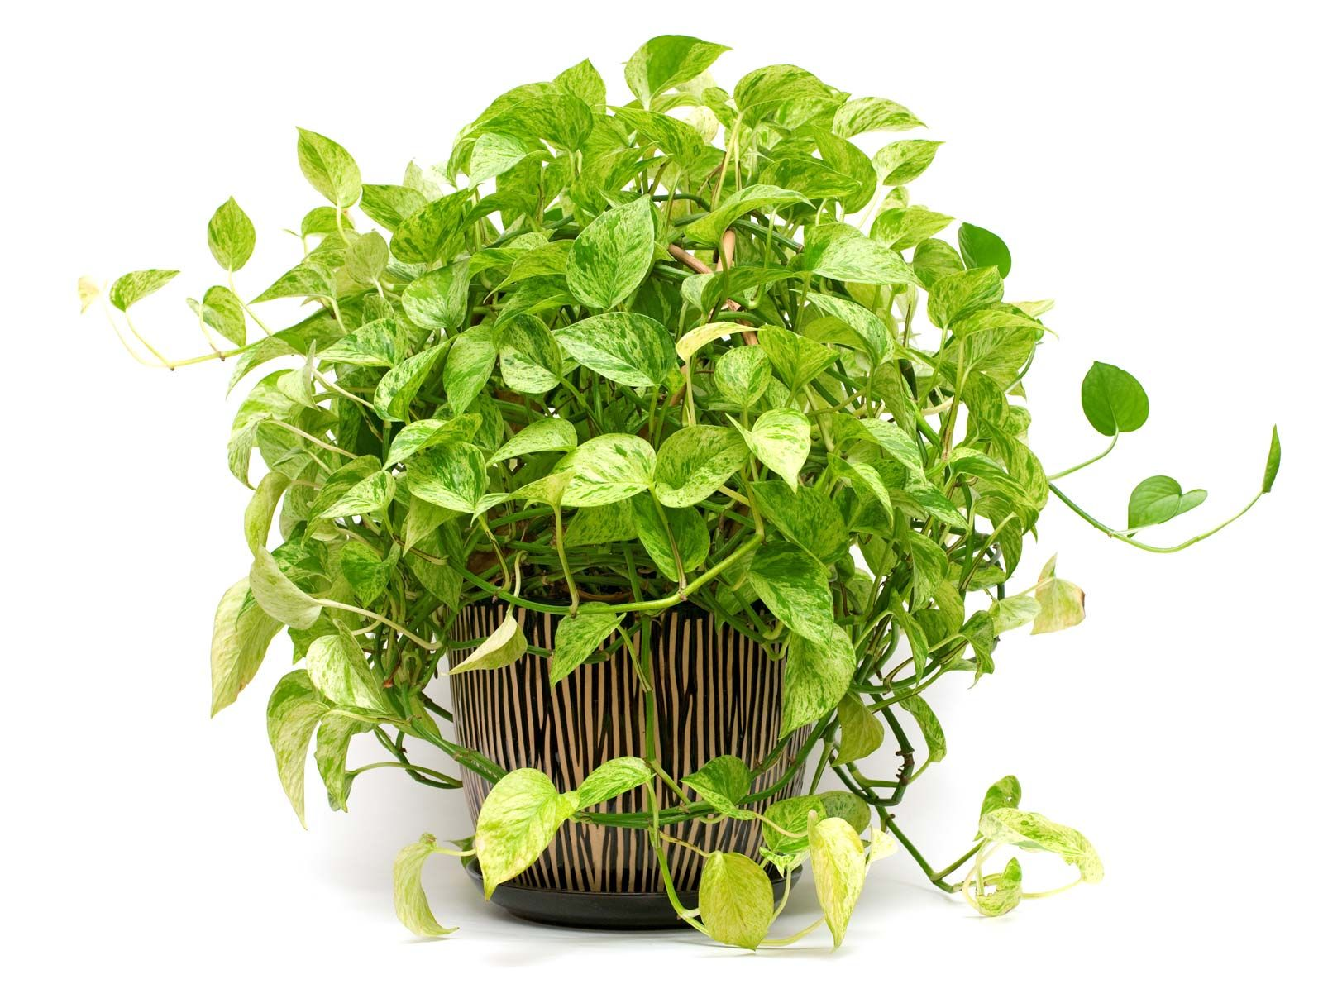

1. A wood grain bladed fan with some stainless steel accents holding the glass in place and a new bed spread should help a lot. I think you\u2019ve got the right idea with some sort of plant. Somebody mentioned something about a hanging plant in the corner, that\u2019d be nice. IF YOU CAN, rotate the head of your bed to the right side wall (the window being your right when you sleep) and place the bedside table at your bedside. And get a headboard lmao. Beyond that. A taller, white light in the corner could also be a nice addition (opposite your new hanging plant), and then a small desk where you currently have the table.
2. Don\u2019t try to put any more furniture in there
3. It\u2019s literally a BEDroom
4. Replace the ceiling fan/ light with a more interesting fixture that is a bit smaller and not the same color as the ceiling.
5. Darker bedsheets
6. You can add some wall art (frames, favourite painting or even shelving with decor) on the wall to the right of the bed. \n\nA nice plant and a body sized mirror will add a lot of depth too.

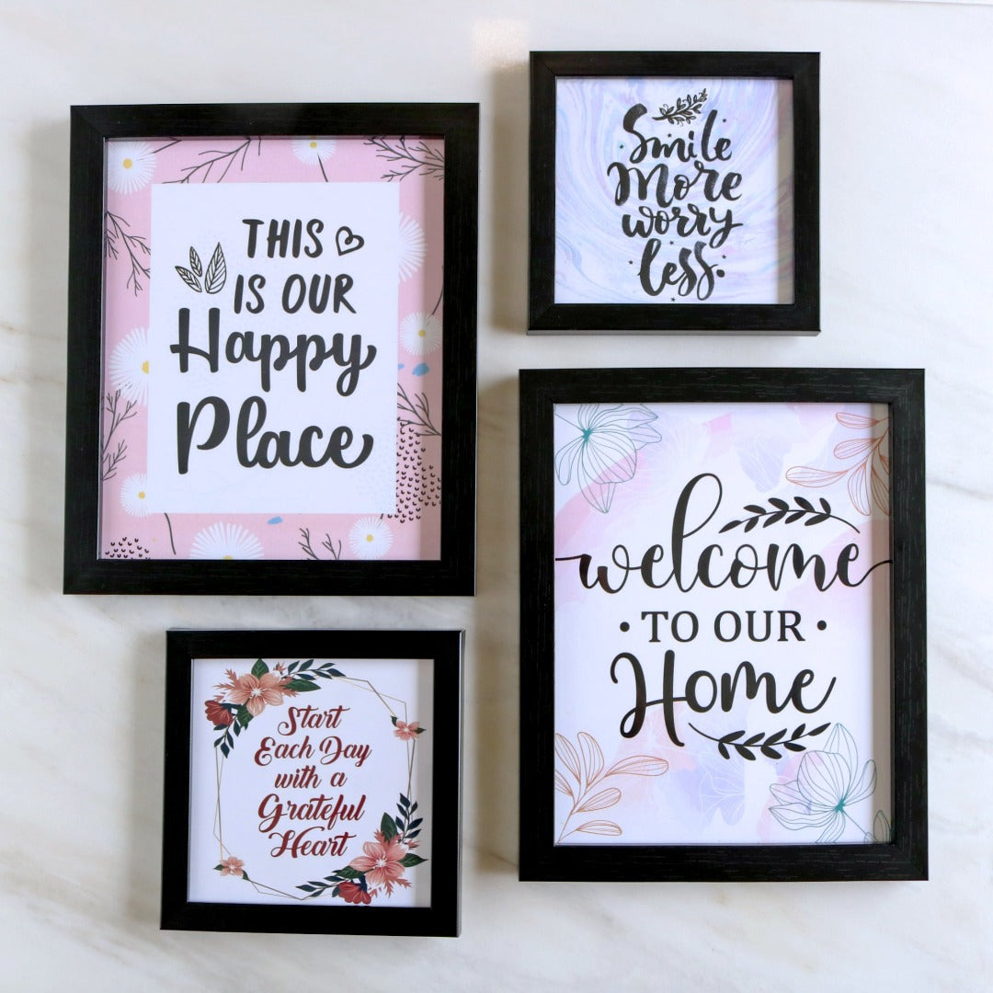

1. Why is the curtain touching the heater?
2. Shoot something like a giraffe.  Full mount it and put it in there.  Maybe like an elephant.

**Post last 7 ( Line - 935880) Archived**

**Url : <https://i.redd.it/z9z9ir3xsdc41.jpg>**



Comments :

1. White / black / ivory
2. Ann Taylor had a lot of this fabric recently and they paired it with those dark blues and greens that are in the plaid itself. You also can\u2019t go wrong with black and white with this. Basically, if it goes with navy, you can pretty much wear it with these pants.
3. Honestly, they are so versatile, you can wear almost anything! Black, green, navy, even shades of deep cranberry or grape, canary or dijon yellow, charcoal, cream, winter white....
4. A canary yellow button down of course!
5. I would also add a matching green tie and blue braces...
6. dark grey or black
7. Mustard, burgundy, white, red
8. i\u2019d wear it with a tight black crop top (ish, not super cropped) and docs or vans
9. Cream shortsleeved blouse, red pumps.
10. You could wear a black or white top with a bright green cardigan as a work outfit.
11. You could do a white top and black leather jacket
12. I would wear a yellow shirt.
13. cream colored sweater and brown booties, fiiiire.

**Post last 8 (Line - 935068)**

**URL : https://i.redd.it/dwm5edw2f9591.jpg**

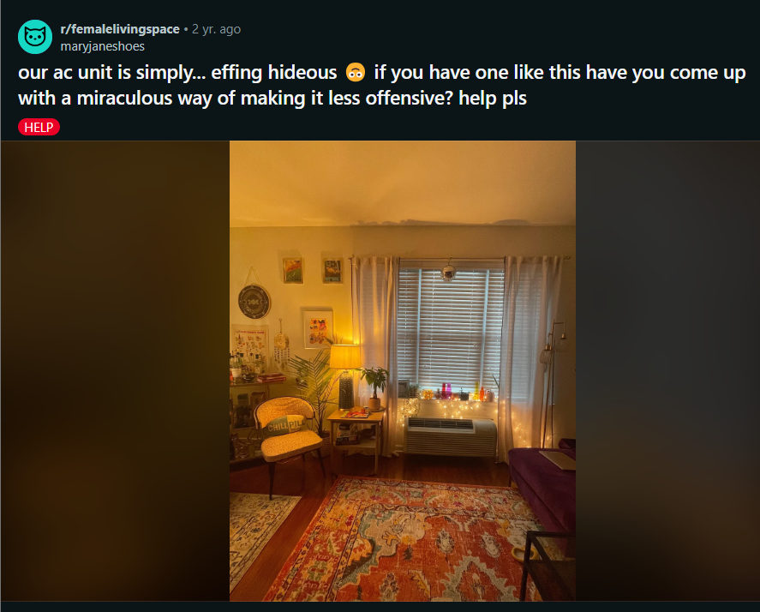

Comments :

1. Honestly I only noticed it after looking for it and it looks fine!
2. Same, my first thought was 'oh what a nice, inviting space!
3. I actually don\u2019t think it looks bad leave it like it is
4. Maybe move the twinkle lights up above the curtain to not draw attention to it? But I barley even noticed it at first. I do like the idea of the vintage radiator box, just be careful with proper airflow.
5. I\u2019ll probably get downvoted for this, but\u2026 the twinkle lights and items on the window sill draw a lot of attention to that area.  If you can clean all that stuff away, maybe you won\u2019t notice it so much.
6. Maybe lights up high to draw attention in the opposite direction
7. I agree if you brought the lights up higher and wrapped them around the curtain rod it would draw they eyes up therefor in a way hiding the AC unit
8. I actually think it's kind of cute
9. yeah, it\u2019s charming
10. Maybe you can get one of those old school radiator covers and place it over the ac unit? They\u2019re available online as either brand [new]([URL] and modern or a more [vintage]([URL] look. These aren\u2019t cheap, but they would definitely improve the look and create space for more stuff!
11. We had this issue in our last place too, but fortunately it was built into a bookshelf and had a top we could set stuff on. Yours doesn\u2019t look too bad though, and I love your chill pill pillow!
12. My friend's dad built a cover for her air conditioner and I painted a leaf on it, turned out so great! But it's just for when not in use. I will send you a pic if you want! How do I do that, in a private chat? I'm so old!
13. I think it adds to the charm of the space, but I have seen people use contact paper or vinyl to make it a color that matches the room
14. it honestly doesn\u2019t look bad at all, just enjoy that a/c, some people would kill for that rn lol
15. You could do a diy like this [URL]
16. I looove this idea pretty much making it level and the length of the window. Potential inner storage on the right and left ends because of the extra space. Ah nothing like a functional built in credenza \ud83e\udd29
17. this is so cute
18. Get a cat.  They help with everything.  \n\n{{{{cats}}}}
19. Cute kitty! Please be aware that snake plants are toxic to cats though
20. Just FYI the plant the cat is next to is toxic to them\n\nEdit: like every cut and easy to care for plant. Cats\u2026
21. A small 12-16\u201d wide table in front with something ostentatious on top. Lay those lights on the table top. \n\nThe unit isn\u2019t bad looking or dated, you need to draw unfamiliar attention to something else.\n\nEdit love that rug
22. It pulls my attention because the curtains are floor length which makes my head say those curtains can\u2019t close cleanly. Have you considered shorter curtains?  Maybe that will draw the eye less?
23. I love it. I think it all looks awesome
24. On an unrelated note I love your rug and have the same one!!
25. Where is it from??! I love it too!
26. it\u2019s really not noticeable!! the only general tip I\u2019d give is to place your curtain rod as high as possible towards the ceiling and get new curtains that touch the floor\u2014this adds height to the room
27. It looks like it works so I would say it\u2019s the opposite of hideous
28. Tell it to take a chill pill
29. Omg same. Our landlord just installed these exact ones in \ud83d\ude23
30. I didn\u2019t even notice it until I read the caption!
31. See, you got all nicely decorated and cozy, that I didn\u2019t even noticed, til I read the caption.
32. At first I thought it was a bench
33. When I was a kid in the 90\u2019s we had a radiator that had a metal cover. It reminded me of a big bench. It would be warm and toasty in the winter I would sit there and watch the show fall.
34. Doing anything to it would draw attention to it. I feel like by leaving it alone and worrying about every other part of the room inadvertently hid the entire unit. It took me so long to find the AC I had to go to the comments. I thought you hadn\u2019t put the window unit up yet or something
35. During the winter I used to cover mine in Christmas wrapping paper
36. Damn, I love this room. It\u2019s so nice you\u2019d never notice the ax unless u pointed it out.
37. I put artificial vine/leaf strands with twinkle lights all over mine and then plants at the top. It\u2019s not the most ideal but it adds some cute nature vibes and would look nice with the room!!\nAmazon has good cheap ones
38. It could be way, way worse. It could be a window unit \ud83e\udee4
39. Paint it teal! Make it custom instead of hiding it!
40. I think it actually adds something to the room. It's a vibe.
41. I honestly couldn't tell until you mentioned it. Your space is so beautiful.\n\nIf you really want to try something: I'm in a veneer mood, so my first instinct is to find a vinyl that matches the side table and cover it, except the grates. Or maybe one that matches the wall.
42. I have the same rug!
43. put some cute stickers on it, maybe give it a little face
44. This is a mini split. It\u2019s sort of like the window AC unit\u2019s cooler older sister. It\u2019s mainly for people who don\u2019t have central air, but don\u2019t want to install and remove a window AC unit every year. Some of them also provide heat. But yeah - it\u2019s way better and more effective than a window AC unit so don\u2019t hate on it too much :)
45. I would put the fairy lights along the curtain rod, maybe draping down a couple times\n\nThe AC unit looks fine IMO, but if you really don\u2019t want it on show you could DIY a sort of box covering that has a big ol\u2019 slit hole for the air to come out and you could paint / design it how you want?
46. I love your space so much that the AC isn\u2019t a concern at all. :) you\u2019re lamps are gorgeous!

**Post last 9 (Line - 934885)**

**Url : https://i.redd.it/0g4pdoi567n21.jpg**

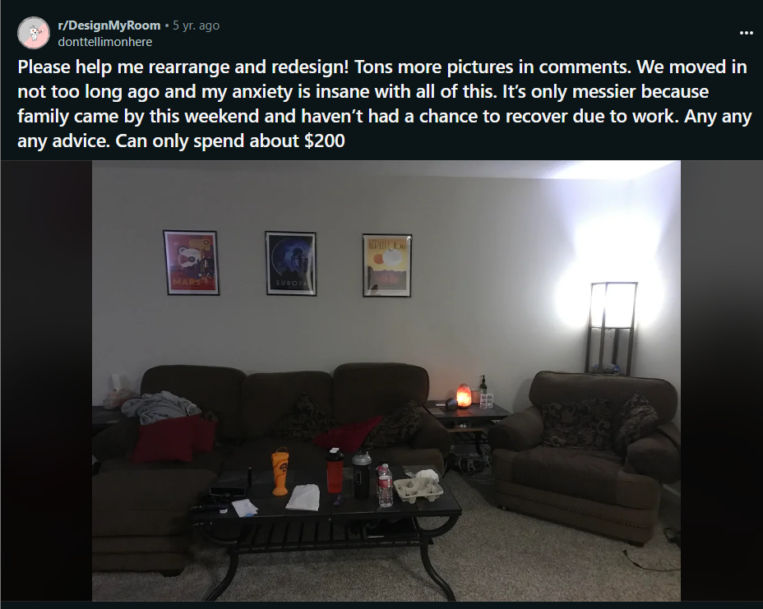

Comments :

1. I think you need more wall decor. Invest in a clock or a shelf or a painting. Either a handful of small stuff or one or two bigger things
2. Goodwill and other resale shops have art...I've found some really great frames...just take their art out and put in your own posters or pictures if you can't find art you like.  Especially frames with nice mattes.  You can mix frame styles as long as you maybe keep them the same color...
3. I picked three spray paints that went well together and painted all my frames with them. It looks great in a room. Also, Facebook marketplace is amazing. I bought two paintings, one for $70 (~30x45inches) and one for $5 (36x50 inches). There are some gems if you can find them
4. I think some nice art on the wall could help bring some light to the room. As suggested above, you could scout some second hand stores for something. I think the 3 pictures you have could move to a different wall and you could get something larger and more in proportion for that wall.\n\nSecondly, you have 2 dark and small storage units that look a bit like bedside tables? Not really sure with the lighting exactly. If you need these for storage you could think about selling these (increasing your budget) and getting something a bit bigger that looks more like it fits the space rather than just looking sort of plonked around the room. Something like a sideboard or buffet or even a nice coffee table with storage underneath.
5. I know you said company was just over so it's messy, but it also looks like there are several items on all of your surfaces that just don't have a place to be put when they're not in use, so they maybe just sit there?\n\nAll that stuff is adding to the visual noise. I'd get a cheap, plastic hanging shoe organizer, and hang it up on the inside of a hallway closet, or something. Put all the \"Misc\" stuff in there--the things you need, just not every day--to get it out of your living room.\n\nSecond, I'd recommend switching out your light bulbs for warmer tones. That cold, clear blue might be great for task-related rooms, like an office, but for a living room, it appears too piercingly cold. Switch them out for LEDs in the 2,700 to 3,000 Kelvin range (warmer).\n\nAlso, get two matching table lamps for both sides of that couch, to bring in more light and balance things out.\n\nLastly, update those dark pillows with a light creme color, or something.
6. I think the prints over your couch are really cool but the way they\u2019re framed isn\u2019t doing them justice. I would pick up some nicer looking frames with more of a mat to make them look more special and to take up more visual space on the wall. I think the Ikea RIBBA frame would be a nice upgrade that\u2019s very cost effective. Just watch out for the cm to inches conversions and make sure you\u2019re getting the right size based on the mat opening and not the actual frame size.  I also agree with someone above who suggested lighter/brighter colored pillows. You can find some great deals on pillow covers on amazon and use the pillow inserts you already have to save some money!
7. You need more light. Go to thrift and look into getting a large mirror or SEVERAL medium sized ones to arrange in a pattern to ensure light bounces in the room especially with your dark furniture. You need more color. Get colorful art from Goodwill and colorful pillows and blankets. Bring more warm tones into the space use wicker basket to hold blankets and other floor items. Put up some fake plants. Your issue is lack of feeling of LIFE in your space.
8. Replace all the pillows with big white ones.  [Something like this maybe.]([URL]  \n\nThe current pillows are too dark and they get lost in the sofa.  The white ones would add contrast and help brighten up the space\n\nAnd maybe throw a light colored throw blanket over the chair back.\n\nAlso...move the salt lamp to one of the TV stand cubbies or on top of the mini fridge...and then get a nice table lamp for each of the end tables.\n\nYou can always add wall decor and plants too.\n
9. There are already severeal fantastic suggestions in this thread, but what really bugs me are the curtains. Is there any way, where you can exchange the rod and place it higher? The fabric is already to short and i think a few inches would make the room appear bigger. \n\nAlso a small, high table with a bowl for clutter next to the door wouldn't go amiss. \n\nThat awkward corner with the stucco(?) just looks like an afterthought and the self shoved in there to fill some space. Because of the feature it's already visually seperated from the room, so the current situation just seems like a waste. It would be a perfect place for a reading or dinning nook? It definitely has potential.

Post last 10 ( Line 934626)

URL : https://i.redd.it/7ucoxcxw36w81.jpg



Comments :

1. I believe the style is called peplum?
2. I call them plumpums or pealumps or pleapums.\n\nEdit: Christ on a cracker no one in this sub has a sense of humor. You cannot deny that peplum is a silly word. Have a laugh.
3. your comment did make me curious as to the origin of the word Peplum\n\nApparently its from an ancient Greek word for tunic
4. Peplum
5. Hi! I also teach high school, and am 4\u201911. I\u2019m a little biased because I had a part time job at Loft while I was student teaching, but I was able to find a ton of stuff there to start a professional wardrobe. They have a decent petites section, and their outlet has some pretty good deals as well. I liked their stuff because it was professional and comfortable without seeming too business-y. \n\nI hope this helps. Good luck in your first year!
6. I\u2019m 5\u20192\u201d and have a LOT of work shirts and dresses from Loft. Love their selection for professional clothes. \n\nI get my work pants from Betabrand. Their \u201cpetite\u201d pants run long if you want to wear heels. Their \u201cpetite short\u201d hits around my ankles. \n\nAnd always\u2026I just wait for their sales
7. Hi! Fellow teacher and I used to be that small \ud83d\ude02 I found a lot at banana republic petites and could\nFind a lot in their sale or clearance section! I get a lot of basics and neutrals so they stay in style. Sorry I can\u2019t help much with the type of top but based off that photo I thought of banana! (Pants too!)
8. Loft and Ann Taylor. That's where I get all my professional stuff (especially pants!) They have a great selection of petite clothes.
9. Loft\u2019s polyester blouses are my work uniform for like 90% or the year (I teach high school ELA). They keep me cool and are easy to move in and to care for. I could definitely imagine playing instruments or conducting in them would be comfortable.
10. Loft, Banana Republic, and J Crew are easy for work stuff. Banana and J Crew have a factory like which is a little cheaper as well. I also get a lot of those brands from reseller marketplaces like Poshmark or Mercuri. It\u2019s common for me to get basics like button ups, v-neck sweaters, etc for a really good price (and sometimes new with the tags still on them).
11. Peplum tops are designed to slim down the stomach area by adding more waist. The fitted ones are generally worn with fitted skirts, preferably in the same colour.

**Post last 11 ( Line - 934284)**

**URL : <https://i.imgur.com/SoS8KJD.jpg>**

**"caption": "any thoughts on how i could add additional lighting?"**

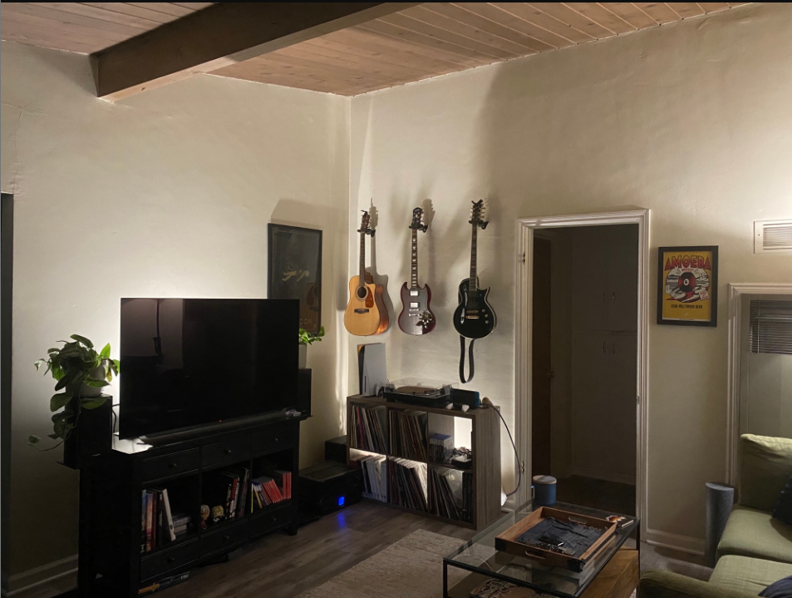

**Comments :**

1. The backlighting is really interesting and unique but not very practical. If you have space, I think a floor lamp with a low wattage bulb would add some light without washing out the backlighting on the cabinets.
2. lightbulbs
3. I'm glad there was a literal Chad to post this. I had to hold myself back from my standard sarcastic joke response
4. Based
5. Get an Arc lamp\u2026just one idea
6. Looks like you need a bit of overhead lighting.
7. Yeah, best you could do, from this angle, is to have it go along the beam straight down behind the TV. With or without a cover.
8. Track light on the beam
9. 3000 lumen bulb. 5000 worst case. It will blow your mind for 25 bucks. A standard 9w led a19 bulb is 800 lumens
10. I agree with what most people are saying, which is to get a floor lamp. But get one that is dimmable. You will have times where you want the room brightly lit, and you\u2019ll have other times where you want it dimmer, like it is in this picture.
11. Hang some naked bulbs on that beam, the type of bulbs that are all attached
12. Definitely could get a lamp
13. Add some dimmable light strips somewhere in the space on the other side of the doorway.
14. can you hang a pendant or something from the beam?
15. Grab an end table and put another lamp on it. Ez pz

**Post last 12 (Line 933921)**

**URL : https://i.redd.it/zjagj7v2pht41.jpg**

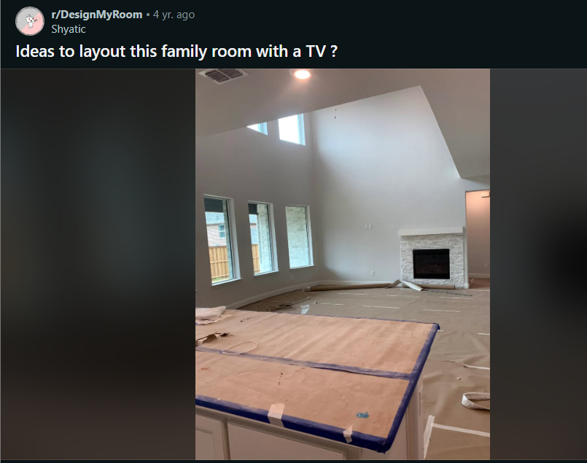

Comments :

1. I lived this layout in reverse \n\nYes you are right the TV must be on a console to the left of fireplace at the perfect viewing height\n\nMay I suggest a very affordable solution? Try a tv console in all white like Ikea besta low to ground w white doors. The console disappears.\n\nThe fireplace can easily have a screen like a simple chrome curve. Match that metal with accent pieces\n\nI don\u2019t think the stone needs to go to left nor too high up. \n\nIt works: the fireplace is key when on and during day to day life you will hardly see fireplace and just see tv\n\nI\u2019d consider art that becomes a tv too.
2. We have this TV stand in our arcade/theater!\n\nIt's real nice but a pain to put together (watch the YouTube video).\n\nIdk what your design style is, but i think the Ikea Besta would look a tad better in this space. The LED/high gloss of this piece has a pretty kitschy vibe. Works great in an arcade but idk if I'd put it in my living room.
3. What about with mounting the tv and then using white mounted shelves (to match the adjacent mantle) for media? It might make things more flush. Then eyes won\u2019t go immediately downward to the console on the ground?
4. I know the answer is \"no,\" but I'd love to rip out that misplaced, too small scale fireplace and put in a long, low one on the left, the tv mounted to the wall on the right, and connect then with some thick, asymetrical shelves that stair step up the wall...\n\nSimilar to [this]([URL] one we just helped design for one of our clients. PS - they added the cabinets below, that was not part of our design :(\n\nYour room is never going to look balanced and scaled appropriately with that tiny fireplace surround. It kinda screamed \"builder cheaped out\" to me.
5. I really like your design and am curious what you would have put in place of their cabinet choice? Nothing? Dark wooden cabinets with a streamlined, no handles look?
6. The original design had a long, low hearth that went wall to wall. But the client decided after contracting us that they wanted storage and didn't re-engage us to modify the design, which I think was a mistake.\n\nWe probably would have added dark cabinets that came up to the height of the first shelf.
7. So I think a console is going to be dwarfed in this space. What\u2019s the budget for the room for all furnishings and work?\n\nIs there any room for millwork? You have these glorious tall ceilings and a lot of space to play with. It would be a shame to put something half assed. \n\nCan you post a floor plan? If it\u2019s just being built you may even have an elevation drawing of the wall. I think this space could be really elegant with the right layout.
8. Is there any way the builders can re-do the fireplace?  It might be a fraction of the price to have them do it now rather than a fireplace contractor down the road.  I love the design in the other comment with the irregular shelves - it pulls the eye up and away from the irregular ceiling.
9. I would recommend the [oversized canvas art]([URL]) , something like 80 by 60 inches.
10. Just returning to say we have besta under our TV. If I might, Ikea seems simple but I simply love besta. It\u2019s modular so you can add to it. Check out Ikea hacks for how to create a built in look with a besta (or pax). \n\nAs a TV console we have one without legs or I think very low ones. We have another with different legs and that small touch changes it. Then we moved, so we had 2 to the ceiling Besta unit frames. Changed the doors and it\u2019s a full new look. Not cheap but worth it for how you can use it in many ways and through moves. \n\nIf it were my wall I\u2019d build this: a custom looking wall bookshelf that frames the TV, e.g a besta bookcase to ceiling right and left, then a 2 wide unit under tv, and then a wall mounted one over TV. If needed mix and match open (top) and doors, and get Ikea storage bins for neat display and open storage. We did cut a round hole in back to hide cables. And a little but of wood trim can make it look like a custom built in next to the fireplace.\n\nSome sleek fire grate can match any accessories or legs. Room for plants on a built in too. Solves the art and cohesion issue \n\nGood liuck! We\u2019d love to have that luxury of space as urban dwellers.
11. I'm big on symmetry -- would go with an above the fireplace pulldown tv mount and center your couch to the tv/fireplace
12. The fireplace is next to a doorway, I don't think I'd work for the flow to have the couch centered to the fireplace
13. That's a good point. A sectional wouldn't work, but a long straight couch might, if they mount the TV to the left of the fireplace.
14. Ah, hard to tell since the right side of the room is cut off in the photo.

**Post last 13 (Line - 933550)  
URL : <https://i.redd.it/rncjybnwlcp31.jpg>**

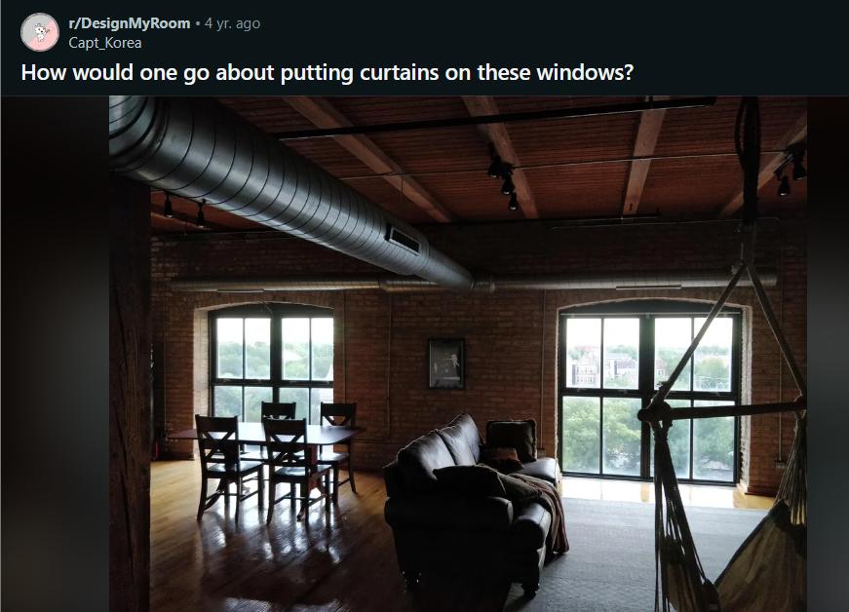

Comments :

1. I don't know how this would work, but have you considered using some kind of shutters rather than curtains? Personally, I think it may be hard to find curtains to match? \nHave to see what others think as well though.
2. I like this idea. Not something you see often. Could really make it your own.
3. Wait... What about sliding barn door type coverings?? That would be so cool in this space
4. Nice place! How about curtain rails wider than the windows, so you can have the curtains open and see the full window? I\u2019d look for an industrial style rail that isn\u2019t obtrusive. Maybe a bold print in a light weight fabric, something that looks good open and closed.
5. I would definitely want them wider than the windows to let in the most light in what appears to be a dimly lit space.
6. Why do you need curtains? There's no one who can see in.\n\n\nYou can look into tint if you want privacy or less light.
7. Long tension rod - think shower curtain style. Maybe some sheer curtains with a slight print? Enough that when open you dint notice them but when closed gives you enough privacy during the day at least
8. Don\u2019t! Maybe a screen/divider if your concerned about privacy. Plants make good screens :)
9. Seconding plants! This space could use some greenery
10. Would look amazing with flowy, white cotton curtains. They would add brightness and coziness while opened and obviously could be closed for privacy. If you\u2019re asking in more technical terms, you will probably need to drill into the brick and put anchors in. Would be worth it in my opinion.
11. Shutters or tension rods
12. curtain rod duh.
13. They make curtain rods that hang from the ceiling instead of the wall. Bump out a few inches if you need to clear those big silver tubes. And in your place I\u2019d do dark industrial pipe style rods.
14. Get tension rods
15. Get a blind installation person over to show you some options then do it yourself.\n\nEdit: Wow apparently none of you live in the real world. I'm a contractor and I can tell you no company is being put out of business because they gave an estimate and showed some examples.

**Post last 14 (Line 933432) --> Deleted**

**Url : https://i.redd.it/y8ga5apfyn541.png**

**Post last 15 (Line 933244) --> Deleted**

**URL : https://i.redd.it/jmheze9x42u61.jpg**

**Post last 16 (Line 933025) --> Deleted**

**URL : https://i.redd.it/ri8p10g6wk951.jpg**

**Post last 17 (Line 932863)**

**URL : https://i.redd.it/gvnwxtp8mk171.jpg**

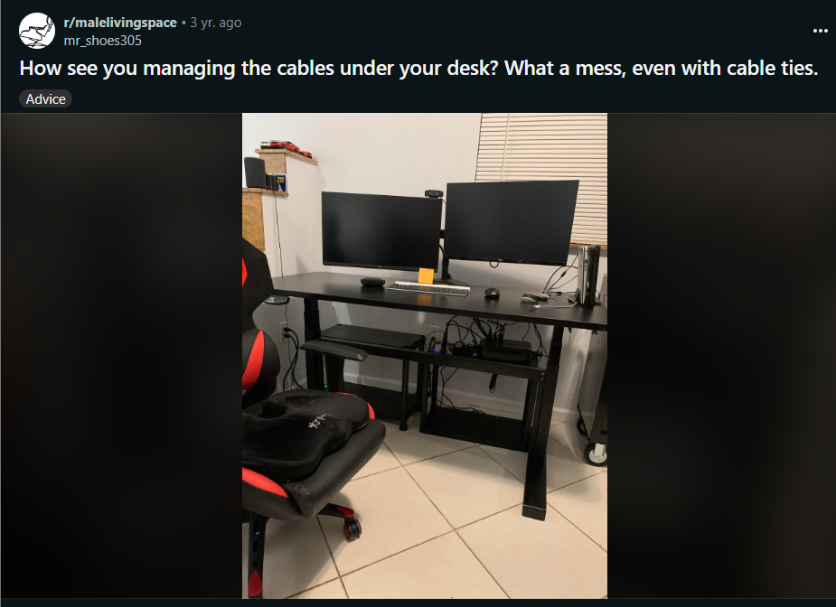

Comments :

1. They sell cord covers where you could put all of them in a bendy tube or a paintable rectangle
2. Just get something like [[URL]  \n\n\nThen you only have to deal with a single cable running up to the desk, and everything else routes into the tray.
3. You could mount your UPS to the bottom of the desk and use braided wire loom to gather the cables.

**Post last 18(Line - 932672)**

**URL : <https://i.redd.it/5agr2ewttrf21.jpg>**

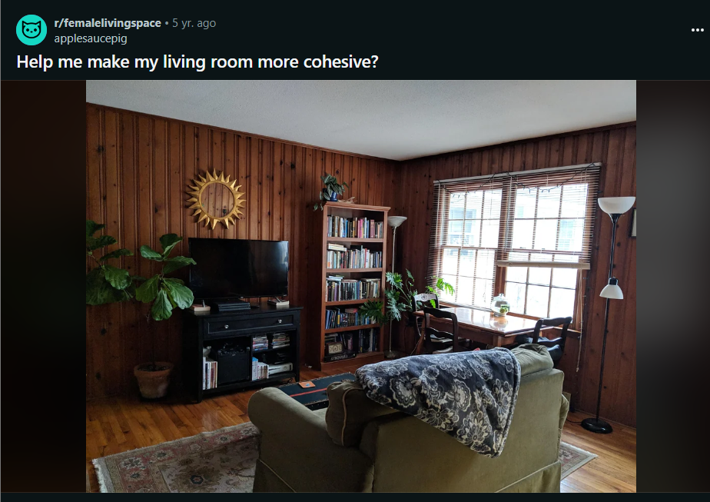

Comments :

1. I actually think it's really beautiful! I might start to replace some of the fixtures, like the black lap, with gold to match the mirror. I think it would keep the overall aesthetic you have going, but tie a common thread through the room without having to do a major makeover.

**Post last 19 (Line - 932429)**

**URL : https://i.redd.it/gj85wyvoxih61.jpg**

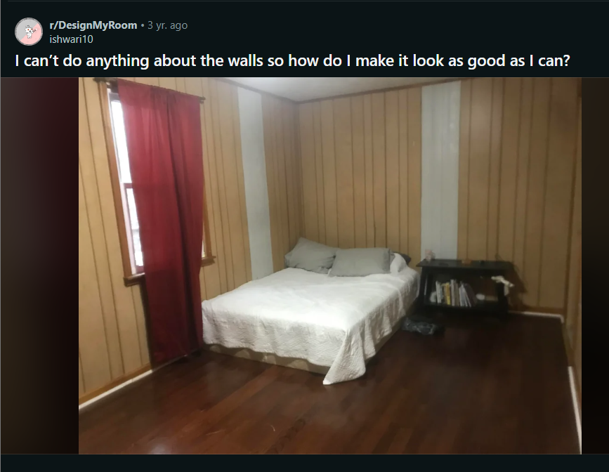

Comments :

1. I would put a vertical series of photo frames/ mirrors on the white portions of the wall to make those awkward chunks look intentional and part of the decor.  Put your bed not in the corner.
2. You're not alone.  We get lots of that here.\n\nLayout comes before anything else.  So either sketch a floorplan, or describe the approx sizes and doorways....any other windows?  Closet?   Hopefully we can get your bed away from the wall.\n\nStarting now, look at Craigslist/Facebook marketplace/buy nothing, EVERY DAY.  Especially the free section (you must be very quick in the free section...and be nice--I use it a lot and rude people don't get an answer from me)\n\nDrive around on bulk pickup trash day.\n\nMy thrift store doesn't have furniture, find one that does.   \n\nMake your family aware that you're looking for stuff...ask them to spread the word.\n\nI can't tell you the number of times that I would have been happy to give to someone starting out, or who was short on funds...rather than someone who I knew was flipping for profit.\n\nAnyway.  I love your matelasse coverlet.  I think it might be the beginning of a good look...maybe cottage-y?  Shabby chic?  \n\nWe're going to find some new curtains...so look for used (thrift stores are great for this as is any used market as they don't sell well)  You're probably looking for 84\" ones, but anything longer can be shortened, easily.\n\nThrift stores are also great for lamps.  \n\nI can help you look if you let me know where you are (if not, that's just fine--I totally understand.\n\nNow, what else do you own that we can repurpose/remake/redo?

**Post last 20 (Line - 932189)**

**URL : https://i.redd.it/cyyayesl8wq31.jpg**



Comments :

1. I think red! Red is such a classic colour and you\u2019d be sure to stand out
2. Wow!! I really cant decide either. Both look lovely on you! But I\u2019m gonna go with red because the pop of color is what my eyes gravitate towards.
3. Red!
4. Black
5. they\u2019re both really pretty but i\u2019m gonna pick red
6. I'm gonna say red. I like the off the shoulder better.

**Post last 21 (Line - 931965) --> Archived**

**URL : https://i.redd.it/gdmyoxneon191.jpg**

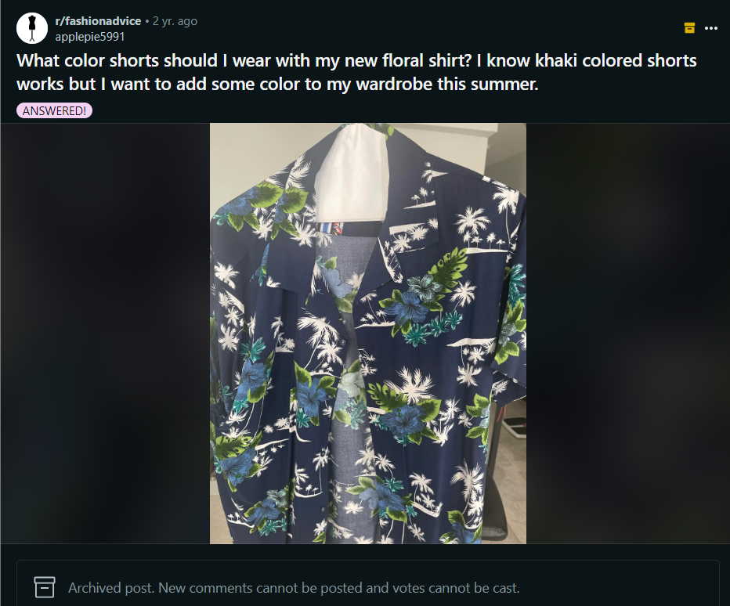

Comments :

1. Bright pink! Or light pink too!
2. White, or the same shade of blue/green on the shirt
3. Yellow!
4. A highlighter green color would be cool. Or, if you're feeling bold, orange could work!
5. a light or dark coral pink  would look good,possibly yellow and mint green as well.
6. Khaki or olive green are your best bets. Let the shirt stand out
7. Hey, \nI would say the color of the shorts should at least be a color in the shirt. Dark Blue would make more sense because matching summer shirts and shorts are very cute. Dark Green would also well. Because the shirt doesn\u2019t have a loud color, I don\u2019t think a loud color short would look cool. I would for a dark color to match the mood and vibe of the shirt. But that\u2019s just my opinion \ud83d\ude0a

**Post last 21 (Line - 931801)**

**URL : <https://i.redd.it/ofq2b0ldro341.jpg>**

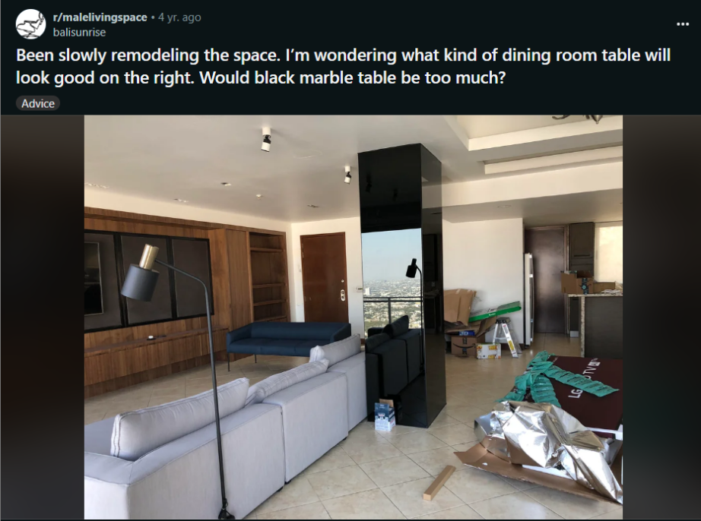

Comments :

1. I see! That\u2019s definitely a strong piece. I think it could work if you ground it by putting a modern green and glass center piece in the table \n\n[URL]
2. The black marble will look amazing in your space imo! It\u2019s like a piece of art, beautiful!
3. IMO, yes? You clearly favor a very stark and modern aesthetic but there's such a thing as too much, and then it looks cold and sterile. \n\nI'd find something in wood-- live-edge tables are very big right now, and it would be a great, organic counterpoint to all the sharp angles and straight lines.\n\nIf not that, then warm-tone metal (brass, gold tone) and glass would add warmth and sparkle to the place.

**Post last 22 (Line - 931220) --> Deleted   
URL : <https://i.redd.it/e9y0lbbrca291.jpg>**

**Post last 23 (Line - 931145) --Archived**

**URL : <https://i.redd.it/yuccvnjbv4541.jpg>**



Comments :

1. Heels or a nice ballet flat. Could do nude, deep gray like the flowers in the dress, or even a navy might look nice if that\u2019s what you already have. I agree that a clutch is probably the way to go. Get it in a solid, neutral color so as not to clash with your dress. Gold jewelry would look nice with that color pink. You could do a pendant necklace if that\u2019s your thing, then some dainty earrings.
2. Either a simple necklace or earrings.\nNude pumps whenever in doubt.
3. Nude, copper/rose gold or maybe a wine satin or velvet shoe.\n\nThat dress is so vintagey I keep thinking a mix of pearls and gold for the jewelry.

**Post last 24 (Line - 930923)**

**URL : <https://i.redd.it/jc3phmzskme21.jpg>**

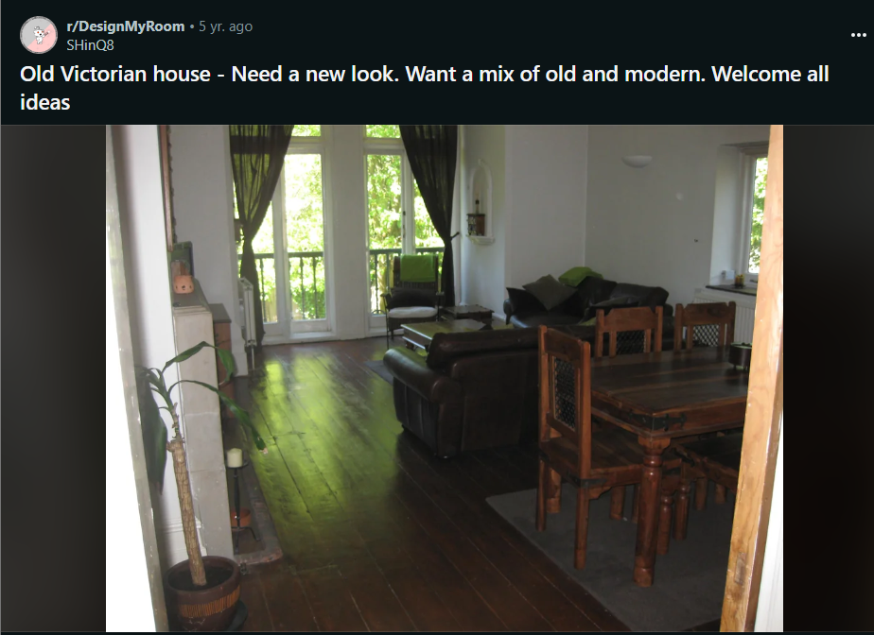

Comments :

1. Shaker-style furniture might look great in this space especially if you're aiming for a balance with sleek modern furnishings. They were the OG minimalists.\n\nA Persian rug would be dope too.
2. Love the floors.   I would go with a more muted wall color.    Maybe light grey on walls and white for trim.\n\n Also I think some modern blinds would look much better than those skimpy curtains.   The shape of the window is bold so play it up.   \n\nI love the sconce light and the wall altar?  whatever that is.    Make those and the radiator stand out with whatever you use for trim color.
3. I get if you like the walls white, but just to put in perspective that the Victorians definitely were not afraid of lots and lots of color.
4. Walls n floors are lovely!\nI\u2019d just get some more modern looking furniture!\nLook on Ikea if you like them
5. \nYou should look on Instagram for interior designers that live in cities or countries with older homes, like [this guy]([URL]  who I follow is based in london and seems to post largely older architecture/modern decor. [This dude is also great ]([URL] Kelly Wearstler is another decent example, although her stuff gets more far out and she often does full remodels of homes, but I think her style is really inspirational for mixing older looking stuff with modern.
6. Do not put blinds on the windows. They have character and should be featured. I also like the green curtains. I think it's a good color. \n\nI suggest a persian rug as well. A light colored one would be best, something definitely colorful to warm up the space. \n\nI don't think you need to paint the walls gray. I like the white. It looks clean in the pic, but a fresh coat of paint always helps. \n\nYou could accent in gold. Gold is a warm color and there are lots of neat modern accent pieces in gold. \n\nFind some mid century modern furniture. It's the best way to mix old and modern. You don't have to spend a fortune on these. Browse craigslist, facebook buy sell groups, facebook marketplace, garage sales, thrift stores, etc. I just bought a mcm chair on Saturday for $10. You can also look at their art and stuff. If you like something, and it brings you joy to look at, get it. It doesn't have to match. You can get multiple pieces and paint all the frames to match and tie it together. \n\nDon't fill a space just because it looks empty, and don't clutter the space with too much \"stuff\
7. You need more color and wall art.  Paint those walls!
8. If I had this lovely place to design, here\u2019s what I\u2019d do:\n\n* [Highlight vintage molding / window frame with dark paint]([URL] and work in soft-colored, modern furniture & light fixtures \n\n* Add some[low bookshelves]([URL] for records etc - they can double as makeshift buffet tables/sideboards and also good surfaces for more plants\n\nThere are so many options! But that\u2019s how I\u2019d start. Also these two inspiration spaces I linked to can be a springboard to more similar & lovely ideas on Pinterest. Enjoy!\n
9. Please don\u2019t get rid of that dining table! It\u2019s sooo beautiful. \n\nYou need more color. The rug under the table is way too small and the color isn\u2019t doing anything for the room. \n\nI totally understand not being able to replace the couches, but you should at least get a big area rug for the living room. I\u2019d go with a warm colored looking rug \u2014 reds/oranges. Try amazon \u2014 they have the same brands as Allmodern/wayfair but a little cheaper sometimes! But check everywhere. \n\nI think keep the art to one big piece. It\u2019s a cool room and it doesn\u2019t need too much distraction.
10. Could you possibly remove the dining chairs and take a picture from chest or navel height (instead of eyeline) from the corner so we can see the fireplace? I'm formulating a plan.\n\nE: the corner behind the dining table, I mean.

**Post last 25(Line : 930752) --> Deleted**

**URL : https://i.redd.it/in1o9swah6391.jpg**

**Post last 26(Line - 930479)**

**URL : https://i.redd.it/12tca2eqwaa61.jpg**

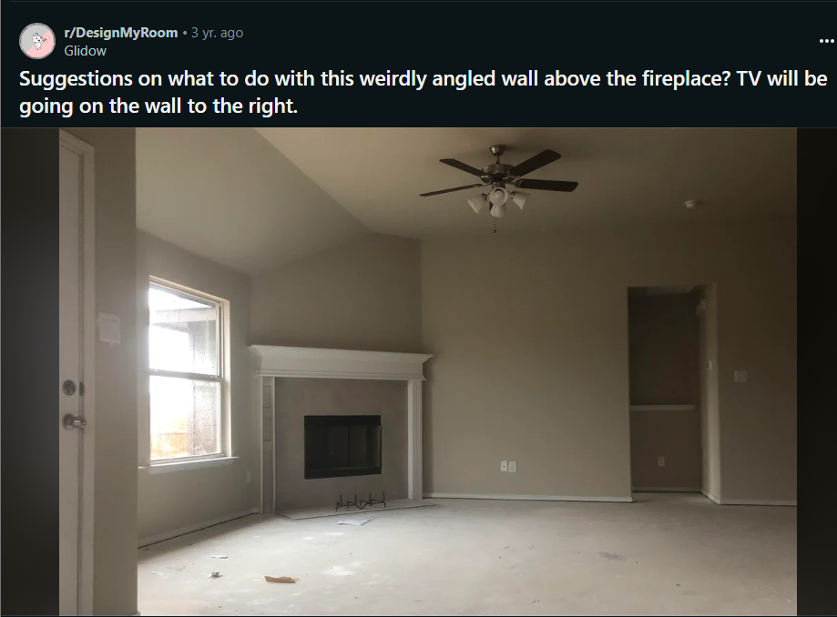

Comments :

1. Add big round mirror
2. I also vote mirror. I'd go with a wide horizontal mirror.
3. I suggest mirror too. But I'd lean more towards an asymmetrical shape instead of perfectly round. \n\nSomething like [this one]([URL] or [maybe something like one of these]([URL] or [googling pebble mirror brings up some cool shapes]([URL]
4. Or a big wall clock maybe
5. You can put a [large abstract wall art]([URL] above the fireplace, and then put a TV on the right wall

**Post last 27 (Line - 930153)**

**URL : <https://i.redd.it/2sq1kwmcidu41.jpg>**

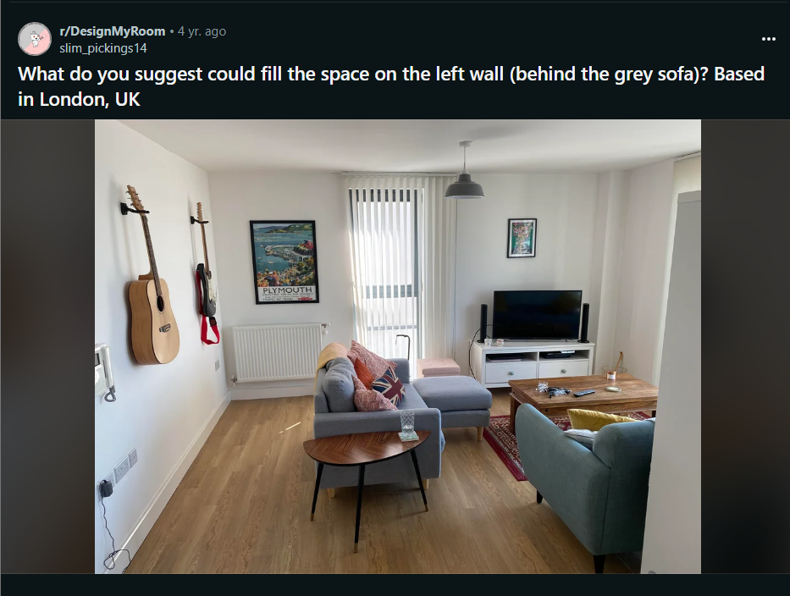

Comments :

1. Unless you really need more storage, I would not add more furniture or knickknacks. I do think a rug runner would look nice. You can buy one with faux fur or made with jute/seagrass for more texture.
2. According to who, the rug police? A runner can go wherever someone pleases. It would be appropriate based on the width of the space.
3. Agree with the No Furniture crowd.\n\nFor me, the room feels too skewed to the right. Could you perhaps invest in a much larger rug, and then move entire seating area a bit more toward that wall? I realize TV viewing is a goal, but it might feel more expansive and welcoming if the seating area was opened up.
4. A nice tall plant
5. Long skinny console table. Perfect place for a small bar display...nice bottles of whiskey/gin/vodka/ your drink of choice with a cocktail set
6. I think a rug behind the sofa would look nice, maybe a long accent table, with a record player on it or something
7. You could move the guitars and hang some art.
8. Framed Platinum record
9. I would put a big potted plant in that corner and maybe a runner behind the sofa

**Post last 28 (Line - 929994) --> Archived**

**URL : <https://i.redd.it/m7cbzvkl5sh41.jpg>**

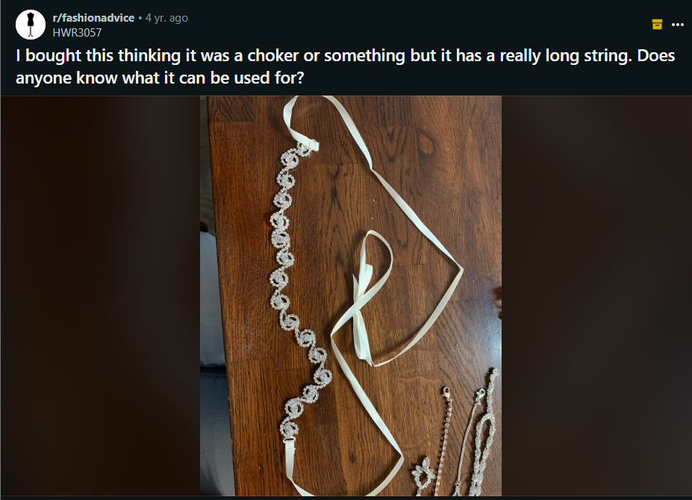

Comments :

1. Bridal belt 100%! I bought one for my wedding dress

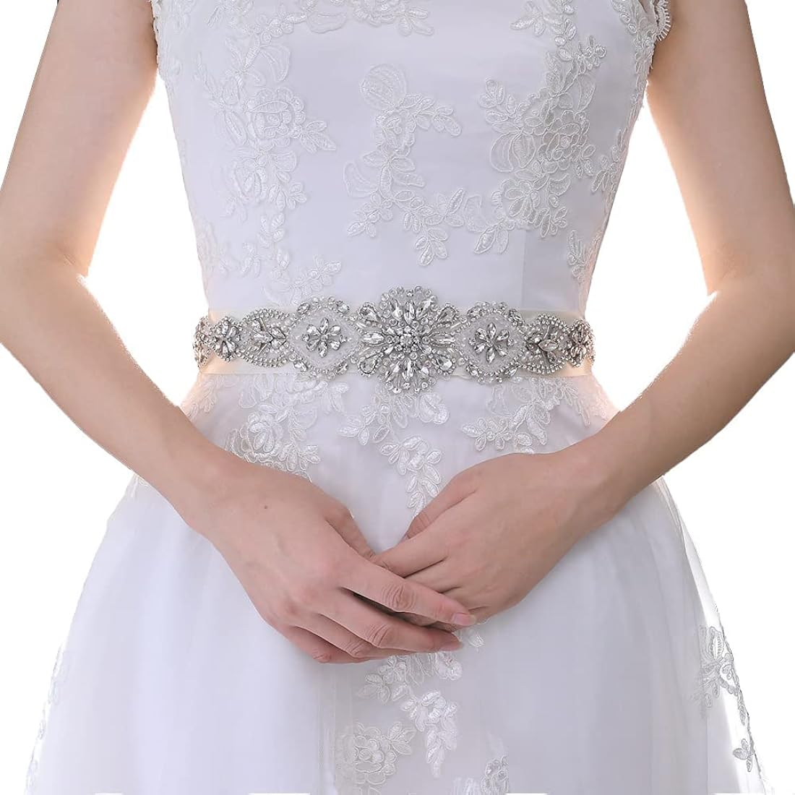

1. Could be a belt, or a headband.

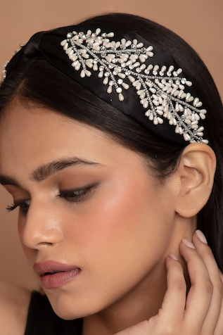

1. Probably a belt then that is supposed to have a long bow. Maybe a wedding dress belt?
2. You could always cut it if you wanted to use it as a choker.

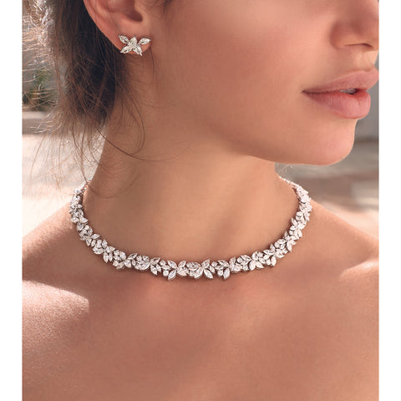

1. Even though it's probably a bridal belt,you could probably just cut the strings to be shorter and still use it as a choker!

**Post last 29 (Line - 929684) --> Deciding poll (no suggestions )**

**URL : <https://i.redd.it/gi2kefcjxzk81.jpg>**



Comments :

1. Love both, but the bottom one is more versatile with the beautiful top handle.
2. I'd choose the top one. I love a good crossbody and that serpentine closure is awesome.
3. I was wondering how the top handle worked. Bottom is cool, I just really love the closure on the top one.
4. Bvlgari snake handle is absolutely insane. You will get constant compliments with that bag!
5. Bottom. It\u2019s a unique looking piece.
6. Bottom right
7. I\u2019m a fan of the top one. I like top hands but I\u2019m not a fan of the way the top handle looks on the bottle. Snakes creep me out!
8. Overall the top bag is my preference but I also love the signature Bvlgari snake top handle.
9. They are both super cute, I like the top one best. I will tell you I\u2019m not a chain strap fan in general, it pulls my hair too much when I\u2019m wearing it crossbody.
10. Top one, leather strap is more comfortable
11. I like the top one
12. I prefer the bottom one.
13. Bottom one is more unique. It's versatile and I prefer the quilting more.
14. I'm a NYC Fashion Head and I would definitely say the Mary Katrantzou! You can dress it up and wear it to a gala or dress it down with a pair of Jeans.

**Post last 30 (Line - 929310) ---> Deleted**

**URL : <https://i.redd.it/ggmafoaec5p81.jpg>**

**Post last 31 (Line - 928569)**

**URL : <https://i.redd.it/704bbbvljie91.jpg>**



Comments :

1. Those are very interesting pants, they look kinda odd but I like how unique they are. The look you\u2019re wearing in the picture seems very formal. If you wanted a more casual look I would wear a white crop top and white sneakers.
2. Snug sleeveless top. The puffy sleeves look too much with the puffy legs.
3. I would go for snug, it\u2019ll make your figure look better
4. The top you're wearing in this photo. If you can find anything similar to it without the bunched sleeves, would go very well with the pants. \nSo either spaghetti strapped, halter top, tube top etc.\nAnd medium high heels. Or even a black strappy heel.\nMatch the shoe colour to whatever colours are in the top you decide to wear. That way it'll bring cohesiveness and make eyes travel from head to toe.
5. Long-sleeved black body suit would elongate and up the vibe of mystery. \n\nIt also would not compete with the pants. They deserve to be showcased. \n\nThen, add accessories. Maybe a multi-strand chain necklace. I first thought gold but silver would work, too.\n\n(that said, there is something very appealing about the top you have on with them)
6. This! The simpler the top the more the pants will stand out!
7. Omg! I love the picture I'm getting in my head of this suggestion...I invision with some super sexy, strappy stilletos. Urgh, I wish I could wear outfits like this! \n\nAlso, second that I kiiinda really like the top in the pic too
8. All eyes would be on her, no doubt, if paired with strappy stilettos!
9. White sneakers or flats
10. i second flats. i don\u2019t know that i\u2019d go with the shoes you\u2019ve got on. \n\n\nas for a top, i quite like what you have here. but a previous poster was right, the puffy sleeves may be a little much. \n\n\nyou have a beautiful figure, a snug top tucked in like that would look great!
11. Maybe a black tube top for sure, idk what shoes tho. Those look SO comfy I love them
12. I would recommend a thin uniqlo fitted black turtleneck on top and some white flats\n\n[URL]
13. As a fellow desi girl, I love how these pants look on you. I like to go with the tight and loose formula. Since your pants are loose, go with a snug spaghetti top. And show some midriff skin so there is some playfulness to it. Some cute delicate heels that match the top would be nice! Wear your hair in a top bun or tie it like Jasmine. Would look soooo pretty ! And if you\u2019re going the Jasmine route, wear an arm bracelet and a choker \ud83d\ude0d
14. I would maybe it with some platform shoes or high calf black boots. \n\nCan I ask where you get these pants from?
15. In addition to all the other great suggestions, id say sleeveless mockneck bodysuit + chunky sandal flats!
16. Fitted simple crop top or fitted long sleeve shirt tucked in. I love them! Could be super cute with white sneakers or a pair of light brown leather ankle boots
17. Yea yea the pants are fine but what about that background is that real?
18. You don\u2019t throw to Goodwill.  To much material for you.
19. you don\u2019t, you rip them thread by thread and smile while the tattered clothes are laying on the floor.
20. I like that top with those harem pants. If you want something more casual a simple tank (tucked in or cropped) would work. I just wouldn't go too cropped as then you might look like a genie. \n\nI think I'd also try a black top to create a column of color.
21. I would do like a fitting crop top and low top shoes like vans or keds.
22. They look cute, I\u2019d prefer it as a skirt so I can have some breeze
23. I also wear patiala/dhoti salwars. I really like how you styled them. Black is a versatile colour. Fitted tops tucked in, and white trainers would go well with these.

**Post last 32 (Line - 928200)**

**URL : <https://i.redd.it/dtlu4q05gwp71.jpg>**

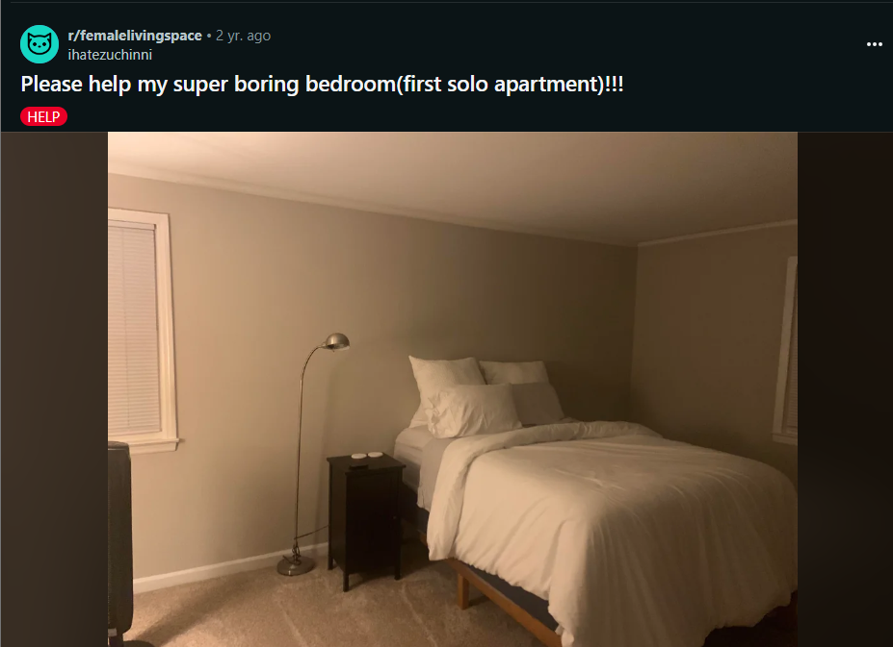

Comments:

1. I would introduce some color. But I\u2019m not sure what you mean by neutral boho. My first thought is to get a pattered duvet cover.
2. Tan and green my friend. Maybe even a light blue or yellow thrown into the mix.\n\nBlankets and rugs with a \u201crope\u201d texture and/or tassel\n\nAnd lights. Even the bohos want to see.
3. Texture will make things much more interesting! Think plants, wicker, or a woven rug of sorts, etc. \n\nCurtains with a substantial rod (not the cheapest, skinniest ones out there) can also really transform a space.
4. agree, swap out that dinky bedside table with a wider wicker table or small chest with drawers
5. Figure out the color palette you want and go from there! Get a nice rug, some throw pillows or blanket, curtains, wall decor, hanging shelves, twinkle lights or a hanging pendant light in the corner perhaps?
6. Maybe some muted tones and natural materials would be your speed. I would suggest a textured  linnen duvet cover with patterned pillows. Maybe with waffle/tuft textures and boots esc patterns so that your able to keep some minimalism but add some style. Plants by the window sil and a few paintings would really make the space come alive.
7. Just needs a colored throw blanket for the bed, some boho art or floating shelves above the bed, and maybe an area rug.
8. Can you get a larger bedside table and lamp?  I think the scale is the major issue. Add in a bright quilt and it would already look cozy.
9. Work out your colour palette and whether you would like warmer or cooler tones etc. And then a wee rug, bedding and some cushions in those tones would add more personality and life to it! Hard to say more as can\u2019t see the rest of your furniture or room, but pretty much go for different textures and materials as that\u2019ll add depth!
10. I would start with a soft pink throw blanket folded across the foot of the bed, and maybe some mint green throw pillows. Move the floor lamp to the other side of the bed and get a table lamp for your nightstand. Some patterned sheer curtains in soft pink would bring more texture to the room. Add a set of three art prints above the head of your bed.
11. A macrame wall hanging, some curtains to add more texture. A rug is also a great idea.
12. Looks like you're starting with a great base. what style are you thinking of incorporating? if you have an iphone, i'd scan the room on the realize design app and add in some colorful decor to see what you like and what feels comfortable. I'd also consider getting a headboard.
13. I love all white minimal bedrooms. Maybe start with a rug.
14. You are off to a good start!  You have a room with a neutral paint color, with nice trim around the baseboards and ceiling.  Your bed is modern and has clean lines.  I would start with replacing the lamp with a bedside table lamp.  In whatever style makes you happy.  Add a couple plants.  Plants are the easiest way to make a space more inviting.  I would suggest curtains in a basic white/off white for your window.  And maybe a small rug in neutral tones, or even something with texture/natural fibers, like a bamboo or jute rug.  A mirror above your bed, or maybe an interesting but understated wall decal would also look nice.  You mentioned that you like understated boho decor, so a few pieces of furniture/knick knacks in wicker would compliment this.  I'm someone who loves color, but I honestly think your duvet/comforter looks fine as is.  I would suggest a couple throw pillows that either have subtle designs in neutral colors, or something textured, just to add some dimension.  If you want to dabble in adding color, I think green, soft pink, or rust orange would be colors that would compliment what you already have.
15. Could you move the floor light to the other side of the bed to make it look a bit more symmetrical? \n\nI think one of those oval headboards would look lovely too.
16. Minimalist is another art. :)\n\nIMHO adding more textures might help make the room feel more personalized. If there's a color that you are particularly fond of, get an oversized lumbar pillow in that color. Having some furry pillows and blanket can also make the bed feel more layered. Next to the nightstand, you could add a rattan basket. It looks pretty and serves the organizing purpose as well - you can put unused pillows and blankets in it to make the room look less cluttered. Lastly, plants and wall hangings would add more flavors to the room.
17. Keep this perfect room exactly as is. Reduce number of pillows on bed

**Post last 33 (Line - 927465)  
URL : <https://i.redd.it/8vvr5uzu63o91.jpg>**



Comments :

1. Anything flared! I think white would stand out, but black would be cute too. I also think a pastel color (purple or blue) flared pant would look amazing. Big silver hoops, a platform shoe, and some gems(small rhinestone in the inner corner or under bottom lash line in the middle) or the TikTok white dots would be fire.\n\nSomething like [these]([URL]  or [these]([URL]
2. Black satin cigarette pants or dark blue bell bottoms
3. PINK BOTTOMS TO BRING OUT THE PINK SHEEN + WHITE ACCESSORIES
4. If you do either of those pants, maybe a medium-thick, mirror-metallic type belt. Silver? Either way, accessories are going to be key to pulling this together.
5. I\u2019d say go w a lower rise! It\u2019s really trendy and depending on your body type, can be super flatting by showing off the curve of your waist. As for accessories I\u2019d avoid anything too sparkly to avoid overshadowing the shirt. I\u2019m thinking white Go-go style boots, maybe a chunky white headband or bandana? Studs for earrings
6. I'd do the high waist pleated flares. Wear what's comfortable for you. Anything in a blue, purple, pink, white, or black will look awesome
7. You\u2019re average size babe! I\u2019m sure it\u2019ll look great, tummies are hot. If you don\u2019t want to, I think a flared bottom would be SUPER cute esp w white boots. Chanel the 90s kinda? You could also do a cute micro/mono skirt or something
8. Black bell bottoms
9. Black flares.
10. I immediately thought black leather cigarette pants with black strappy heels with an open toe.
11. Black fit and flare/bell bottom pants
12. White pants with a flared bottom and maybe some silver, pink, or baby blue heeled sandals
13. Are bags allowed? If they are not, you\u2019ll probably want a lot of pockets. \n\nMy taste would be to pair with black techwear cargos and live my best 90\u2019s vibe
14. I would do either black leather pants, black straight leg pants, or white straight leg pants. \nThere are a couple pairs of leather pants from My Little Halo that would look great with this top.\n\nI personally would probably want to bring this to a more glam punk style, straight leg leather pants, studded cuffs, some form of leather jacket if it\u2019s cold, a studded collar, black smoked out cat eye and some rhinestone facial jewelry (I have a new rhinestone septum that I think would look amazing with this).\n\nOn the flip side, maybe doing a high glam, slightly alternative look. Black straight leg pants, some black heels, statement earrings, some rings, maybe a necklace.\n\nCould also look good with some pink or blue pants to bring out the respective color in the shirt.
15. I thought black leather pants also!
16. Honestly some black palazzo pants come to mind, but I don\u2019t even know if those are a thing anymore haha! A pair of black skinny jeans would also work
17. Jeans or puddle. They will both look amazing
18. Black leather or vinyl pants?? Something shiny anyway!
19. Bleached high wasted bell bottom jeans, then some vans or whatever shoes you think fits. Some cool jewlery and your set. Ooh maybe a plain white peaked cap would look great too!
20. Black silk pants and sandals.
21. Definitely low rise flares
22. A blue/purple/white miniskirt - preferably satin.
23. Some tie wrap silky skirt. White
24. White jeans with a fun pair of heels
25. white pedal pushers would look lovely!!
26. Cargo pants.
27. This reminds me of a shirt I had in 1999, and I used to wear it to the club with white flares. So white flares is my suggestion,  looks amazing under blacklight.

**Post last 34 (Line - 927353) --> Deleted**

**URL : <https://i.redd.it/ubi60bxqpjt81.jpg>**

**Post 35 (Line - 926596)**

**URL : <https://i.redd.it/su3zs9j9zqc41.jpg>**

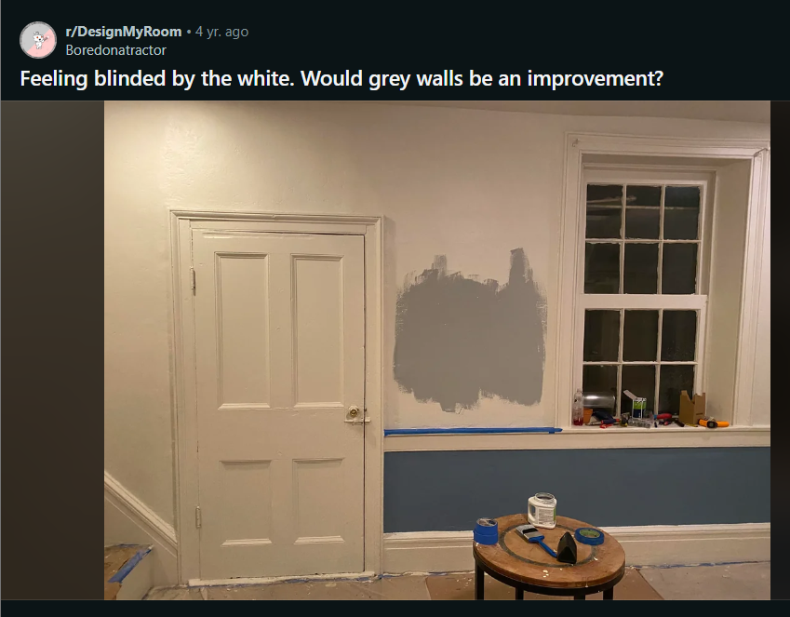

Comments:

1. Grey is good. But it needs to be much lighter. Stick to blueish grey.
2. The original grey was better than any of the new ones.
3. Get a sample from Lowe\u2019s (if you\u2019re in US) of a gray named Icicle. It\u2019s very light and neutral. \n\n(Any paint company can reproduce any other company\u2019s colors, so you can still buy your paint anywhere you want.)
4. I like the third one, but that's what I tried to paint my walls with so I might be biased (I ended up with a tone more in the light blue side but I still like it)
5. The third one. Maybe go even lighter.
6. First, love the song pun! Second, I agree the grey should be lighter. Love the blue and grey together.
7. My favorite thing is to take the photos and do a quick photoshop of colors. Honestly, I think the grey you're looking at might be great. A lighter grey could work, but since the photos are at night, there's a lot of yellow light from the bulbs inside, so staying on the cool/blue side of grey is good. Keep that in mind.\n\n[Dark Grey Vs. Lighter Grey]([URL]
8. I like the grey you picked. You can see from the comments that people are all over the place on it - everyone has a different style.  Do YOU like it?  It matches well. Do you have concerns about the room being too dark - or not dark enough?  Some people like it darker than others. There's not a wrong answer here. :)
9. I personally really like the grey you already picked and wouldn\u2019t go lighter. I think it adds a really nice warmth to the room.
10. I like this gray too, but I think you will want to paint the trim a brighter white.
11. I love the idea of getting a color a few shades lighter than the blue on bottom for the top. If you want gray, I love Light French Gray by Sherwin Williams.
12. I would personally stick with the white and not go gray...I feel like we\u2019re getting to the point with gray that we were with beige 20 years ago;  it was so over done that beige immediately screams 1990s and now gray just screams 2010 to me haha. \n\nCheck out [THIS]([URL] room for some inspo on making white look crisp and modern and cozy all at the same time...maybe paint the door instead, and add an interesting area rug and plants?
13. I still like beige alright, but personally really like some color on my walls. The whole grey thing is getting so overdone though (in my opinion) that every new/renovated house on the market looks like youre walking into a black and white film.  I feel it looks so bland - just personal preference. I like the blue and grey mix though that OPs got going on. \n\nAlso really nice pic, definitely looks cozier than i was expecting for white.
14. Give \"Knitting Needles\" by Sherwin Willams a try. In my opinion, its a nice balanced grey that isn't too dark or too light. I think it would work well with the blue.
15. I don't think you need to go lighter; having it as a patch in the middle of a light wall makes it very deceiving.\n\nOne trick is to paint a piece of paper/card with a few coats, and then look at it alongside whatever furniture/floor will be in the room, away from the existing walls.
16. I think that gray looks fine, don't know why people are saying it's too dark.
17. A tinted white would work. I like artists canvas. A soft ivory, creamiah could work too.
18. Yes but keep the trim white
19. Yaaaas. This is my favourite colour scheme (blue and grey divides by bright white). I like it but maybe lighter will be better like other people say :)
20. Try a lighter complex neutral grey, Cement Grey - Benjamin Moore.\nDoing the lower portion in white would be classy, IMHO
21. Maybe for one wall. The rest should be a light grey.
22. Repose Gray is the gray we love. We have had it in two houses. I also think it\u2019s by Sherwin Williams
23. Bher metropolitan gray is a good one
24. Yeah blueish Greyish looks real \u201cfancy\u201d\n\nDid one wall in my bedroom that color and it really looks good
25. I would keep the white but you have to add pictures, curtains, rugs, furniture and toss pillows. Make sure you have lots of texture too, like velvet, a basket to hold blankets, a couple of plants, and it will look great.
26. Agreed! I think adding personalized homey and modern  touches will make the room be much more on trend. Mid-tone Gray is beginning to feel very dated and early 2000s to me haha
27. I am not a fan of the blue and gray! Lol just my useless two cents.
28. Yes, but either go with a much lighter or a bit darker tone
29. Deep green.
30. Look at agreeable gray by sherwin Williams!! With natural light or regular lighting, it looks white but without any lighting, it\u2019s a nice cool gray.
31. Sherman williams Agreeable Gray would be nice. Grays you need to decide on gray gray (no other undertones), gray blue, gray tan, gray purple. So Evening Shadow has some blue. Lazy gray would be gray gray. Argos is tan gray. Those are just a few options. It\u2019s good to know what you like And what you don\u2019t. Lighter is needed.
32. Ues but that is WAY too dark. Try Sherwin Williams Ice Cube

**Post last 36 (Line - 925899)**

**URL : <https://i.redd.it/q24zasnj0w551.jpg>**

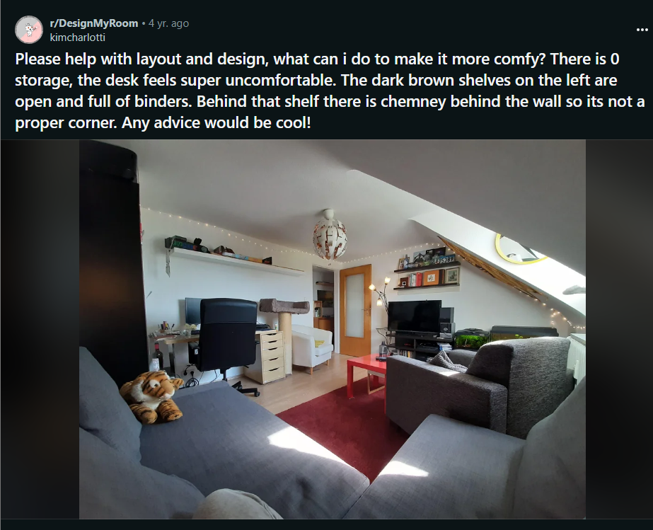

Comments :

1. My suggestion would be to reduce the amount of furniture you have. \n\nWhat is this room used for mainly? How many people etc?
2. For two people, it seems like you have at least two too many seats in this room.  Do you actually use the sectional for sitting, or do you both just sit in the chairs closer to the tv? If you don't use it, I would remove the sectional. If you use the area for guest seating, it would depend on how often and how many you have people over (pandemic not withstanding). I would utilize the shelving above the desk more fully, and I would add additional shelving below the stairs.  Move the floor lamp to wherever you actually need the light.  Most people don't really want that much light right next to a television, because it competes with the picture on your set. If you like it, keep the ceiling fixture, but personally, I would change that out for something more to my taste.\n\nFor the desk, you probably are looking for more empty desk space.  Aim to have nothing but your computer on the desk at the end of the work day. That should feel less cramped.  (Hence, utilize the shelves above the desk more, and maybe add more if necessary.) Think about an empty library table, and sigh at how wonderful it feels to sit down to work at one.  I find rolling desk chairs deeply uncomfortable, so I just use regular side chairs (like dining chairs) whether I work from home or at my office.  Generally, the way for me to feel better when I am sitting for a prolonged time while working is to get up, and office chairs don't help with that. The arms on those things interfere with side stretches, and the wheels encourage you to roll towards things you need, rather than stand up and walk to them. Plus, they are huge and unsightly. So, if it genuinely feels more comfortable to you, and you can maintain good posture while working in it, keep it.  But if you just use it because you have never considered getting rid of it, maybe put the desk chair in the closet for a couple weeks and see how you feel sitting at your desk in a regular chair. I personally would rather sit on a folding chair than sit in a rolling office chair, but it is your body, so do what works for you.
3. Which chair do you sit in- grey or white?
4. Agree! That way, you can kind of designate two different living spaces - and flip the rug maybe
5. We can advise you better if you provide more pictures of different angles of the room. At first glance it looks like the white and grey chair are both too many in this room. If we can see more angles, we might be able to tell if you can make it work.
6. I think pulling out the rug from under the sofa might help reorient the space, I think the usual recommendation is to have furniture legs on about 6 inches of rug depending on relative size. (I can't remember where I've heard this so be aware I may just be making up design rules here.)\n\nI live the red color and texture.
7. I would definitely switch the desk and the TV. Get rid of the boxy armchair, it\u2019s too large for the space. I would suggest a lighter color rug, maybe a light grey one with red accents? \n\nAnd to break up the grey, get nice new red (or whatever color you like) throw pillows for the couch and white chair. I would toss the ones you have- they look deflated and old, so it makes the furniture look dated. \n\nThe only other thing bothering me is the shelf above your desk- it is in plain view from the main sitting area, so you should definitely declutter it. Get rid of the snickers box and add a few small plants, pictures, books, or trinkets like you have with the other shelves. Or even put small little baskets to hide clutter in. \n\nOh, and if you move the tv where the desk is, you can put the white armchair where the boxy one is now and angle it toward the TV. That way there\u2019s more seating and the cat tower isn\u2019t dangling over your head! \n\nI love your light fixture btw!!\n\nEdit: added suggestion
8. You could get some decorative wall decals to put above or \"on\" the shelf. Maybe something like [this]([URL] if it wouldn't freak your cats out lol.
9. It\u2019s hard to tell but I\u2019d put the desk under the window as a start. Looking at a wall from a desk is always a no no for me. If you are working and look out to the outside sky, it feels more motivating. \n\nIt looks like a large space. So I would use the back of the couch to split into two spaces. Rugs also help w that. \n\nAnd remove some stuff you\u2019ve got too much furniture in there. The bookcase w binders sounds like it might need to go. Do you really use / ref stuff in it? Trash it or put into deep storage. \n\nA few more pix would help!
10. Yeah! It\u2019s a cool space, I think a few small changes will make a huge diff. Make sure you post an update!
11. Alles an diesem Zimmer schreit Deutschland :)
12. Ist \u00fcberhaupt nicht negativ gemeint :)\n\nHatte \"das Feeling\", dass dies mein Zimmer sein k\u00f6nnte. Aber typisch deutsch d\u00fcrften sein: die T\u00fcr, die Ikea-M\u00f6bel, ausgebautes Dachgeschoss, weil Land teuer ist :)\n\nAnd now back to english, so we don't discourage someone who want's to give you advice :)
13. Desk where the TV is with the bookshelf to it's left. If the couch can split, put one half on the wall where the desk currently is and leave the other half where it currently is. Move the TV to the right of the window. Face the chairs in towards the couches/TV.
14. Yeah I personally can't stand the grey box chair - it's so large and blends in to your sectional - however you have it facing away so when sitting on the couch irs so in the way of the TV and feels like you can't settle in. I'm also not big on having the cat stuff in the living room, if possible pop it somewhere else like the hallway or bedroom if possible. Declutter parts of the walls and move the TV to where the desk is and move the fish tanks on to the work desk or somewhere else?
15. Move tall shelf. Put couch on desk wall. Put tv caddy cornered where couch is. This way you can look out the window. Put desk where tv wall is. Move gray chair into open space facing tv like it is now. Pull the rug out from underneath the back legs of the couch to cover more floor space. Find place for tall shelf somewhere? Possibly next to new desk space where the three bulb lamp is.
16. Move the fish tanks and put the tv over the desk. Move the grey chair into the corner and then get rid of the white chair. It would give you a little more space
17. I would take out the white chair and the grey chair. Move the sectional significantly closer to the tv. Move the desk to the same wall as the brown bookshelf.
18. I would try putting the TV where the sectional is now. I would also either get rid of the sectional or the two chairs. Whatever you choose, face the seating towards the TV about halfway across the room. Get a lighter rug. The couch and rug are too dark to be together. Take a few things off the walls. It\u2019s nice to personalize your room, but it feels a little cluttered now. Move the desk to where the TV is currently. Take down the string lights (personally I think it can feel very college dorm room).
19. The chair makes it super cramped, especially since the couch is pretty spacious.\n\nOh jeez just noticed there are TWO extra chairs that just seem unnecessary.
20. Alright. Since you have trouble seeing the tv I would move the tv where the sectional is and put the sectional on the desk wall into the corner. Then you could use the white chair on the door side of the wall to section off that side of the room as sitting area eithout completely blocking access... get rid of the grey chair, it just doesn\u2019t fit at all and takes up too much space. If you are able to, I would also get rid of the coffee table and replace it with 1 or 2 side tables for the sectional... you could even wedge a console table between the back of the sectional and the wall to create more functional space and also get your furniture closer to the tv to help with your vision. Then I would set the desk up on the tv wall, and turn the fish tank sideways so the length of it goes along the sloped ceiling wall instead of the same wall as the desk. I would add a rug to center the couch area and a separate rug to section off the desk area... creating designated spaces will make the room feel more cozy. i would move the bookshelf between the sectional and the door if you are able to move the white wall shelf....

**Post last 37 (Line - 925564)**

**URL : <https://i.redd.it/6nvfbnmd79o41.jpg>**

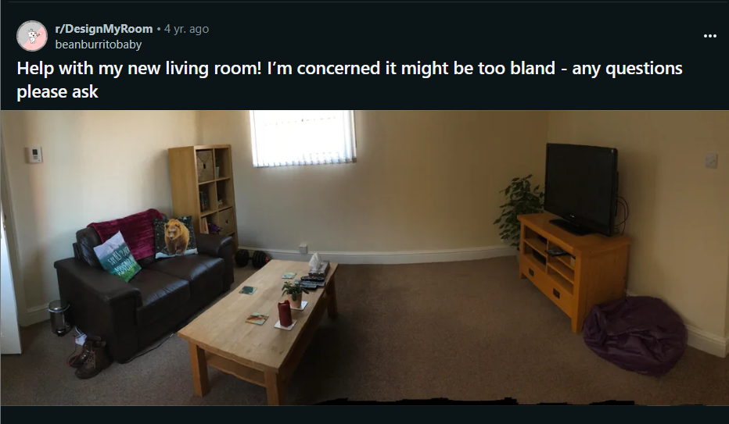

Comments :

1. what if you put that shelf that is behind your couch sideways below the window? Then you could add some colorful books or plants?
2. I agree with NoelleDash about moving the bookcase under the window. Then center the couch and tv a bit better.   \nStart with some art over the couch. Make sure it\u2019s something you really like. Large and colorful. Add a nice knitted throw to the couch to soften the leather.   \nYou could put a cluster of smaller pictures over/next to the tv. Add some nice floor lamps to brighten the room and a few plants to give it life.
3. I would paint the walls over. Select a farrow&ball white shade (maybe white tie, or wimborne white) Use a colour match service at your local Decorator center/valspar to get it cheaper. \nThis will transform your space and be relatively cheap to do. If you have spare money, then maybe find new furniture. You can find great second hands online find on gumtree/ebay.
4. Love the idea of white walls here!  It will really brighten the place up.
5. First off it looks like the couch is very far from the tv, if that\u2019s just an artifact of the pic ignore this, but I\u2019d more the couch more to the middle of the room and have a reading nook behind. A cute rug under the couch to the tv would be cute. Whatever art and plants you want and you\u2019re most of the way there.
6. You can definitely still have area rugs on top of wall to wall carpeting, maybe something patterned with a few colors and then you can pick the rest of your decor items in those colors. Re nook: idk, just a chair, bookcase and side table? But it doesn\u2019t have to be that, put whatever you need personally,  could be storage, a record player, whatever.
7. What style do you like or are you going for in this room?  I think an area rug and some wall art would be a great place to start.
8. Very similar to yours, but with some art on the walls (a large piece above the couch, smaller pieces next to the windows), a throw rug, a large potted plant to the left of my couch, and a dog crate to the right of it. Also throw pillows on the couch and a little pillow seating area on the ground below the window.
9. There\u2019s nothing wrong with this place. You have a clean, safe place to live. Much of the world doesn\u2019t have that.\n\nBland to me is just a blank slate. You add in the things that make it yours and reflect your personality. Art on the walls is the best place for that, and choose things that you really love and that are important to you. I see you like bears. Maybe some nice framed photos or posters of nature? Or places you\u2019ve traveled or want to travel to?\n\nYou just need some color. With that \u201cbland\u201d base, you can take it in any direction.
10. I would add art, a light colored area rug, colorful throw pillows, and plants
11. You need to hang a piece of [large canvas art]([URL])  you like on the wall, and your colors are a little flat, so this is a good choice.
12. how serious are you? i'd love to help. i'm redoing my room and now that i'm waiting on all my new furniture and decor, i realized i have an itch to scratch with interior designing. take a measuring tape and measure everything. measure your windows l x w. measure the small distance from the wall to the left side of the window. measure the height from the bottom of the window to the floor. measure your ceiling height. measure your room and any nooks. measure your doors and closets, and also the spaces between them and the other walls like you do with the window. also tell the main me the main entrance. what's your budget?\n\nif you're daring enough, paint your wood shelves and furniture white. those are great looking pieces, but painting it white will brighten up the room a lot more than just extra lighting will. that coffee table will look beautiful with a white top and under shelf, and pale greyish blue legs.
13. U can find a lot of cute & stylish home stuff [URL] Could be useful\ud83d\ude0a
14. You bought or rented a generic condo. It\u2019s bland because you might not be able to afford all the exciting stuff. Just get some nice ikea furniture and enjoy the blandness. Save money they buy a sweet historic home\nWith lots of Interesting details

**Post 38 (Line - 925476)**

**URL : <https://i.redd.it/2kss1tlyl6b91.jpg>**



Comments :

1. this has very dan levy vibes to me so i\u2019d say \n\nthis type of pants: [URL]\n\nthis type of shoes: [URL]\n\nand a chunky silver watch :)
2. If this is long and baggy enough to be worn as a dress I think that would be cute. Just put a belt around the waist to cinch in and add some strappy sandals or heels. \ud83e\udd37\u200d\u2640\ufe0f Just depends on your preference and style really.
3. I would say white or black pants to go with it or plain red ones